Introduction to Cognitive Science EXAM MASTER DOCUMENT

Highlight the following:

experiments

key terms

other relevant stuff

perspectivation

Table of Contents

1: The Science of Cognition 4

Key Terms 10

2: Perception 13

Visual perception --> Early + late phase 13

The eye 14

Information coding in primary visual cortex 15

Depth + location perception 16

David Marr (1982) → 21/2 D sketch 16

Visual pattern recognition 17

REMEMBER THIS IS ONLY A BOTTOM-UP MODEL (TOP-DOWN also plays a part!) 18

Speech recognition: 18

Categorical perception 18

Context – top-down processing 19

Key Terms 20

Additional: Hoffman (The construction of visual reality) 22

3: Attention and Performance 24

2 Conceptions once held: - We cannot attend to one thing unless we are conscious of it ○ Cognitive psychology is now beginning to recognize that attention operates at an unconscious level - Eg. not conscious of where they have moved their eyes - Attention, like consciousness, is a unitary system ○ Today we have realized that attention is multifaceted. It makes sense to separate auditory attention from visual attention and attention in perceptual processing from attention in executive control from attention in response generation. 24

Attention: 24

Serial bottlenecks 25

Auditory attention 25

Visual attention 26

Other types of attention 27

Additional: paper: Treisman (A feature-integration theory of attention) 29

Key Terms 30

4: Mental imagery 33

Visual >< verbal imagery in the brain - Roland and Friberg (1985) 33

Visual Imagery and Brain Areas 33

Spatial and Visual components in imagery 34

Visual imagery: Mental rotation 34

Spatial encoding >< linear encoding 35

Image scanning 35

Magnitudes 36

Manipulating imagined objects 36

Cognitive maps 37

Map distortions 37

Representations of space 37

Key Terms 38

5: Representation of Knowledge 39

Brain areas: 39

Memory for verbal information: 39

Memory for visual information: 39

Additional reading: 46

Key Terms 46

6: Human Memory: Encoding and Storage 49

Chapter answers the questions: 49

Memory and The Brain: 49

All of the brain plays a role in memory, but two regions in particular 49

Sensory memory 49

· Short-Term Memory 50

Working Memory 52

Activation and long-term memory 53

Practice and memory strength 54

Neural correlates of the Power Law (Details not expected!!!) 54

Factors influencing memory 55

Techniques for Studying Textual Material   55

Incidental vs intentional learning: 55

Flashbulb-memories 56

Keyterms 56

7: Human Memory: Retention and Retrieval 59

THEORIES OF FORGETTING 59

THE RETENTION FUNCTION & POWER LAW OF FORGETTING 59

FORGETTING AND SLEEP 62

FALSE MEMORIES 62

Key Terms 65

8: Problem Solving 67

Key Terms 70

9: Expertise 72

Brain changes with skill acquisition 72

3 stages of skill acquisition (J. R. Anderson, 1983; Fitts & Posner, 1967) 72

The power law of learning 72

Anderson's dimensions of expertise development 73

Strategic learning and problem solving approaches (Priest and Lindsay) 73

Problem perception 74

Pattern learning and memory 74

Long-term memory, working memory and expertise 74

The role of deliberate practice 74

Transfer of skill 74

Theories 75

Doctrine of formal discipline (No one really believes anymore) 75

Theory of identical elements (behaviorism, Edward Thorndike) 75

Educational implications 76

Key Terms 76

10: Reasoning 78

Reasoning and the Brain   78

Different types of reasoning 78

Evaluating Conditional Arguments in a Larger Context 80

Wason selection task 80

Deductive Reasoning: Reasoning About Quantifiers 82

Categorical syllogisms 82

Woodworth and Sells (1935) : The Atmosphere Hypothesis 82

**Limitations of Atmosphere** 82

Mental models 83

Dual Process theory 84

**Dual-Process Theories (criticism)** 84

Key Terms 85

xx: EMOTION 88

What is an emotion? 88

How to measure emotions? 88

How we communicate emotions 88

History 88

Basic emotions → Ekman 89

Other views on emotions 90

Fear 91

Disgust 91

Reward values 92

Key Terms 92

11: Decision Making 94

Key Terms 99

The additional reading key terms 100

14: Individual Differences in Cognition 101

Learning in the brain 102

Postnatal development 103

**Some development is simply a matter of training:** 103

Nature >< Nurture and intelligence 104

The concept of Heritability (NATURE) 104

BUT it's complicated!: 105

Intelligence: The Flynn Effect 105

One or many intelligences? Different theories: 106

Crystallized vs. Fluid intelligence 106

Key Terms 106

# 1: The Science of Cognition

**Cognitive psychology** is the science of how the mind is organized to produce intelligent thought and how the mind is realized in the brain.

**Why do people study cognitive psychology?**

* Cognitive psychologists strive to understand the mechanisms that make such intellectual sophistication possible.
  + Like wanting to know about the magical tech that gives you netflix to chill with
* Want to create AI with general intelligence as sophisticated as human
* The basic mechanisms governing human thought are important in understanding the types of behavior studied by other social sciences. For example, an appreciation of how humans think is important to understanding why certain thought malfunctions occur (clinical psychology), how people behave with other individuals or in groups (social psychology), how persuasion works (political science), how economic decisions are made (economics) why certain ways of organizing groups are more effective and stable than others (sociology), and why natural languages have certain features (linguistics)
  + Cognitive psychology is thus the foundation on which all other social sciences stand, in the same way that physics is the foundation for the other physical sciences.
* If we really understood how people acquire knowledge and intellectual skills and how they perform feats of intelligence, then we would be able to improve their intellectual training and performance accordingly.
  + Preview, Question/goal to find out during reading, read, reflect, recite, review
    - The books best guess at optimal reading for comprehension
    - PQ4R METHOD (Thomas and Robinson, 1972) - chapter 10

**Where and when did cognitive psychology originate?**

* Nativism - Plato -> Expanded by Kant and Descartes *"I think therefore I am"*
* Empiricism - Aristotle - continued by Berkeley, Hume and Locke "Tabula Rasa"
  + Cognitive psychology, like many other sciences, suffered because of our egocentric, mystical, and confused attitudes about ourselves and our own nature, which made it seem inconceivable that the workings of the human mind could be subjected to scientific analysis. As a consequence, cognitive psychology as a science is less than 150 years old, and much of the first 100 years was spent freeing ourselves of the misconceptions that can arise when people engage in such an introverted enterprise as a scientific study of human cognition. It is a case of the mind studying itself.
  + The date usually cited as the beginning of psychology as a science is 1879, when Wilhelm Wundt established the first psychology laboratory in Leipzig, Germany.
    - **Introspection (**the examination of one's own conscious thoughts and feelings)
      * **(What a behaviorist would call Armchair psychology)**
  + **The American behaviorists** (inspired by pragmatism and functionalism)
    - *Completely disregarded conscious thinking as relevant - We should only trust what we can measure objectively .*
    - *The mind is a black box we don't have access to. We only know stimulus/cause and response/effect.*
      * *And reinforcement of stimulus gives stronger associations*
    - The Behaviorists began their own formulation of the problem of psychology by sweeping aside all medieval conceptions. they dropped all subjective terms such as sensation, perception, image, desire, purpose, and even thinking and emotion from his scientific vocabulary, as they were subjectively defined. (John Watson, 1930, pp. 5–6)
  + Thorndike, Skinner, Pavlov went on with their animal research (sticks and carrots for the rats, doves and dogs)
    - A quick critique: You gotta keep your animals hungry for them to react according to stimulus
  + **Gestalt psychology** tried to fight the narrow view of behaviorists for a while, claiming that the activity of the brain and the mind was more than the sum of its parts - conflicting with the introspectionist program in Germany that tried to analyze conscious thought into its parts, but brought the mental aspect back into cognitive sciences.
    - The world was a whole in itself and we were filling in to have our own coherent version of it
      * the laws of similarity, proximity, continuity, and closure - As detailed in chapter 2 on Perception.
* In both the introspectionist and behaviorist programs, we see the human mind struggling with the effort to understand itself. The introspectionists held a naive belief in the power of self-observation. The behaviorists were so afraid of falling prey to subjective fallacies that they refused to let themselves think about mental processes.
* Current cognitive psychologists seem to be much more at ease with their subject matter. They have a relatively detached attitude toward human cognition and approach it much as they would any other complex system.

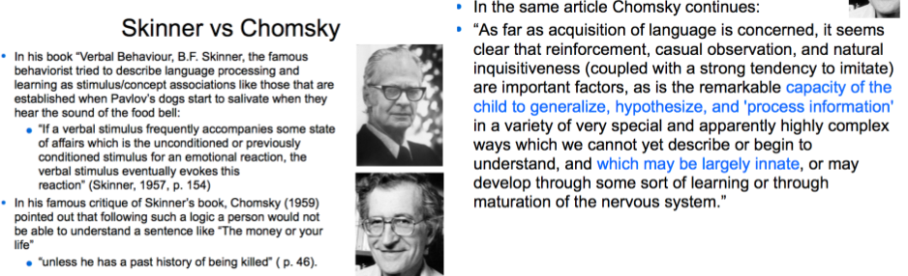

* Cognitive psychology as we know it today took form in the two decades between 1950 and 1970
  + Brought by a need to boost learning ability and soldiers coping abilities during the WWII, interest in information processing and the emerging theory of AI and Chomsky's complex linguistics
* Important dates
  + Ulric Neisser’s book: *Cognitive Psychology* in 1967 - milestone
  + the journal *Cognitive Psychology* in 1970 - milestone
    - Integrated research-efforts from psychology, philosophy, linguistics, neuroscience, and AI
  + “Cognitive Science” first time used in 1973 in a report on artificial intelligence by Christopher Longuet-Higgins
  + The Cognitive Science Society founded in 1979

**How is the mind realized in the body?**

* The factors described in the previous sections have converged in the **information-processing approach** to studying human cognition, and this has become the dominant approach in cognitive psychology. The information-processing approach attempts to analyze cognition as a set of steps for processing an abstract entity called “information.”
* Here's an example of it.
* Sternberg paradigm (1966)
  + The time needed to recognize a digit increases with the number of items in the memory set. Sternberg showed that different variables would influence each of these information-processing stages. Thus, if he degraded the stimulus quality by making the probe harder to read, participants took longer to make their judgments. Though this did not impact the linearity
  + An experimental procedure in which participants are presented with a memory set consisting of a few items and must decide whether various probe items are in the memory set.
  + 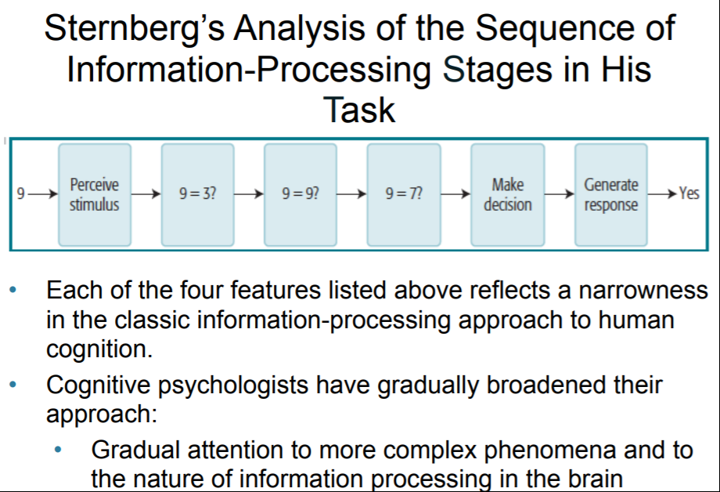
  + 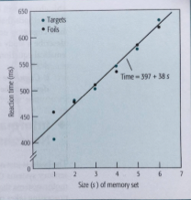
  + Information-processing analysis breaks a cognitive task down into a set of abstract information-processing steps.
  + This is a very computational view of information processing
* See chapter 10 for differences between humans and computers way of thinking

**How do the cells in the brain process information?**Neuron

* + a cell that receives and transmits signals through electrochemical activity.
  + Body = soma
  + Attached is the dendrite
  + Extending from soma = axon
  + End of axon = arborizations
  + The gap between arborizations and another neurons dendrite = synapse
  + Communicate with neurotransmitter (chemicals released)

**Neurons** communicate by releasing **neurotransmitters (**chemicals that can cross over to neighboring neurons and activate them), from the **axons (**The single long fiber that extends from the neuron , that send information to other neurons, muscle cells, or gland cells)( What we call **nerves** are actually bundles of axons coming from many neurons) **terminal buttons (Releases information)** on one side of the **synapse** (The junction between the axon terminal of one neuron and the cell body/dendrite of a neighboring neuron), and these neurotransmitters act on the membrane of the receptor **dendrite (Receives information)** to change its electric potential.

The average soma and dendrite have about 1,000 synapses from other neurons, and the average axon synapses to about 1,000 neurons. The change in electric potential due to any one synapse is rather small, but the individual excitatory and inhibitory effects will accumulate.

Potential changes accumulate on a **cell body (Soma) (**It contains the nucleus and other structures common to all cells in the body, such as mitochondria), reach a threshold, and cause an action potential to propagate down an axon covered in **myelin** (Fat layer)**.** This pulse in turn causes neurotransmitters to be sent from the axon terminal to the body of a different neuron, causing changes in that neuron’s membrane potential.

the membrane potential can be more or less negative. Additionally the number of action potentials, or nerve impulses, an axon transmits per second, called its **rate of firing,** can vary from very few to upward of 100. The greater the rate of firing, the greater the effect the axon will have on the cells to which it synapses.

Neurons interact by driving up the activation level of other neurons (excitation) or by driving down their activation level (inhibition). All neural information processing takes place in terms of these excitatory and inhibitory effects; yet intelligence arises from this simple system of interactions.

The challenge for cognitive neuroscience is to understand how.

The time required for this neural communication to complete the path from one neuron to another is roughly 10 ms—definitely more than 1 ms and definitely less than 100 ms; the exact speed depends on the characteristics of the neurons involved.

* Where computers have and on/off switch in communication-wise, neurons have a **gradual** **firing-rate** of either inhibition or excitation.

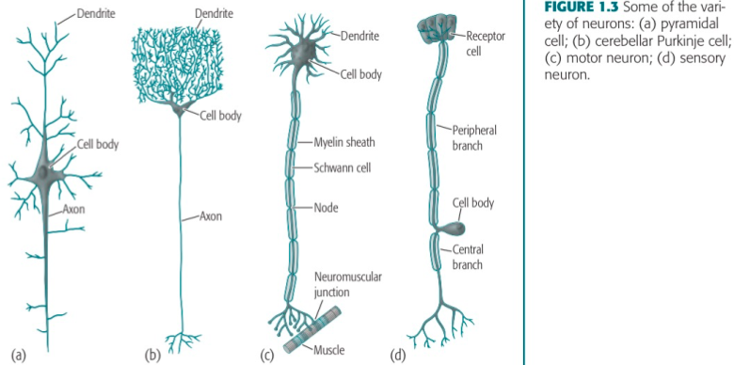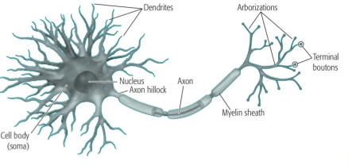

**How do neurons represent information?**

The brain does not maintain the same pattern for minutes, let alone days. This means that neural activation patterns cannot encode our permanent knowledge about the world. It is thought that memories are encoded by changes in the synaptic connections among neurons. By changing the synaptic connections, the brain can enable itself to reproduce specific patterns.

Questions like “ How does a change in a bit result in the solution of an algebra problem?” fail to see the forest for the trees. The concepts of a sport, a problem solution, or an emotion occur in large patterns of bit changes. Similarly, human cognition is achieved through large patterns of neural activity.

* (Mazoyer et al., 1993) compared participants who heard random words to participants who heard words that made nonsense sentences, to participants who heard words that made coherent sentences.
* activity in more and more regions of the brain as participants went from hearing words to hearing sentences, to hearing meaningful stories

**What parts of the brain are responsible for different functions?**

***Different specific areas of the brain support different cognitive functions.***

* **Glial cells**, which make up the support structure of the nervous system, perform four functions:
* Provide structural support to the neurons
* Insulate neurons
* Nourish neurons
* Remove waste products

**Spinal cord**

sensory information goes up and muscle messages out

**Neocortex**

* The large amount of folding and wrinkling of the cortex is one of the striking physical differences between the human brain and the brains of lower mammals. A bulge of the cortex is called a **gyrus,** and a crease passing between gyri is called a **sulcus.**
* Divided into right (spatial) and left(analytical and linguistic) hemisphere -> Right side of body is mainly controlled from left hemisphere and vice versa
  + The Hemispheres are connected by a broad band of fibers called the **corpus callosum.**
  + The corpus callosum has been surgically severed in some patients to prevent epileptic seizures. Such patients are referred to as split-brain patients. In one experiment, the word *key* was flashed on the left side of a screen the patient was viewing. Because it was on the left side of the screen, it would be received by the right, nonlanguage hemisphere. When asked what was presented on the screen, the patient was not able to say because the language-dominant hemisphere did not know.

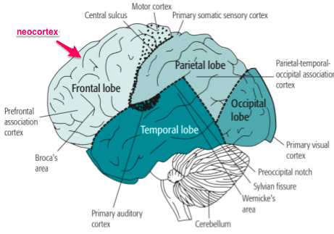

* Major folds, or **sulci, on the cortex separate the areas**. The **occipital lobe** contains the primary visual areas. The **parietal lobe** handles some perceptual functions, including spatial processing and representation of the body. It is also involved in control of attention, as we will discuss in Chapter 3. The **temporal lobe** receives input from the occipital area and is involved in object recognition. It also has the primary auditory areas and Wernicke’s area, which is involved in language processing. The **frontal lobe** has two major functions: The back portion of the frontal lobe is involved primarily with motor functions. The front portion, called the **prefrontal cortex,** is thought to control higher level processes, such as planning. The frontal portion of the brain is disproportionately larger in primates than in most mammals and, among primates,
* The neocortex is not the only region that plays a significant role in higher level cognition.
* **Hippocampus** situated in temporal lobe is deeply entwined with memory ( See chapter 6)
* **Basal ganglia** involved both in basic motor control and in the control of complex cognition. These structures receive projections from almost all areas of the cortex and have projections to the frontal cortex.
* **Broca's area/bodega** = speech impairment & **Wernicke’ area** = loss of meaning in speech

In many areas of the cortex, information processing is structured spatially in what is called a **topographic organization (adjacent parts in the body/sensory field = adjacent parts in the brain).** For instance, in the visual area at the back of the cortex, adjacent areas represent information from adjacent areas of the visual field. (Tootell, Silverman, Switkes, & DeValois, 1982). Monkeys were shown the bull’s-eye pattern and the pattern of activation was recorded on the occipital cortex by injecting a radioactive material that marks locations of maximum neural activity. We see that the bull’s-eye structure is reproduced with only a little distortion

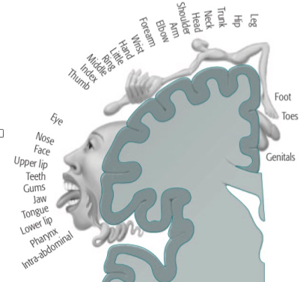

* Moreover adjacent cells in the somatosensory cortex tend to process sensory stimuli from adjacent areas of the body.
  + It turns out that the overrepresented areas correspond to those that are more sensitive. Thus, for instance, we can make more subtle discriminations among tactile stimuli on the hands and face than we can on the back or thigh

**What are the methods for studying the brain?**

Much of the past research in neuroscience has been done on animals. Some research has involved the surgical removal of various parts of the cortex. By observing the deficits these operations have produced, it is possible to infer the function of the region removed.

* Other research has recorded the electrical activity in particular neurons or regions of neurons - **EEG**

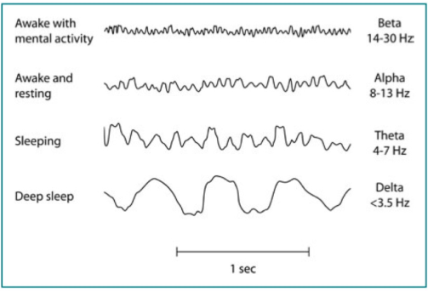

* **R**esponses aligned to a particular stimulus are called **event-related potentials (ERPs)**
* A recent variation of ERP that offers better spatial resolution is **magnetoencephalography (MEG),** which records magnetic fields produced by the electrical activity. Because of the nature of the magnetic fields it measures, MEG is best at detecting activity in the sulci (creases) of the cortex and is less sensitive to activity in the gyri (bumps) or activity deep in the brain.
* Two other methods, **positron emission tomography (PET) (**In PET, a radioactive tracer is injected into the bloodstream**)** and **functional magnetic resonance imaging (fMRI) (**It offers even better spatial resolution than PET and is less intrusive. fMRI uses the same MRI scanner that hospitals now use as standard equipment to image various structures, including patients’ brain structures. With minor modification, it can be used to image the functioning of the brain. fMRI does not require injecting the participant with a radioactive tracer but relies on the fact that there is more oxygenated hemoglobin in regions of greater neural activity. - **Radio waves are passed through the brain, and these cause the iron in the hemoglobin to produce a local magnetic field that is detected by magnetic sensors surrounding the head. T**hus, fMRI offers a measure of the amount of energy being spent in a particular brain region**),** provide relatively good information about the location of neural activity but rather poor information about the time course of that activity. Neither PET nor fMRI measures neural activity directly. Rather, they measure metabolic rate or blood flow in various areas of the brain, relying on the fact that more active areas of the brain require greater metabolic expenditures and have greater blood flow. PET and fMRI scans can be conceived as measuring the amount of work a brain region does.
* **New emerging brain scanner technique - cheap and less confining**
  + Near-infrared sensing, light is shined on the skull, and the instrument senses the spectrum of light that is reflected back. It turns out that near-infrared light tends not to be absorbed by oxygenated tissue, and so by measuring the amount of light in the near-infrared region (which is not visible to human eyes), one can detect the oxygenation of the blood in a particular area of the brain.
  + A major limitation of this technique is that it can only detect activity 2 or 3 cm into the brain because that is as far as the light can effectively penetrate.
* **transcranial magnetic stimulation (TMS)** 
  + A noninvasive Magnetic stimulation of brain regions
  + Mikkel is afraid of its side effects

# Key Terms

|  |  |
| --- | --- |
| **Action potential** | The sudden change in electric potential that travels down the axon of a neuron. (p. 12) |
| **Aphasia** | An impairment of speech that results from a brain injury. |
| **Artificial Intelligence (AI)** | A field of computer science that attempts to develop programs that will enable machines to display intelligent behavior. |
| **Axon** | The part of a neuron that carries information from one region of the brain to another. |
| **Basal ganglia** | Subcortical structures that play a critical role in the control of motor movement and complex cognition p. 16 |
| **Behaviorism** | The theory that psychology should be concerned only with behavior and should not refer to mental constructs underlying behavior. (p. 6) |
| **Blood oxygen level dependent (BOLD) response** | A measure obtained in fMRI studies of the amount of oxygen in the blood. (p. 24) |
| **Broca's area** | A region in the le frontal cortex that is important for processing language, particularly syntax in speech. (p. 17) |
| **Cognitive neuroscience** | The study of the neural basis of cognition. (p. 10) |
| **Cognitive psychology** | The scientific study of cognition. (p. 1) |
| **Corpus callosum** | A broad band of bers that enables communication between the le and the right hemispheres of the brain. (p. 17) |
| **Dendrite** | The branching part of a neuron that receives synapses from the axons of other neurons. (p. 11) |
| **Electroencephalography (EEG)** | Measurement of electrical activity of the brain, measured by electrodes on the scalp. (p. 20) |
| **Empiricism** | The position that all knowledge comes from experience in the world. Compare nativism. (p. 4) |
| **Event-related potential (ERP)** | Measurement of changes in electrical activity at the scalp in response to an external event. (p. 21) |
| **Excitatory synapse** | A synapse in which the neurotransmitters decrease the potential difference across the membrane of the neuron.(p. 12) |
| **Frontal lobe** | The region at the front of the cerebral cortex that includes the motor cortex and the prefrontal cortex. (p. 15) |
| **Functional magnetic resonance imaging (fMRI)** | A method for determining metabolic activity by measuring the magnetic field produced by the iron in oxygenated blood. (p. 21) |
| **Gestalt psychology** | An approach to psychology that emphasizes principles of organization that result in holistic properties of the brain that go beyond the activity of the parts. (p. 7) |
| **Gyrus** | An outward bulge on the brain. Contrast with sulcus. (p. 15) |
| **Hemodynamic response** | The increased flow of oxygenated blood to a region of the brain that has greater activity—the basis of fMRI brain imaging. (p. 21) |
| **Hippocampus** | A structure within the temporal lobe that plays a critical role in the formation of permanent memories. (p. 16) |
| **Information-processing approach** | An analysis of human cognition into a set of steps in which information is processed. (p. 9) |
| **Inhibitory synapse** | A synapse in which the neurotransmitters increase the potential difference across the membrane of a neuron. (p. 12) |
| **Introspection** | A methodology much practiced at the turn of the 20th century in Germany that attempted to analyze thought into its components through self-analysis. (p. 4) |
| **Linguistics** | The study of the structure of language. (pp. 8, 283) |
| **Magnetoencephalography (MEG)** | Measurement of magnetic fields produced by electrical activity in the brain. (p. 21) |
| **Nativism** | The position that children come into the world with a great deal of innate knowledge. Compare empiricism. (p. 4) |
| **Neuron** | A cell in the nervous system responsible for information processing. Neurons accumulate and transmit electrical activity. (p. 11) |
| **Neurotransmitter** | A chemical that crosses the synapse from the axon of one neuron and alters the electric potential of the membrane of another neuron. (p. 11) |
| **Occipital lobe** | The region at the back of the cerebral cortex that controls vision. (p. 15) |
| **Parietal lobe** | The region at the top of the cerebral cortex concerned with attention and higher level sensory functions. (p. 15) |
| **Positron emission tomography (PET)** | A method for measuring metabolic activity in different regions of the brain with the use of a radioactive tracer. (p. 21) |
| **Prefrontal cortex** | The region at the front of the frontal cortex that controls planning and other higher level cognition. (p. 15) |
| **Rate of firing** | The number of action potentials, or nerve impulses, an axon transmits per second. (p. 13) |
| **Split-brain patients** | A patient who has had surgery to sever the corpus callosum, which connects left and right hemispheres. (p. 17) |
| **Sternberg paradigm** | An experimental procedure in which participants are presented with a memory set consisting of a few items and must decide whether various probe items are in the memory set. (p. 9) |
| **Sulcus** | An inward crease of the brain. Contrast with gyrus. (p. 15) |
| **Synapse** | The location at which the axon of one neuron almost makes contact with the dendrite of another neuron. (p. 11) |
| **Temporal lobe** | The region at the side of the cerebral cortex that contains the primary auditory areas and controls the recognition of objects. (p. 15) |
| **Topographic organization** | A principle of neural organization in which adjacent areas of the cortex process information from adjacent parts of the sensory field. (p. 18) |
| **Transcranial magnetic stimulation (TMS)** | A magnetic field is applied to the surface of the head to disrupt the neural processing in that region of brain. (p. 22) |
| **Wernicke's area** | A region of the le temporal lobe important to language, particularly the semantic content of speech. (p. 17) |

# 2: Perception

Lots of sensory modalities - But 50% of brain power diverged to Visual Modality

## Visual perception --> Early + late phase

* Early phase – shapes + objects extracted from visual field
* Late phase – shapes + objects are recognized

- e.g. agnosia (inability to process sensory information)

- apperceptive (problems in early processing)

- associative (problems in pattern recognition)

## The eye

- Light --> lens → Iris --> vitreous humor --> retina

- The retina: contains light-sensitive photoreceptors

o Cones (color vision, high resolution + acuity)

o We have 3 dif. kinds of cones and if you by genetic disposition miss one of them, you go colorblind

o Rods (poorer resolution, less light energy required, black/white)

- Fovea: focus of visual field (middle of the retina)

o High concentration of cones → detect fine details

o Focus on an object, we move our eyes so that the light of the object falls on the fovea

o Eye – slight tremor

- Periphery of visual field: global information + movement

Photoreceptor cells (retina) (Roughly 120mio pr. eye) --> bipolar cells --> ganglion cells (roughly 800.000 pr. eye)

- Ganglion cells: each cell represent small area of retina = receptive field

- Axons of ganglion cells form optic nerve --> connects to brain

- Direct + indirect pathway from photoreceptor to bipolar cells (explains on/off difference)

o Direct: light hits receptive field

o Indirect: light hits receptive field surround --> opposite effect (intervening horizontal cells)

- Two types of receptive fields of ganglion cells: off-center and on-center

o On-center -->light on center of receptive field --> rate of firing up

§ Light on receptive field surround -->rate of firing down

o Off-center --> light on center of receptive field --> rate of firing down

§ Light on surround of receptive field → rate of firing up

Neural pathway from eye to brain

- Both optic nerves meet in optic chiasm --> splits apart

- Right side of visual field --> processed in left hemisphere, visa versa

- Ganglion cells synapse to cells in subcortical structures (lateral geniculate nucleus - relay center on way to visual cortex)

- Connected to primary visual cortex (first cortical to receive)

- Follows “what” and “where” pathway

o “What” – Temporal lobe – semantic pathway - recognition of objects

(Ventral route - towards the belly)

o “Where” – Parietal lobe – spatial processing + coordinating vision with action

(dorsal rute - toward the back)

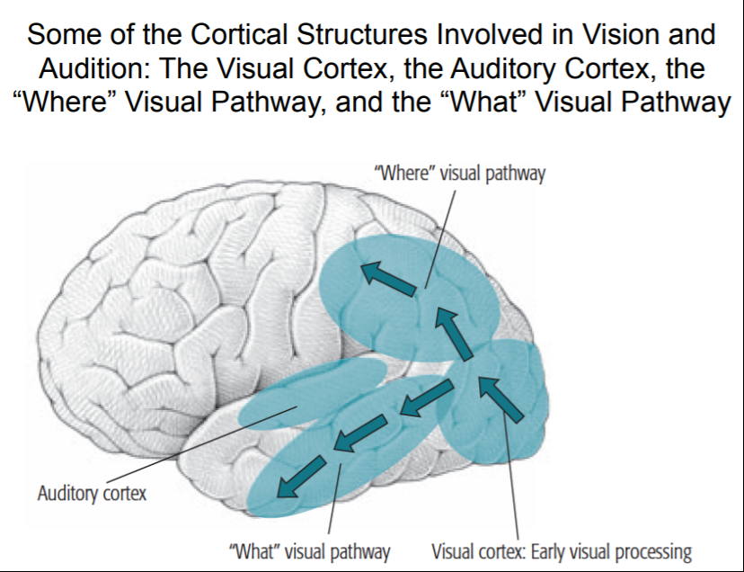

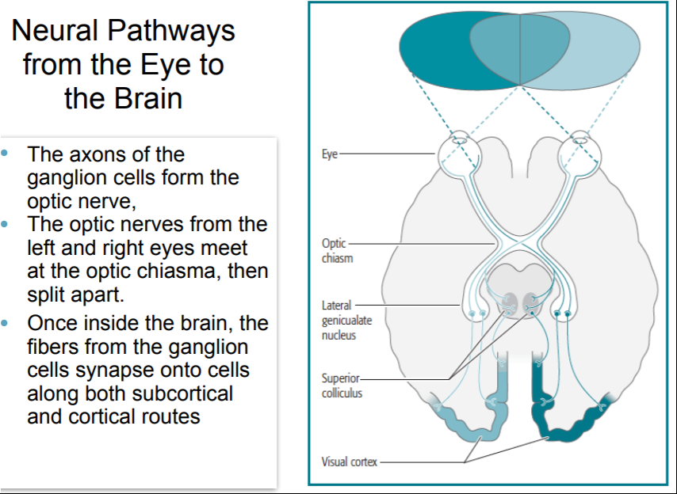

The visual cortex – Topologically mapped

- Right/left - visual field --> opposite in primary visual cortex

- Upper/lower – visual field --> opposite in primary visual cortex

- The fovea – larger representation in primary visual cortex

o More acuity

- Adjacent areas in visual field --> processed in adjacent areas in visual cortex

## Information coding in primary visual cortex

- Hubel and Wiesel (1962), in their study of the primary visual cortex in the cat

- Cells responds more complex compared to ganglion cells

- Two kinds: Edge + bar detectors (elongated shapes)

**o Edge**: Respond positive to light on one side of a line, negative to the other side, visa versa

**o Bar:** Respond positive to light in center, negative to light on periphery, visa versa

- Detector cells responds to patterns of input from on-center/off-center ganglion cells

- Detectors – specific with respect to position, orientation and width

o E.g. detectors which only respond to a small region of visual field + bars/edges in specific orientations

- Hypercolumns (Hubel and Wiesel)

o Visual cortex divided in 2*2 mm regions --> represent particular region of visual field

§ Topographic organization(see somatosensory cortex chap 1): Adjacent areas in visual field --> represented in adjacent hypercolumns

o A hypercolumn:

§ A set of columns, responsive to lines of all orientations from particular region in visual field

· Adjacent rows represent similar orientations

§ Viewed by both eyes (information from both eyes are brought together --> depth perception, later visual processing)

o Similar detector-cells are located close to each other in columns in the cortex

§ The information encoded in these cells are kept separate traveling up cortical hierarchy (moving through early visual processing) until a point, where the info is integrated (late visual processing)

o Sooo .. Livingstone and Hubel (1988) proposed that the visual system processes stimulus into independent features with specific orientation (feature maps) --> Separate maps for color, orientation, movement → Many different visual pathways and many different areas of the cortex are devoted to visual processing (32 visual areas in the count by Van Essen & DeYoe, 1995). → integrated later

· Binding problem (chapter 3)

## Depth + location perception

**Cues for depth perception:**

The visual system uses a number of cues to infer distance

o Texture gradient

o evenly spaced elements to appear more closely packed together as the distance from the viewer increases.

o Stereopsis   
 o ability to perceive 3-D depth based on the fact that each eye receives a slightly different view of the world

o Motion parallax

o information about 3-D structure when a person and/or the objects in a scene are in motion

### David Marr (1982) → 21/2 D sketch

- 2 ½ D sketch: where various visual features are located in relation to viewer + represents only parts of surfaces and does not yet identify how these parts go together to form images of objects in the environment

- 3 D model: later representation of objects in visual scene

How the brain segments visual scenes into objects:

- Gestalt principles of organization (Wertheimer, 1912/1932)

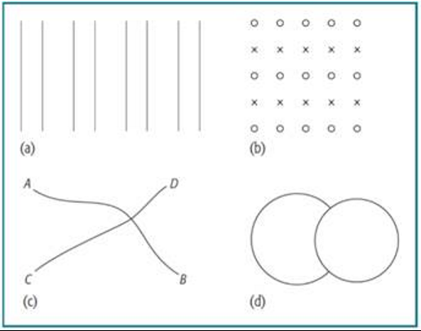

1. Proximity
2. Similarity
3. Good continuation
4. Closure and good form

- Palmer (1977) Exp. Participants could recognize part more rapidly, when following gestalt principles

Current view: The ability to identify position and shape of an object in 3D largely is innate (e.g., Granrud, 1986, 1987)

## Visual pattern recognition

- Letters

o Template matching model (wrong theory!)

§ A retinal image of an object is faithfully transmitted to brain

§ Compare to stored templates

§ Report template with best match

o Feature analysis

§ Stimuli are thought of as combinations of elemental features

§ An object can be perceived because the parts/features are stored in long-term

§ Compare retinal image and see what object in long-term has most matching features

o Advantages for feature analysis

§ Reduce number of templates needed

§ Features are simpler and it is easier to extract the separate features

§ Possible to specify relationship among features, which are most critical to the pattern

o Evidence for feature analysis

§ e.g. similar C and G often confused (Kinney, Marsetta, 1966)

§ Eye – slight tremor, if prevented → part of object start to disappear

§ Whole features are lost – suggest features are important units in perception

§ Remaining part forms recognizable letters/numbers – remaining features are combined to recognizable patterns

o Other evidence for feature analysis:

§ C and G --> many features in common --> more prone to confuse

- Object recognition

Feature analysis does a satisfactory job of describing how we recognize such simple objects as the letter A, but can it explain our recognition of more complex objects that might seem to defy descrip. in terms of a few features?

o Recognition by components theory

§ Biederman (1987) (old, wrong, simplified!)· 1: The object is segmented into basic subobjects

· 2: The category of each subobject is classified --> geons (36)

· 3: The object is recognized from the patterns formed by the geons.

o Crucial assumption: Object recognition is mediated by the recognition of its components

## REMEMBER THIS IS ONLY A BOTTOM-UP MODEL (TOP-DOWN also plays a part!)

- Face recognition (Chapter 4, p 89 - visual imagery)

o Fusiform gyrus (responds when faces are present in visual field)

o Some research indicates that processing of faces is special: Evolutionarily predisposed – compare between faces and houses (up-sight down, context) Yin (1969)

Anderson (2000) found that bird experts or car experts showed high activation in the fusiform gyrus when they made judgments about birds or cars.

Other research show evidence that fusiform gyrus is involved in making fine grained distinctions in stuff that has been given a lot of practise --> Greeple figure experts

Prosopagnosia: selective difficulties in recognizing faces (face blindness)

## Speech recognition:

* **Proposed a kind of feature analysis for speech as well**

“speech appears to be a continuous stream of sounds with no obvious word boundaries. It is our familiarity with our own language that leads to the illusion of word boundaries.”

- Phonemes: Minimal unit of speech that can result in a difference in the spoken language = the basic units for speech recognition

o Should not be confused with single letters (e.g. “school” = “s” “k” “u” “l”)

o Some of the features of phonemes:

§ Consonantal feature

§ Voicing

§ Place of articulation

- Another difficulty in speech perception involves a phenomenon known as coarticulation (Liberman, 1970) → As the vocal tract is producing one sound— say, the /b/ in bag—it is moving toward the shape it needs for the /a/.

- Phonemes are recognized through analyzing features involved in their production → the kind of logic we saw in the Kinney et al. (1966) study on letter recognition.

- People can lose the ability to recognize speech, as a result of injury to the left temporal lobe (see M. N. Goldstein, 1974)

## Categorical perception

Categorical perception: The perception of a stimulus as belonging in different categories + the failure to perceive the graduations among stimuli within a category. (

- Increased discriminability between categories

- Decreased discriminability within categories

- e.g Studdert-Kennedy (1976) → People are very poor at discriminating between a pair of /b/’s or a pair of /p/’s that differ in voice-onset time but are on the same side of the phonemic boundary

- e.g. Emotions in faces --> a clear shift from happy to fearful

- e.g. Russian blue experiment (siniy + goluboy)

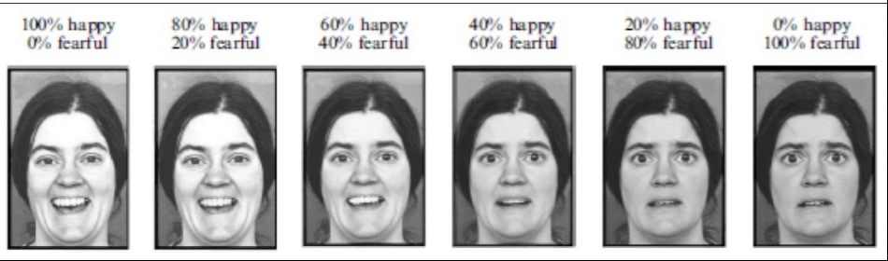

## Context – top-down processing

High level general knowledge contributes to interpretation of low level perceptual stimuli -->



Selfridge (1955) Same stimulus in different contexts --> perceived as different letters

Word superiority effect

* Reicher (1969) and Wheeler (1970). Participants were flashed words or letters and presented two options

The superior recognition of letters in a word context, rather than alone

- Word context can be used to supplement feature information in the recognition of letter

- Supports top down approach

Massaro (1973) – Fuzzy logical model of perception (FLMP)

proposes that contextual information combines independently with stimulus information to determine what pattern is perceived

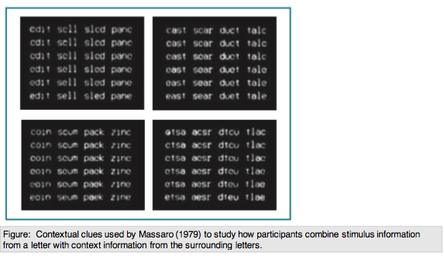

* The four quadrants represent four possibilities in the amount of contextual evidence: Only an e can make a word, only a c can make a word, both letters can make a word, or neither can make a word.
* As one reads down within a quadrant, the image of the ambiguous letter provides more evidence for letter e and less for letter c.
* Participants were briefly exposed to these stimuli and asked to identify the letter.
* these data reflect an independent combination of evidence from the context and evidence from the letter stimulus.

Phoneme restoration effect :

- Warren (1970) exp. Participants are presented with sentences such as “It was found that the *eel was on the shoe”, where the last word differed (axle, orange, table)

- Participants reported hearing *heel, wheel, peel, meal*

o The identification of the critical word is determined by what occurs after it.

§ The context is used --> top down processing

Change blindness: Perceptual phenomenon that occurs when a change in a visual stimulus is introduced and the observer does not notice it. People are unable to keep track of all the information in a typical complex scene.

- If elements change at the same time as some retinal disturbance occur (e.g. a flash, eye movement), people often fail to detect the change.

- McConkie & Currie, 1996) Exp. The experimenter stopped pedestrians on Cornell University and asked for directions.

o While participants gave instructions, workers carrying a door passed between them and an accomplice took the place of the experimenter

§ Only 7 out of 15 noticed the change

Context promotes the insensitivity to change --> the participants’ thought they were speaking to a student, as long as the changed experimenter fit that interpretation, they did not process him as different.

# Key Terms

|  |  |
| --- | --- |
| 2 1/2 - D sketch | Marr’s proposal for a visual representation that identifies where surfaces are located in space relative to the viewer. (p. 34) |
| 3 - D model | Marr’s proposal for an object-centered representation of a visual scene. (p. 34) |
| Apperceptive agnosia | A form of visual agnosia marked by the inability to recognize simple shapes such as circles and triangles. (p. 27) |
| Associative agnosia | A form of visual agnosia marked by the inability to recognize complex objects such as an anchor, even though the patient can recognize simple shapes and can copy drawings of complex objects. (p. 27) |
| Bar detectors | A cell in the visual cortex that responds most to bars in the visual field. Compare edge detector. (p. 31) |
| Bottom-up processing | The processing of a stimulus in which information from a physical stimulus, rather than from general context, is used to help recognize the stimulus. Contrast with top-down processing. (p. 47) |
| Categorical perception | The perception of stimuli being in distinct categories without gradual variations. (p. 45) |
| Change blindness | The inability to detect a change in a scene when the change matches the context. (p. 50) |
| Consonantal feature | A consonant-like quality in a phoneme. (p. 44) |
| Edge detectors | A cell in the visual cortex that responds most to edges in the visual field. Compare bar detector. (p. 31) |
| Feature analysis | A theory of pattern recognition that claims that we extract primitive features and then recognize their combinations. (p. 37) |
| Feature maps | A representation of the spatial locations of a particular visual feature. (p. 32) |
| Fovea | The area of the retina with the greatest visual acuity. When we focus on an object, we move the eyes so that the image of the object falls on the fovea. (p. 29) |
| Fusiform gyrus | A region in the temporal cortex involved in recognition of complex patterns like faces and words. (p. 42) |
| Fuzzy logical model of perception (FLMP) | Massaro’s theory of perception, which states that stimulus features and context combine independently to determine perception. (p. 49) |
| Geons | One of Biederman’s 36 primitive categories of sub- objects that we combine to perceive larger objects. See also recognition-by-components theory. (p. 40) |
| Gestalt principles of  organization | Principles that determine how a scene is organized into components. The principles include proximity, similarity, good continuation, closure, and good form. (p. 34) |
| Phonemes | The minimal unit of speech that can result in a difference in a spoken message. (p. 43) |
| Phoneme-restoration effect | The tendency to hear phonemes that make sense in the speech context even if no such phonemes were spoken. (p. 49) |
| Place of articulation | The place at which the vocal tract is closed or constricted in the production of a phoneme. (p. 44) |
| Primal sketch | The level of visual processing in Marr’s model in which the visual features have been extracted from a stimulus. (p. 51) |
| Prosopagnosia | A neurological disorder characterized by the inability to recognize faces. (p. 42) |
| Recognition-by-  components theory | Biederman’s theory stating that we recognize objects by first identifying the geons that correspond to their subobjects. (p. 40) |
| Template matching | A theory of pattern recognition stating that an object is recognized as a function of its overlap with various pattern templates stored in the brain. (p. 36) |
| Top-down processing | The processing of a stimulus in which information from the general context is used to help recognize the stimulus. Contrast with bottom-up processing.  (p. 47) |
| Visual agnosia | An inability to recognize visual objects that results neither from general intellectual loss nor from loss of basic sensory abilities. (p. 27) |
| Voicing | The property of a phoneme produced by vibration of the vocal cords. (p.44) |
| Word superiority effect | The superior recognition of letters presented in a word context than when the letters are presented alone. (p. 48) |

## Additional: Hoffman (The construction of visual reality)

Homo sapiens have through evolution ended up with usually veridical perception. But sometimes our perceptions are still fallible.

* Many people, when viewing a windmill in the distance, report that the blades sometimes seem to rotate in the wrong direction. This is a visual illusion.
  + Not to be confused with a person suffering delirium tremens, and therefore might see a spider that no one else sees.

Neon color spreading is often used as an example of a visual illusion.

* The glowing green and the sharp edges are all constructed by your visual system, an effect known as neon color spreading (Redies and Spillmann 1981 )

Why no True perception?

* What Mark et al. find is that true perceptions are not, in general, more fit. In most cases of interest, an organism that sees none of the truth, but instead sees abstract symbols related to utility, drives the truth perceivers to swift extinction. Natural selection does not usually favor true perceptions. It generally drives them to extinction.
  + Truer perception needs more calories.

If a bus is hurdling down the road, any normal observer will agree that they indeed see a bus hurdling down the road. But consensus does not logically imply that we are all seeing the truth. It simply implies that we have similar perceptual interfaces and that the rules of visual construction hat we use are similar.

Dragonflies find pools of oil even more attractive than bodies of water, and end up dying in large numbers. Apparently their visual system evolved a quick trick to find water: Find

something that polarizes light, the more polarization the better. In the environment

in which they evolved, this trick was a useful guide to behavior and allowed them to

avoid constructing a complex understanding of the truth.

The key to a new theory of illusions is to think about the evolutionary purpose served by perceptual systems: They have evolved to be guides to adaptive behavior.

This suggests the following new definition: An illusion is a perception, experienced

by most people in a specific context, that is not an adaptive guide to behavior.

* The windmill illusion, for instance, in which one misperceives the movement of the blades, is an illusion because such a perception is not an adaptive guide. One could be injured by a blade whose movement is misperceived

# 3: Attention and Performance

## **2 Conceptions once held:** - We cannot attend to one thing unless we are conscious of it ○ Cognitive psychology is now beginning to recognize that attention operates at an unconscious level - Eg. not conscious of where they have moved their eyes - Attention, like consciousness, is a unitary system ○ Today we have realized that attention is multifaceted. It makes sense to separate auditory attention from visual attention and attention in perceptual processing from attention in executive control from attention in response generation.

## Attention:

* Cognitive process of selectively concentrating on one aspect of the environment
* The attentional system also called the dorsal pathway (see picture)

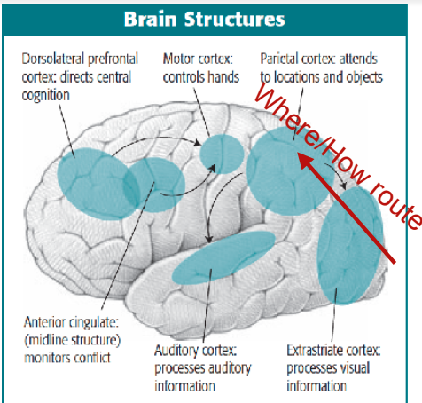

* + Passive - Bottom Up System Attention Grabbers
    - The world catching our attention, stimulus driven, bottom-up processed, incidental
      * Eg. An unpredicted change "catches" your attention:
        + "be be be be be ba be"
  + Active -Top Down system
    - What we choose to look at, top-down processed, goal-directed, intentional
      * Example: Being told to attend to the 4th sound in a sequence
* Example: THE COCKTAIL PARTY EFFECT (Moray, 1959)
  + Where a person in a crowded room tunes in to one conversation and blocks out others
    - This may lead to a situation in which we are listening to one person and hear our own name mentioned by someone else.
    - We automatically shift our attention.
  + Two types of factors
    - Goal-directed
      * Eg. A person telling us to attend to something --> have a goal
    - Stimulus-driven
      * Eg. Eyes driven to a part of a painting --> attention grabbed

## Serial bottlenecks

* + Limit to parallelism in the motor system --> bottleneck
    - Example: rubbing stomach while patting your head
* When do they occur?
  + Early-selection theories
    - Filter occurs before perceived stimulus
  + Late-selection theories
    - Filter occurs after perceived stimulus (e.g. suddenly hearing your name)
* Mikkel’s words: “Probably a mix of both”

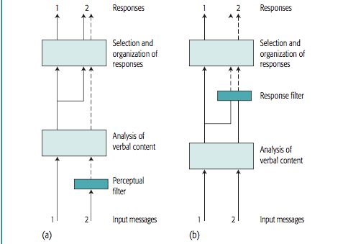

## Auditory attention

* Research using dichotic listening task
  + Two messages at once - one in each ear --> has to shadow one message and repeat back the words of the other
  + Goal-directed processing
* The other message is filtered out → filter theory (Broadbent, 1958)
* Meaning can also affect how we attend to a message (Gray & Wedderburn 1960).
  + Two lists are presented simultaneously, e.g.
    - dogs, two, fleas & eight, scratch, six
  + Participants often shadow
    - dogs, scratch, fleas
* The attenuation theory **(Treisman, 1960)**
  + Messages attenuated NOT filtered out completely
  + Neural evidence that there is some sort of auditory signals in both ears but enhanced response in the attended ear and decreased in the other ear
  + Messages not completely filtered out --> possible to select them at later points of processing
* Late-selection theory **(Deutsch & Deutsch 1963)**
  + Perceive multiple messages, but can only say one at a time
  + If they use meaning as criteria they would switch ear to follow the message
* Results show that the primary auditory cortex is the earliest area to be influenced by attention
* Just as auditory attention directed to one ear enhances the cortical signal from that ear
  + As shown through attention exercises under ERP--> topographically organised (p. 60)

**^^ ALL OF THESE MODELS ARE PROBABLY MORE OR LESS WRONG! A SIMPLISTIC APPROACH… ^^**

## Visual attention

* More apparent bottleneck
* When focusing vision we use our most powerful visual processing resources
  + When people attend to a particular spatial location, there is greater neural processing in portions of the visual cortex corresponding to that location.
* Experiment analog to the auditory shadowing task Neisser, U., & Becklen, R. (1975)
  + Watch a movie with two videotapes superimposed over each other
    - Participants able to monitor one film and filtered out the other
    - When monitoring both they missed many critical events

* Overlapping stimuli (O’Craven (1999))
  + Face and a house
  + When looking at faces = fusiform face area activated
  + Places = the parahippocampal place area - in the temporal cortex
    - Depending on what participants are attending to
    - Relate to cognitive maps

* People can focus their attention on parts of the visual field and move their focus of attention to process what they are interested in.

* Visual search
  + Experiment trying to find the K in a set of lines - Kanwisher & Wojciulik, 2000
    - Taking row by row
    - The further down the letter is the longer it takes for the participants
  + Experiment with conjunctions by Treisman 1980 (from additional reading)
    - Trying to find a green T in an array of blue T’s and green X’s
      * Participants having to find a T in an array of I's and Y's
    - It is necessary to search through a visual array for an object only when a unique visual feature does not distinguish that object.
    - Pop-out effect
      * Distinctive targets tend to be much easier to find (pop out at you) in a display than when they blend with the context.
      * Spiders among flowers (Ohman et al., 2001) - Chapter 10
        + Generally believed (Adolphs, 2002) that there’s a fast direct subcortical route from thalamus (receives and passes on sensory signals) to amygdala and a slow route via the visual cortex (See chapter on emotions)

* The Binding Problem
  + As discussed in Chapter 2, there are different types of neurons in the visual system that respond to different features, such as colors, lines at various orientations, and objects in motion: So How does the brain put together various features in the visual field?
    - The binding problem is not a hypothetical dilemma—it is actually experienced.
      * In an unattended part of the visual field, letters in various colors were presented, such as a pink T, a yellow S, and a blue N. Treisman 1995
      * People reporting combinations of features that did not occur (Illusory conjunctions) (e.g., a pink S) almost as often as they reported seeing correct combinations.
      * Thus, it appears that we are able to combine features into an accurate perception only when our attention is focused on an object.
        + patients with damage to the parietal cortex who are particularly prone to such illusions
  + Feature-integration theory (Treisman)
    - Focus attention to a stimulus before it can synthesize its features into a pattern
      * A striking demonstration of the effects of sustained attention was reported by Simons and Chabris (1999): video where two teams play basket, one team in white and one in black, participants had to count the number of times the ball was thrown --> require attention - gorilla would appear - if the participants looked for the team in white they would not notice the gorilla (only 8% of the time). When looking at the black team (67%)

**^^ but… ‘attention is needed’ doesn’t explain how it’s bound together^^**

* Neglect of the visual field
  + Robertson and Rafal (2000) argue that the right parietal region is responsible for attention to such global features as spatial location, whereas the left parietal region is responsible for directing attention to local aspects of objects.

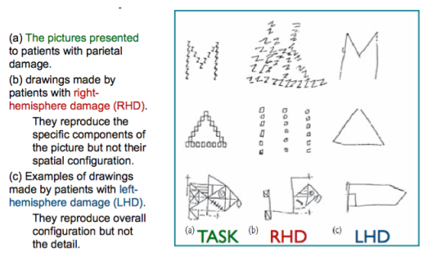

* + Extreme = unilateral visual neglect --> completely ignore the opposite side of the visual field
    - Eg. If told to put slashed through all circled they will only do it in one side , because they ignore the other
    - Forget to shave one side of the face

Neglect is an attentional deficit - not visual, they are not blind! (cues help)

## Other types of attention

* + Space-based attention = people allocate their attention to a region of space
    - Right-parietal region
  + Object-based attention = people focus their attention on particular objects
    - Experiment with number of bumps on objects Behrmann 1998
      * Judgements faster when bumps are on the same object
    - Left-parietal region
  + Inhibition of return
    - Harder to return to a region we already looked at/paired attention to
      * If we move our eyes to location A and then to location B, we are slower to return our eyes to location A than to a new location C.
      * Tipper, Driver, and Weaver (1991) - Flickering squares
        + if the square flicker the same space twice

Central Attention: Selecting lines of thought to pursue

* In many circumstances people are able to only pursue one line of thought at a time
  + Experiment Byrne & Anderson (2001)
    - Impossible to multiply and add two numbers at the same time
      * Told to do either one or two task
        + Seeing digits: 3, 4 and 7

Task 1: do the two first add up to the third?

Task 2: the product of the first and third

* + - * + Participants took almost twice as long to do both tasks simultaneously
* Illustrating perfect-time sharing Schumacher et al. (2001)
  + Definition: The ability to pursue more than one task at the same time
  + Seeing a single letter on a screen and hearing a tone - having to do either one task or both
    - Task 1: press a key according to where the letter occured
    - Task 2: say "one" "two" or "three" according to the tone heard
  + After five sessions of practice participants achieved perfect-time sharing.

* Automaticity
  + When one has practiced the central cognitive component of a task so much that the task requires little or no thought
    - Example:
      * Experienced drivers are much more successful at doing secondary tasks like changing the radio (Wikman, Nieminen, & Summala, 1998).
      * Spelke, Hirst, and Neisser (1976) Typist --> little awareness of what they are typing
        + nondeclarative procedural skills
* Stroop effect
  + Reading a word is such an automatic process that it is difficult to inhibit, and it will interfere with processing other information about the word.
  + A phenomenon in which the tendency to name a word will interfere with the ability to say the color in which the word is printed

* Prefrontal regions are particularly important in direction of central cognition = executive control
  + Two important regions:
    - The dorsolateral prefrontal cortex (DLPFC) (upper portion of the prefrontal cortex)
      * setting of intentions and the control of behavior. For instance, it is highly active during the simultaneous performance of dual tasks
    - The anterior cingulate cortex (ACC) (is folded under the visible surface of the brain along the midline)
      * active when people must monitor conflict between competing tendencies. For instance, brain-imaging studies show that it is highly active in Stroop trials when a participant must name the color of a word printed in an ink of conflicting color (J. V. Pardo, P. J. Pardo, Janer, & Raichle, 1990)
  + Experiment: "Simon says task"
    - Children only have to follow the action doll and not the inhibit doll - they all followed the action doll, but had difficulties ignoring the other doll. From 36 to 48 months they progressed from 22% to 91%

## Additional: paper: Treisman (A feature-integration theory of attention)

* The visual scene is analyzed at an early stage by specialized populations of receptors that respond selectively to such properties as orientation, color, spatial frequency, or movement, and map these properties in different areas of the brain
* Features come first in perception
  + "The feature-integration theory of attention"
    - Features are registered early, automatically, in parallel across the visual field
    - Objects are identified separately at a later stage
      * Requires focused attention
* The visual scene is initially coded along a number of separable dimensions such as:
  + Color, orientation, spatial frequency, brightness, direction of movement
* Focal attention is the "glue" that makes the initially separable features into unitary objects
* With interference features can be disintegrated and "float free" and recombine to form "illusory conjunctions".
* Attention is necessary for correct perception of conjunctions.

**Experiment 1:**

Explore the possibility that extended practice on a particular shape -color conjunction could lead to a change from serial to parallel detection, which would suggest the possible emergence of a unitary "green T" detector.

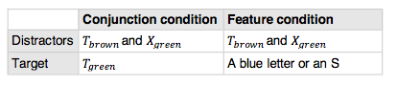

Participants had to make a key press with the dominant hand if the target was presented

*Results*:

* In both conditions, all subjects showed the same pattern of results, with individuals varying mainly in the absolute values of slopes and intercepts.
* The difficulty of search for conjunctions arises only when more than one stimulus is presented
* Difference between conditions
  + Difference in the positive and negative displays
    - The slope for conjunction positives i half the slope for the negatives, suggesting a serial, self-terminating search.
* Feature condition
  + If the target is present, it is detected automatically; if it is not, subjects tend to scan the display, although they may not check item by item in the strictly serial way they do in conjunction search
* No qualitative changes in performance in conjunction search

**Experiment 2:**

Explore the relation between the discriminability of the features which define a conjunction and speed of detecting that conjunction as a target in the display.

* By making the two shapes and colours in a conjunction harder or easier to distinguish = change the rate of scanning, while keeping the serial search pattern

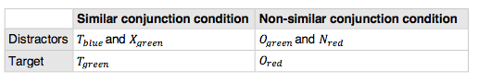

*Results*:

* Error rates higher in the difficult discrimination condition
  + Almost twice as high compared to the non-similar condition
* Evidence supporting serial, self-terminating search through the display for the target

# Key Terms

|  |  |
| --- | --- |
| anterior cingulate cortex (ACC) | Medial portion of the prefrontal cortex important in control and dealing with conflict. (p. 75) |
| attention | The allocation of cognitive resources among ongoing processes. (p. 54) |
| attenuation theory | Treisman’s theory of attention, which proposes that we weaken some incoming sensory signals on the basis of their physical characteristics. (p. 56) |
| automaticity | The ability to perform a task with little or no central cognitive control. (p. 72) |
| binding problem | The question of how the brain determines which features in the visual field go together to form an object. (p. 63) |
| central bottleneck | The inability of central cognition to pursue multiple lines of thought simultaneously. Contrast with perfect time-sharing. (p. 72) |
| dichotic listening task | A task in which participants in an experiment are presented with two messages simultaneously, one to each ear, and are instructed to repeat back the words from only one of them. (p. 54) |
| dorsolateral prefrontal cortex (DLPFC) | Upper portion of the prefrontal cortex thought to be important in cognitive control. (p. 75) |
| early-selection theories | A theory of attention stating that serial bottlenecks occur early in information processing. Contrast with late-selection theory. (p. 54) |
| executive control | The direction of central cognition, which is carried out mainly by prefrontal regions of the brain. (p. 75) |
| feature-integration  theory | Treisman’s proposal that one must focus attention on a set of features before the individual features can be synthesized into a pattern. (p. 63) |
| filter theory | Broadbent’s early-selection theory of attention, which assumes that, when sensory information has to pass through a bottleneck, only some of the information is selected for further processing, on the basis of physical characteristics such as the pitch of a speaker’s voice. (p. 55) |
| goal-directed attention | Allocation of processing resources in response to one’s goals. Contrast with stimulus-driven attention. (p. 54) |
| illusory conjunction | The illusion that features of different objects actually came from a single object. (p. 63) |
| inhibition of return | The decreased ability to return our attention to a location or an object that we have already looked at. (p. 67) |
| late-selection theories | A theory of attention stating that serial bottlenecks occur late in information processing. An example is Deutsch and Deutsch’s theory, according to which all sensory information can be processed, but our ability to respond to that information has attentional limitations. Contrast with early-selection theory. (p. 54) |
| object-based attention | Allocation of attention to chunks of visual information corresponding to an object. Contrast with space-based attention. (p. 67) |
| perfect time-sharing | The ability to pursue more than one task at the same time. Contrast with central bottleneck. (p. 70) |
| serial bottleneck | The point in the path from perception to action at which people cannot process all the incoming information in parallel. (p. 53) |
| space-based attention | Allocation of attention to visual information in a region of space. Contrast with object-based attention. (p. 67) |
| stimulus-driven attention | Allocation of processing resources in response to a salient stimulus. Contrast with goal-directed attention. (p. 54) |
| Stroop effect | A phenomenon in which the tendency to name a word will interfere with the ability to say the color in which the word is printed. (p. 73) |

# 4: Mental imagery

* Processing of perceptual-like information *in the absence of an external source*
* DEBATED: same as…
  + Perception?
  + Attention? (a sub-component of imagery)
  + Working memory? (see ch 6)
  + Consciousness?

**Theory: Dennett (1969): mental imagery is an epiphenomenon**

**(false, behaviorist theory**): *"Imagery is a mental experience without any functional role In information processing" (like the appendix = blindtarm)*

* *‘not the same as visual perception’*

## Visual >< verbal imagery in the brain - Roland and Friberg (1985)

* measured changes in blood flow in the brain as participants either mentally rehearsed a nine-word circular jingle or mentally rehearsed finding their way around streets in their neighborhoods.
  + **Visual**: parietal cortex (Where visual pathway (see chapter 2, page 28)), occipital cortex, temporal cortex
    - All these areas are involved in visual perception and attention, as we saw in Chapters 2 and 3.
  + **Verbal**: prefrontal cortex (Broca's area), (Wernicke's area)
    - Chapter 1, patients with damage to these regions show deficits in language processing

*The same areas are used as when we* ***actually*** *see/read something! Just weaker response:*

## Visual Imagery and Brain Areas

Experiment: seeing and imagining pictures of faces and houses.

Faces: Activation in the **fusiform face area** (FFA)

Houses: Activation in the **parahippocampal place area** (PPA)

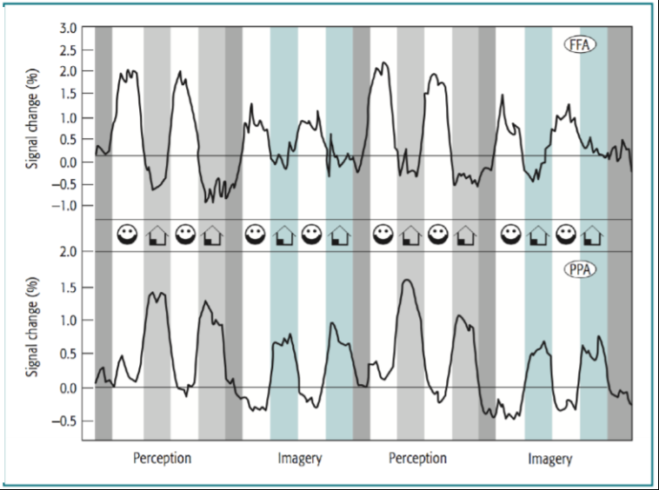

SAME areas active when seeing and just IMAGINING faces or houses! Just weaker response (blue part in picture)

* Imaging studies like this show that perceptual regions of the brain are active when participants engage in mental imagery
  + BUT do not establish whether these regions are critical to imagery (like the epiphenomenon critique - it could be that the activation plays no role in the tasks being performed)

*Correlation does NOT equal causality!*

**‘Proof’ against epiphenomenon critique:**

Kosslyn et al. (1999)

* showed participants pictures with figures, asked them to form a mental image
* removed the picture, asked questions (e.g. ‘which quadrant has more stripes?’)
* Applied TMS (transcranial magnetic stimulation) to primary visual area 17
  + → they took significantly longer to answer the questions. Impaired information processing!

**→ visual regions DO seem to play a causal role in mental imagery!**

### Spatial and Visual components in imagery

They are distinguishable!

Remember (ch 2):

The “what” visual pathway (temporal lobe)

* processes object information (e.g. appearances)

The “where” visual pathway (parietal regions)

* processes spatial information (e.g. locations, mental rotation)

**Not only true for visual perception - also for imagery!:**

(Levine, Warach, and Farah (1985))

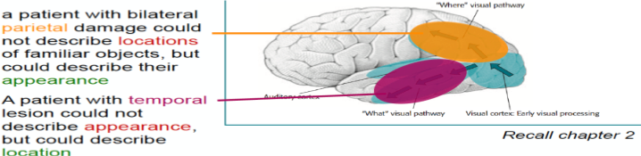

# Visual imagery: Mental rotation

* (Shepard & Metzler, 1971). Participants were presented with pairs of 2-D representations of 3-D objects
  + participants rotated the object in a 3-D space within their heads.
  + Bigger angle of disparity between the two objects → longer RT
* Activation in the parietal “where-pathway” in the brain

RT is modulated by angular transformation (both in 2D and 3D)

* + More rotation necessary = longer RT (a set nr. of milliseconds per needed rotation)
  + *--> imagery is an analogue simulation of real life* ***(embodiment)***

## Spatial encoding >< linear encoding

Different ways of encoding mental imagery.

Experiment: Recognizing shapes (con 1) and words (con 2) in different spatial configurations Santa (1977)

Conclusions:

* Geometric condition fastest recognition when in the SAME SPATIAL configuration! (encoded spatially, resembling a face)
* Word condition fastest recognition when in a different, LINEAR configuration! (linear encoding, like normal reading order)

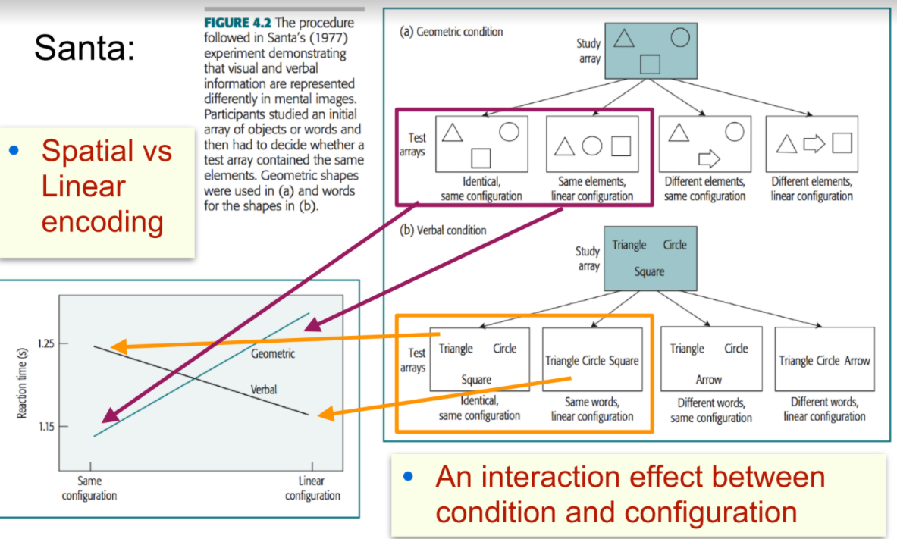

*Different parts of the brain are involved in verbal and visual imagery, and they represent and process information differently.*

Words encoded linearly, shapes encoded spatially.

## Image scanning

**Interference effect**

People suffer interference in scanning a mental image if they have to simultaneously process a conflicting perceptual structure.

Brooks (1968) performed an important series of experiments on the scanning of visual images

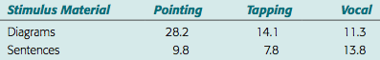

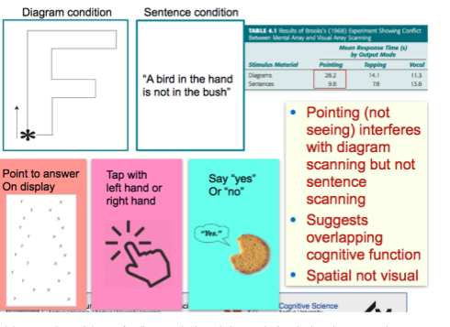

Suggests overlapping in cognitive function. Unilateral areas. Scanning a mental visual array conflicts with scanning a physical array.

Baddeley (1976) These are SPATIAL effects, not visual effects (using spatial areas)

The spatial auditory tracking task produced far greater impairment in the image-scanning task than did the brightness judgment task. This result also indicates that the nature of the impairment in the Brooks task was spatial, not visual.

## Magnitudes

Moyer (1973) → Animals: People experience greater difficulty in judging the relative size of two pictures or of two mental images that are similar in size.

## Manipulating imagined objects

*You can come up with insights through mental imagery - imagining things never seen! Farah (1989)*

* E.g. imagine a capital N - make a line from bottom left to top right corner - rotate 90 degrees
* The ability to perform such tasks illustrates an important function of imagery (NOT an epiphenomenon): It enables us to construct new objects in our minds and inspect them.

Limitations:

* Evidence that there are differences between a mental image and visual perception of an object:
  + chambers and Reisberg (1985): Participants can interpret visual images in only one way, and it is not possible to find an alternative interpretation.
  + This is in contrast to visual perception.
  + Peterson et al (1992) found that more explicit instructions helped, but it was still hard. “instruction to consider the back of the head” (for the duck-rabbit illusion)
* *Imagery is unambiguous* (or hard to interpret more ways)
  + → not as rich and more demanding than visual perceptions
  + Given a choice: actual picture > imagery. Players of Tetris prefer to rotate shapes on the screen to find an appropriate orientation rather than rotate them mentally (Kirsh & Maglio, 1994).

# Cognitive maps

Mental representations of the location of objects and places in the environment

**Route maps (Action information)**

* Known paths between locations (landmarks, street names)…

**Survey maps (Spatial information)**

* Known relative positions of locations in space (hard, takes time)
* The hippocampus:
* (taxi drivers: larger hippocampus (need survey maps) compared to bus drivers (just route maps), Tom Hartley (2003)
  + (link to memory, where the hippocampus is crucial!)

### Map distortions

When people have to work out the relative positions of two locations, they will often reason in terms of the relative positions of larger areas that contain the two locations.

* can lead to mistakes!

### Representations of space

|  |  |
| --- | --- |
| **Egocentric representation** | **Allocentric representation** |
| The representation of space relative to our own body  (e.g. relative left/right axis)  Relative | Maps not specific to a particular viewpoint  Cardinal directions (north to the top)  Absolute |

* Dependent on language - culture-specific!
  + Finns and danes are usually going for the Egocentric representation - Mexicans go for the allocentric

Experiment: see drawing, turn around, draw it.

Tenejapans from South America, Mayan tribe people (allocentric language) >< Dutch (egocentric language)

(left in table 2 >< right in table 2)

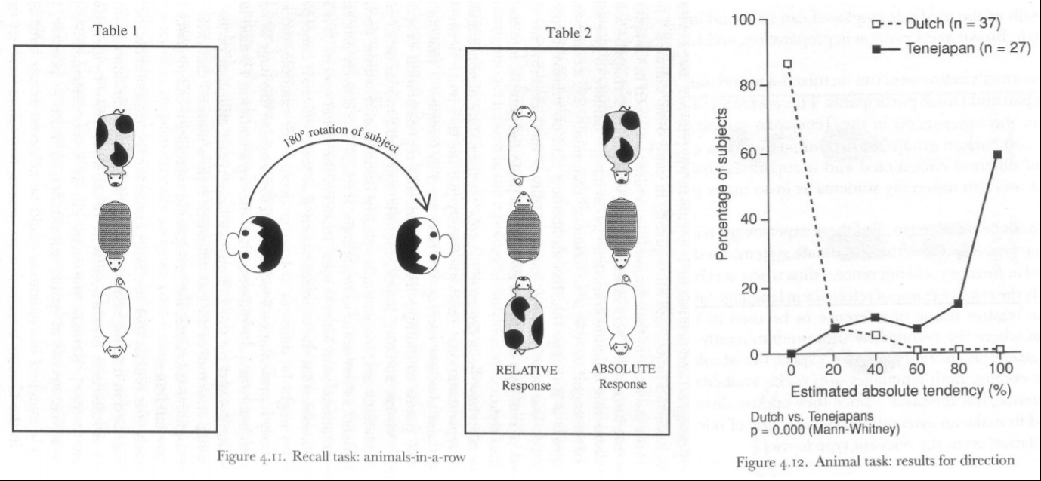

**In conclusion:**

Perception and imagery best understood as two overlapping, but not identical processes.

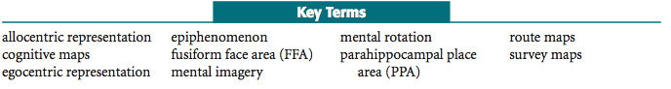

# Key Terms

|  |  |
| --- | --- |
| allocentric representation | A representation of the environment according to a xed coordinate system. Contrast with egocentric representation. (p. 92) |
| cognitive maps | A mental representation of the locations of objects and places in the environment. See also route map; survey map. (p. 89) |
| egocentric representation | A representation of the environment as it appears in a current view. Contrast with allocentric representation. (p. 91) |
| epiphenomenon | A secondary mental event that has no functional role in the information processing. (p. 78) |
| fusiform face area (FFA) | A part of the temporal cortex that is especially involved in fine discriminations, particularly of faces. (p. 87) |
| mental imagery | The processing of perceptual-like information in the absence of an external source for the perceptual information. (p. 79) |
| mental rotation | The process of continuously transforming the orientation of a mental image. (p. 82) |
| parahippocampal place area (PPA) | A region adjacent to the hippocampus that is active when people are perceiving places. (p. 87) |
| Route maps | A representation of the environment consisting of the paths between locations. Contrast with survey map. (p. 89) |
| survey maps | A representation of the environment consisting of the position of locations in space. Contrast with route map.  (p. 89) |

# 5: Representation of Knowledge

We create representations in our mind, a representation of the world

Knowledge is representations, which is equal to memories

- Knowledge is filtering away insignificant details and context

o From episodic memory to semantic memory

- Knowledge is semantic memory

o Abstract and context free

* Parker, Cahill, and McGaugh (2006) individual with highly detailed memory. perform poorly on tasks of abstract reasoning such as processing analogies.
* (LePort et al., 2012)11 such people: It seems like their memories are bogged down in remembering insignificant details, without any special ability to remember critical information.

## Brain areas:

The “What” pathway in temporal cortex/lobe is the semantic pathway

- Involved in object recognition → needs to be context free → involves abstraction

-  **Categorical information** is represented in posterior regions, particularly in temporal cortex Chapter 2

Prefrontal regions: associated with meaningful processing of verbal and visual material

- Left prefrontal à verbal material

- Right prefrontal à visual material

## Memory for verbal information:

Wanner (1968): sentence experiment, differed in style and meaning

- After processing a verbal message, we remember the meaning, but not the exact style

o Possible to remember exact wording if cued (attention)

o Memory for meaning is equally good, whether cued or not

- We usually encode the meaning of a message, we can also encode other things, but have to pay attention to that thing, e.g. details such as wording

## Memory for visual information:

Shepard (1967): compare memory for visual and verbal material

- Participants were presented with pairs of pictures or pairs of sentences (1 novel, 1 studied)

- Indicate which they had seen before

o Sentence memory (11.8% error) → good

o Picture memory (1.5% error) → nearly perfect

Visual memory > verbal memory

Brady (2008): 2500 pictures

- Had participants study 2500 pictures

- Asked to identify studied picture, when paired with similar alternative (token) or with novel alternative (type)

- More difficult when paired with similar alternative → what is remembered is the meaning

o Made 12.5% error in similar condition

Nickerson and Adams (1979): Penny

- Asked participants to indicate picture with the real penny à they could not

Some research show good visual memory some does not?

- If we want to remember details, we need to attend to it

- Because normally what we attend to is what we consider meaningful

→ attention is important for memory

**Experiments showing the importance of meaning to memory:**

Mandler and Ritchey (1977): Classroom, type and token shift

- Participants studied a classroom for 10 seconds

- Presented with classroom scenes they had studied but with distractors

o Token distractor: differ in unimportant visual detail

o Type distractor: differ in important visual detail (change in meaning)

- Results: More sensitive to meaning changes à naturally attend to meaning

o Scenes with type distractors: 94% correct rejection

o Scenes with token distractors: 60% correct rejection

- People remember meaning (type) better than style (token)

§ Similar results as with sentence experiment (Wanner) + experiment with study of 2500 pictures (Brady)

Bransford and Johnson (1972): Clothes washing

- Participants were asked to read text (hard to make sense of)

- One group were told “It’s about clothes washing” à made text more sensible

o Could recall twice as much as uninformed group

- Memory is better when in meaningful context

- Similar results as in a experiment with droodles, abstract pictures

o Good memory for pictures are tied to people’s ability to make sense of those picturesà apply meaning

Goldstein and Chance (1970): Memory for faces and snowflakes

- Compared participants memory for snowflakes (30%) with memory for faces (74%)

o Snowflakes à distinct physically à but not meaningful à difficult to remember

Bower et al (1975): Abstract pictures

- Participants were shown drawings (abstract) with or without explanation

o Weird looking picture + “A bird that caught a very strong worm”

- Asked to redraw it

o With explanation à 70% correctly reconstructed

o Without explanation à 51% correctly reconstructed

- Good memory for pictures are tied to people's ability to make sense of those picturesà apply meaning

**→ meaning is important for memory!!!**

Mnemonic technique: Memory assisting technique

- In order to remember material --> associate the material with meaningful interpretation

Propositional representation: Developed by psychologists to become more exact about what is meant by “meaning”.

- Meaning has been thought to be organized in propositions

o A complicated message à broken down into propositions

We remember the propositions, not the order - the meaning, not the structure

Proposition: The smallest unit of knowledge that can be meaningfully judged as true or false.

- E.g. Humans are mortal

A long complex sentence can be communicated by simpler sentences

- If any of smaller sentences are false → the complex sentence is wrong as well

Theory of propositional representation --> What is encoded when we read a complex sentence is not simple sentences, instead the material is encoded in a more abstract way

- Kintch: Each proposition can be written as a list containing a relation followed by a list of arguments (also called subject and/or predicate)

o e.g. [is: human, mortal]

o e.g. Lincoln freed the slaves à [free: Lincoln, slaves]

Bransford and Frank (1971): Ants and jelly proposition experiment

- Result: People tend to remember the propositions they encounter, but are insensitive to the actual combination of propositions

How is information represented in the brain?

- In amodal or perceptual symbol system?

- The two systems have been competing against each other → perceptual symbol system seems to be winning

Amodal symbol system: A system that does not refer to any perceptual modality → abstract

- e.g. The original stimulus might be sentence, but the representation is abstracted away from verbal/visual modality → not expected to remember wording

- Abstractions could be represented through propositions, smallest unit that can hold knowledge. Things are boiled down to their propositions.

Perceptual symbol system: Information is represented in terms that are specific to a particular modality (visual, auditory…)

- Extension of Pavios verbal-visual dual code theory

o Combine verbal and visual codes à when we hear a sentence, we also develop a visual image of what it describes

Evidence for perceptual symbol hypothesis:

- Participants read a sentence “The ranger saw the eagle in the sky”

- Shown a picture + asked if the object was mentioned in the sentence just read

- Picture A: Eagle in the sky, picture B: Eagle on a branch

- If representation of eagle is amodal --> the shape of eagle should not matter

- Picture A was recognized faster

o The representation contains perceptual detail

Stanfield and Zwaan (2001)

participants read a sentence about a nail being pounded into either the wall or the floor. Then they viewed a picture of a nail oriented either horizontally or vertically and were asked whether the object in the picture was mentioned in the sentence that they just read. If they had read a sentence about a nail being pounded into the wall, they recognized a horizontally oriented nail more quickly. When they had read a sentence about a nail being pounded into the floor, they recognized a vertically oriented nail more quickly. In other words, they responded faster when the orientation implied by the sentence matched the orientation of the picture. → their representation of the sentence seemed to contain this perceptual detail.

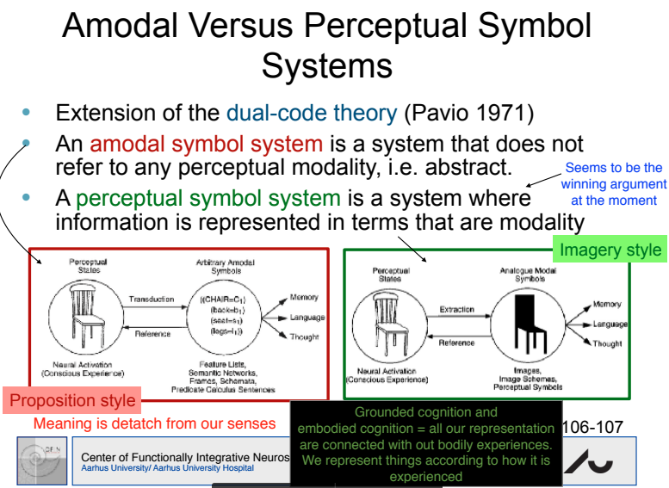

* Grounded cognition is still about mental representations, just ones that are shaped by the body. The key move is the *grounding*, shaping internal content with external, modality specific factors.
* Embodied cognition replaces representations with our activity in a richly perceived world. The key move is the *embodiment*, emphasising the role of the body and its place in the environment in creating cognition.

**PROBABLY A COMBINATION OF BOTH OF THESE THEORIES! (amodal + perceptual)**

Embodied cognition:

Emphasizes the contribution of motor system + perceptual system to our cognition

Cognition arises from our experiences from having a body with particular perceptual and motor capabilities.

Hauk et al (2004): FMRI

- Participants listened to verbs that involved the face (lick), arm (pick) or leg (kick)

- As participants listened to each word à greater activation in part of motor cortex that would produce that action

- We can relate information from verbal system to motorsystem (part of understanding the word kick)

**How is different perceptual and motor modalities connected with one another?**

- e.g. part of understanding the word kick, is the ability to relate it to a picture of a person kicking a ball

- Two examples: Multimodal + amodal

Multimodal hypothesis:

- Representations are tied to different perceptual and motor modalities

- We have systems for directly converting one representation to another

o No abstraction → meaning can be translated back and forth

Amodal hypothesis:

- There is an intermediate abstract meaning system --> might be composed of propositional representations

- We have systems for converting back and forth between any perceptual or motor representation and this abstract intermediate representation.

o Abstraction

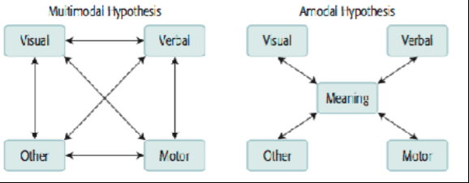

Conceptual knowledge

We see the world in terms of categories

- Positive effects of categorization

o Great economy in representation and communication

o Abstraction à able to generalize, to predict

- Negative effects of categorization

o Can lead to stereotyping

o E.g. “Elisabeth/Bob was not very surprised upon receiving her/his math score”

§ Categorize Elisabeth as a woman + stereotype: women are poor at math

- Can be biased in our generalization

o E.g. once bitten by a dog à are now afraid of all dogs

Different ways in which we represent conceptual knowledge:

- Two early theories: Semantic networks + schemas

Semantic networks:

Store properties together with concepts

- Stored in hierarchical way

* Superordinate level
* Basic level
* Subordinate level
* These levels are connected with isa links

Properties true of higher level categories → also true of lower level categories

- When property not stored directly with concept → can be retrieved from higher order concept

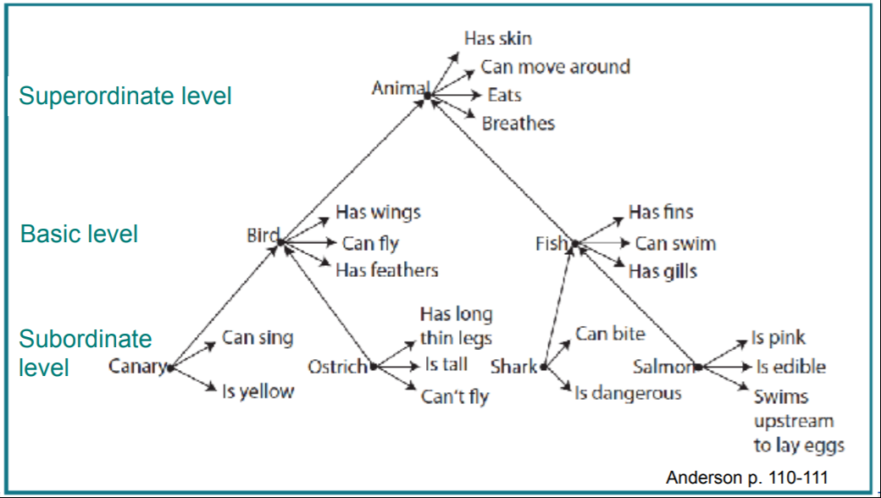

Participants asked to confirm sentences:

1: Canaries can sing à sing is stored directly with canary

2: Canaries has skin à make an inference from three pieces of info from the hierarchy

e.g. Canary is a bird → bird is an animal à an animal has skin

- Results, the time it took to confirm sentence:

o 1. Canary can sing: 1310 ms

o 2. Canary has skin: 1470 ms

- Longer time to infer facts that are not directly stored with a concept

Additional research has shown:

- If a fact about a concept is experienced often, it will be stored with that concept, even if it could be retrieved from higher order concept

o E.g. eaten is stored together with an able (eat, part of food)

- The more frequent a fact is experienced together with a concept --> the stronger connection between the two

o Faster to verify “apples are eaten” than “apples have black seeds”

Schemas:

An organized cluster of information about a particular topic

- The information is abstracted from specific instances

- Can be used to make inferences about what a topic consist of

Partial schema of a house:

Isa: Building

Function: Human dwelling

Materials: Wood, brick, stone

Slots: isa, function, materials

- isa-slot (special slot) → a concept inherits the features of its superset

Default values: Wood, brick etc (does not exclude other possibilities)

- Values often have their own schemas

Feature = slot (material) + value (wood)

Experiment: The effects of schemas in memory (Brewer, 1981)

- Participants spend a short time in office room

- Asked to write down all remembered from the room

o Most recalled a chair, desk, walls

o 8/30 recalled a skull (correct, but few remembered it)

o 8/30 falsely recalled books (default value in schema for an office)

- Schema for an office --> used to make inferences about a specific instance of that concept

Degree of category membership:

Important feature of schemas: allow variations in the objects that might fit a particular schema

- There are constraints but few prohibitions

When encoding knowledge about a concept in a schema → more or less typical members of that concept

- The features of some members will better satisfy the schema constraints than others

o E.g. penguin less typical bird than an eagle

§ Fly is a bird feature, penguins cannot fly

- More typical members of a category have an advantage in processing

o When people have to identify the category of an object à faster when prototypical

Experiment: Boundaries of categories cup or bowl

- Posed with items in different sized.

- Participants asked to judge items a being cups or bowls

o Results: Not a clear cut boundary à varies continuously

§ Allow for variation in objects that might fit a category

- Asked to imagine the items filled with mashed potatoes

o Results: The context played a role in classification

o → Top down processing

Events has conceptual structure as well as objects

- e.g. Going to a wedding à the bride walks down the aisle

→ involve stereotypic sequences of actions

A script → abstract information about an event

- Go from episodic to semantic memory

- Scripts decontextualize events

- The more weddings you have been at, the more semantic it becomes

Research with stories about events has shown similar results as when people used schemas to infer things about an office room.

- New events are encoded with respect to general scripts, so later recall of these specific events will be influenced by the scripts

- Scripts enable us to fill out missing information

Categories can be represented either by abstracting their central tendencies or by storing many specific instances of categories:

Abstraction theories (Locke): We abstract the general properties of a category from the instances we have studied. The abstractions are stored.

Exemplar/instance theories (Berkeley): We only store the specific instances and the general properties are inferred from these instances.

- If asked whether a penguin is a typical member of bird category --> compare specific bird to other specific birds + make judgment of average difference

Processing of prototypical members will be easier in both abstraction and exemplar theories.

Natural categories + their brain representation:

Artifact categories (e.g. tools, furniture)

Biological categories (people, animals, vegetables)

Documenting biases about natural categories as artifacts and living things, has been done on school children, who are learning these categories:

Children come to believe that all things in a biological category have the same parts (like pectin in apples) and that all things in an artifact category have the same function (like imbibing for cups).

Neuroscience suggest that these categories are represented differently in the brain:

Greater visual involvement in representation of biological categories

Greater motor involvement in representation of artifacts

# Additional reading:

<https://en.wikipedia.org/wiki/Normalized_Google_distance>

The logic behind this approach is that if two words have similar meaning, or are used in a similar context, then the chances of both words occurring together on a large number of web pages are high. On the other hand, if a pair of words has nothing in common then there will be relatively fewer web pages having both words - as compared to the hits of the two words on their own.

# Key Terms

|  |  |
| --- | --- |
| abstraction theories | A theory holding that concepts are represented as abstract descriptions of their central tendencies. Contrast with exemplar theory. (p. 118) |
| amodal hypothesis | The proposal that meaning is not represented in a particular modality. Contrast with multimodal hypothesis. (p. 109) |
| amodal symbol system | The proposal that information is represented by symbols that are not associated with a particular modality. Contrast with perceptual symbol  system. (p. 106) |
| arguments | An element of a propositional representation that corresponds to a time, place, person, or object. (p. 105) |
| default values | A typical value for a slot in a schema representation. (p. 113) |
| dual-code theory | Paivio’s theory that there are separate visual and verbal representations for knowledge. (p. 106) |
| embodied cognition | The viewpoint that the mind can only be understood by taking into account the human body and how it interacts with the environment. (p. 108) |
| exemplar theories | A theory holding that we gain our knowledge of concepts by retrieving specific exemplars of the concepts. Contrast with abstraction theory. (p. 118) |
| isa links | A particular link in a semantic network or schema that indicates the superset of the category. (p. 110) |
| mirror neurons | A neuron that fires either when the animal is performing the action or when it observes another animal performing the action. (p. 108) |
| mnemonic technique | A method for enhancing memory performance by giving the material to be remembered a meaningful interpretation. (p. 103) |
| multimodal hypothesis | The theory that knowledge is represented in multiple perceptual and motor modalities. (p. 109) |
| perceptual symbol system | Barsalou’s proposal that all knowledge is represented by information that is perceptual and tied to particular modalities. Contrast with amodal symbol system. (p. 106) |
| proposition | The smallest unit of knowledge that can stand as a separate assertion. (p. 104) |
| propositional representation | A representation of meaning as a set of propositions. (p. 104) |
| relation | e element that organizes the arguments of a propositional representation. (p. 105) |
| schema | A representation of members of a category based on the type of objects that they are, the parts that they tend to have, and their typical properties. A slot-value structure is used to represent this information. (p. 112) |
| scripts | A schema representation proposed by Schank and Abelson for event concepts. (p. 116) |
| slot | An element of a schema that indicates different attributes of a concept. (p. 112) |

# 6: Human Memory: Encoding and Storage

**pp. 124-149**

**"Memory is everything. It makes us dynamical creatures - makes experiments extremely complicated - noise in measurements" - Mikkel's rant**

## Chapter answers the questions:

o How do we maintain a short-term or working memory of what just happened?

o How does the information we are currently maintaining in working memory prime knowledge in our long-term memory?

o How do we create permanent memories of our experiences? This is what did not work anymore for Leonard.

o What factors influence our success in creating new memories?

## Memory and The Brain:

neural plasticity - the basis of all memory

o the connections among neurons are capable of changing in response to experience.

## All of the brain plays a role in memory, but two regions in particular

o the hippocampus

§ named after its resemblance to the seahorse

§ Humans and other mammals have two hippocampi, one in each side of the brain - located next to the medial temporal lobe in the subcortical structures of the brain.

§ Used for permanent storage of memories

o prefrontal brain regions

§ strongly associated with both the encoding of new memories and the retrieval of old memories.

## Sensory memory

o **Visual**

§ Traditionally (whole-report procedure)

· participants are presented with a visual array of items, such as the letters, for a brief period of time (e.g., 50 ms). Then asked to recall the items, participants are able to report three to six items.

o Yet participants report being aware of more items.

§ Sperling 1960 (partial- report procedure)

· methodological variation

o presented arrays consisting of three rows of four letters. participants were cued with a tone to attend to just one row of the display and to report only the letters in that row.

o Participants were able to recall all or most of the items from a row of four

o Sperling argued that they must have had most or all of the items stored in some sort of short-term visual memory.

§ Sperling’s experiments indicate the existence of a brief visual sensory store (sometimes called iconic memory)

· a memory system that can effectively hold all the information in the visual display. While information is being held in this store, a participant can attend to it and report it, but any of this information that is not attended to and processed will be lost.

o **Auditory**

§ Auditory sensory store (sometimes called echoic memory)

· people can report an auditory stimulus with considerable accuracy if probed for it soon after

· Sams, Hari, Rif, and Knuutila (1993)

o presented one tone followed by another at various intervals. If the delay between the two tones was less than 10 s, a mismatch negativity was produced whenever the second tone was different from the first. This indicates that an auditory sensory memory can last up to 10 s,

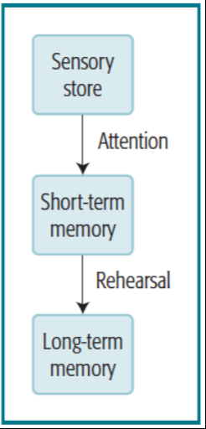

## · Short-Term Memory

All representations are memories - therefore memory is everywhere in the brain

* Aikinson & Shiffrin (1968)

o Information coming in from the environment tends to be held in transient sensory stores from which it is lost unless attended to

§ Sensory store –(Attention)> short-term memory –(Rehearsal)> long-term memory

o Earlier short-term memory was identified with the memory span, referring to the number of elements one can immediately repeat back

§ The magical seven items

· Miller (1956): Humans have a span of seven (plus or minus two) meaningful verbal items/chunks.

· Cowan (2000), however, argues that when eliminating other factors it is actually only four items.

o One factor is Chunking

o Relies on meaning/long-term memory, i.e. the numbers “13 17 509” probably have to be stored separately, whereas the numbers “9 11 2001” may probably be stored as a single chunk.

Related to expertise (ch 9) (experts have more experience -> more chunked knowledge in their field)

* ch 9 One running guy (“SF”) could hold 20 digits because he related them to running times
* chess experts use chunking to remember meaningful chess board positions

o One can't keep information in short-term indefinitely, new information push out old information from the limited short-term memory

* Shepard and Teghtsoonian (1961)

o Presented participants with a long sequence of 200 three-digit numbers. The task was to identify when a number was repeated

o Result: the longer the lag (intervening numbers between repeats) the less reported numbers (no longer in their short-term memory)

* Rundus (1971)

o The amount of rehearsal controls the amount of information transferred to long-term memory - the more rehearsed, the more likely to remember

o Information has to "do time" in short term in order to get into long-term.

* Vaik & Lockhart (1972)

o Propose that rehearsal improves long-term memory only if the material is rehearsed in a deep and meaningful way.

o The depth of processing is critical (to get into long term) (deliberate practice - chapter 9)

§ A number of experiments have shown that passive rehearsal results in little improvement in memory performance.

o It's critical that we process information in a way that is conductive to setting up a long-term memory trace

o Glenberg, Smith, and Green (1977)

§ had participants study a four-digit number for 2 s, then rehearse a word for 2, 6, or 18 s, and then recall the four digits. final surprise test for the words.

§ On average, participants recalled 11%, 7%, and 13% of the words they had rehearsed for 2, 6 and 18 s. Their recall was poor and showed little relationship to the amount of rehearsal.

o Kåpuret al (1994)

§ participants judged whether words contained a particular letter; in the deep processing task, they judged whether the words described living things. Even though the study time was the same, participants remembered 75% of the deeply processed words and only 57% of the shallowly processed words

§ Greater activation during deep processing in the left prefrontal regions

## Working Memory

o Baddeley’s (1986)

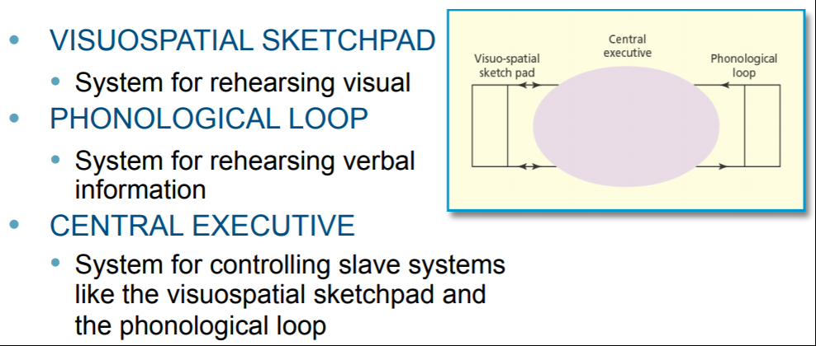

o hypothesized that there are two systems, a visuospatial sketchpad (System for rehearsing visual info) and a phonological loop (System for rehearsing verbal

o info), which he called “slave systems”

o Central executive: controls how the slave systems are used - it controls what we pay attention to, as both systems require attention

§ Phonological loop

· ARTICULATORY LOOP

o “Inner voice” used during rehearsal of verbal info

o Activation in Broca's area. Treating ourselves as if we're the listener.

o most compelling evidence Baddeley (1975).

§ wit, sum, harm, bay, top

§ participants were able to repeat back an average of 4.5 words out of 5 such one-syllable words

§ university, opportunity, hippopotamus, constitutional, auditorium

§ Participants were able to recall only an average of 2.6 words out of 5 such five-syllable words.

· PHONOLOGICAL STORE

o "Inner ear" that hears the inner voice and stores information in phonological form.

o Activation in parietal-temporal region

o the difference between short-term memory and Baddeley’s phonological loop is that processing information in the phonological loop is not critical to getting it into long-term memory. Rather, the phonological loop is just an auxiliary system for keeping information available.

· Visuo-spatial sketch-pad: Rehearsing visually

o Corsi block Test done in class

§ Corsi span is typically around five, about two less than digit span.

o Frontal cortex and primate working memory

§ Frontal cortex plays an important role in working-memory tasks!

Delayed match-to-sample task:

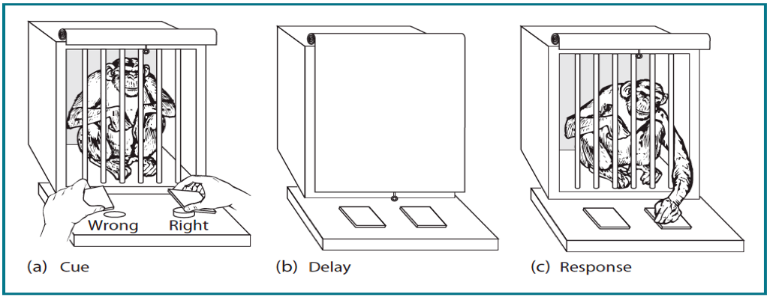

§ Goldman-Rakic (1987): Brodmann area 46 in the frontal cortex active in monkeys when remembering where food is hidden. Neurons only fire during delay interval, and are inactive before and after

§ Monkeys with lesions in frontal cortex couldn't perform the task

§ Human infants can't either until frontal cortices are fully matured

o E. Smith et al When visual information is held in working memory, there's activation in right prefrontal area 47

§ A stable core of prefrontal and parietal regions are active across different tasks (working memory)

o A meta-analysis of 189 fMRI studies, Rottschy et al. (2012)

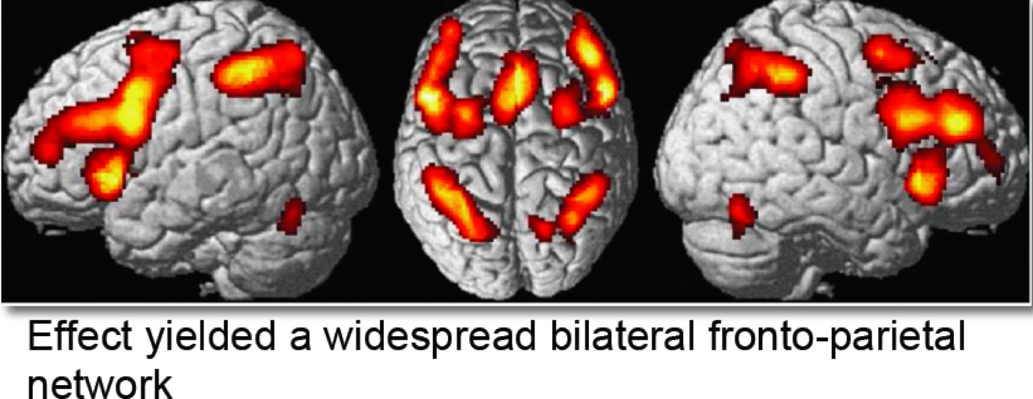

o It was pointed out that activity in these areas occurs across a range of tasks, not just working-memory tasks.

§ One possibility is that activity in these areas corresponds to Baddeley’s central executive

§ Postle (2006, in press) has argued that this activity may reflect the operation of brain systems that play a role in controlling the representation of information in more specialized regions of the brain.

## Activation and long-term memory

* Andersen: ACT theory: Adaptive control of thought

§ Memory traces as varying in their activation

§ The speed and probability of accessing a memory are determined by its base-level activation and the activation it receives from associated concepts.

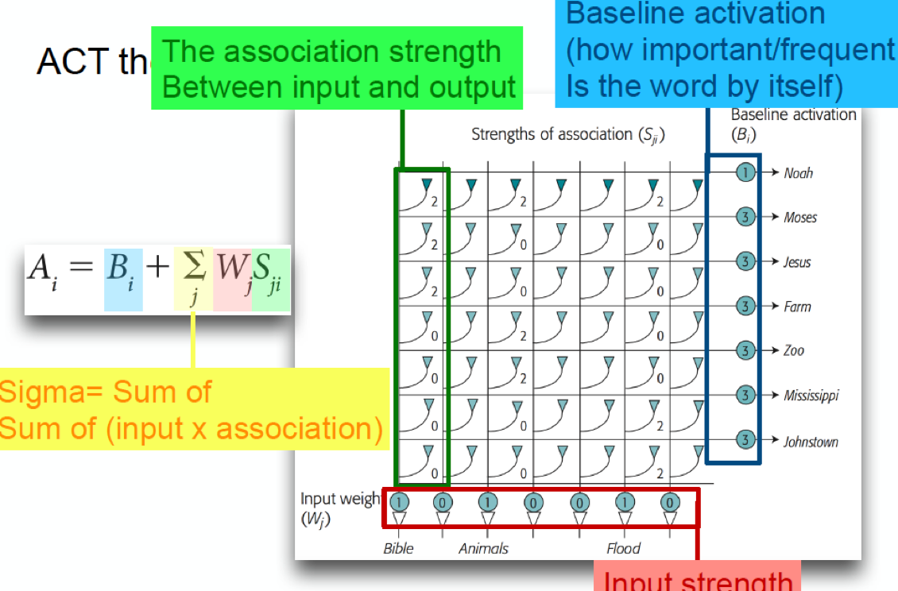

* Spreading activation: the process in which currently attended items can make associated memories more available

o Memories are primed by what we attend to

*"Those that fire together wire together!"*

o Meyer & Schvaneveldt (1970)

§ lexical decision task. Two items shown, participants were to judge if whether or not both items were words. Positive pairs: They were quicker to respond when items were related (bread and butter vs nurse and butter).

o Kaplan (1989)

§ solving problems like riddles too. (Watermelon primed answer in mens bathroom)

§ Activation spreads from presented items through a network of memories related to that prime item.

## Practice and memory strength

* Each time we use a memory trace, it increases a little in strength.

o More available memories: more frequently used. Each time a trace is used, it increases a bit in strength

§ Strength: The quantity which determines the inherent availability of a memory

· Power law of learning

* Increasing practice has diminishing returns
* The opposite: Power law of forgetting (chapter 7)

o Pirolli and Anderson (1985)

§ participants taught a set of facts to practice for 25 days; then looked at the speed with which the participants could recognize these facts

· plotted in log–log terms, and there is a linear relation

o Blackburn (1936)

§ practicing addition problems for 10,000 trials by two participants.

· plotted in log–log terms, and there is a linear relation

o Newell and Rosenbloom (1981) refer to the way that memory performance improves as a function of practice as the power law of learning.

## Neural correlates of the Power Law (Details not expected!!!)

* long-term potentiation (LTP), which occurs in the hippocampus and cortical areas. When a pathway is stimulated with a high-frequency electric current, cells along that pathway show increased sensitivity to further stimulation.

o Barnes (1979) looked at LTP in rats by stimulating the hippocampus for 11 successive days and measuring the percentage increase in excitatory postsynaptic potential (EPSP) over its initial value.

§ Showed diminishing increase in LTP with amount of practice.

* Two studies illustrating the role of the prefrontal cortex in forming new memories in normal participants

o (Wagner et al., 1998) investigated memory for words; the other (J. B. Brewer, Zhao, Desmond, Glover, & Gabrieli, 1998) investigated memory for pictures

§ Wagner et al. found that activity in left prefrontal regions was predictive of memory for words whereas Brewer et al. found that activity in right prefrontal regions predicted of memory for pictures

o note that these studies are a good example of the lateralization of prefrontal processing, with verbal material involving the left hemisphere to a greater extent and visual material involving the right hemisphere to a greater extent.

## Factors influencing memory

* Elaborative processing involves thinking of information that relates to and expands on the information that needs to be remembered

o J. R. Anderson & Bower (1973)

§ had participants try to remember simple sentences such as *The doctor hated the lawyer*

§ Some just studied the sentence, others were asked to generate an elaboration – e.g. *because of the malpractice suit.*

§ *Later recall -> 57% or 72%*

o B. S. Stein and Bransford (1979) showed why self- generated elaborations are often better than experimenter-provided elaborations.

§ Reflect back to Depth of processing

## Techniques for Studying Textual Material

· *Study techniques that involve generating and answering questions lead to better memory for text material.*

* PQ4R METHOD (Thomas and Robinson, 1972)
  + 1. Preview
  + 2. Questions
  + 3. Read
  + 4. Reflect
  + 5. Recite
  + 6. Review

## Incidental vs intentional learning:

* It does not seem to matter whether people intend to learn the material; what is important is how they process it
  + Hyde and Jenkins (1973)
    - True intention was to learn a lot of words
    - 4 Groups: pleasantness-intentional, pleasantness-incidental, letter checking-intentional, and letter checking-incidental.
    - What matters is how the person processes the material during its presentation. If one engages in identical mental activities when processing the material, one gets identical memory performance whether one is intending to learn the material or not.
    - In rating a word for pleasantness, participants had to think about its meaning, which gave them an opportunity to elaborate upon the word.

## Flashbulb-memories

* Memories that are so important that they "burn" themselves into our memory forever (9/11)
* (Brown & Kulik, 1977) proposed that we have a special biological mechanism to guarantee that we will remember those things that are particularly important to us.
* McCloskey et al (198S) found that although recalling an important memory is vivid and detailed, they are often inaccurate
* Palmer, Schreiber, and Fox (1991) - You need to be directly affected by event for it to become a flashbulb memory

o Margaret Thatcher’s resignation in UK. participants from the United Kingdom, the United States, and Denmark. 60% of the participants from the UK showed perfect memory 11 months after whereas only 20% of those outside.

* Sarot et al. (2007) interviewed the participants where they were in Manhattan when the Twin Towers were struck. 2 or 5 miles away. They focused on activity in the amygdala, which is a brain structure known to reflect emotional response. They found greater amygdala activation in the downtown group when they were recalling events from 9/11 than in the midtown group.

o This is significant because there is evidence that amygdala activity enhances retention (Phelps, 2004). In a state of arousal, the amygdala releases hormones that influence the processing in the hippocampus that is critical in forming memories (McGaugh & Roozendaal, 2002).

## Keyterms

· Activation,ACT (adaptive control of thought), anterograde amnesia, articulatory loop, associative spreading, auditory sensory store, central executive, depth of processing, echoic memory, elaborative processing, flashbulb memories, iconic memory, long-term potentiation (LTP), memory span, method of loci, partial-report procedure, phonological loop, power function, power law of learning, short-term memory, spreading activation, strength, visual sensory store, visuospatial sketchpad, whole-report procedure, working memory.

|  |  |
| --- | --- |
| activation | A state of memory traces that determines both the speed and the probability of access to a memory trace. (p. 133) |
| ACT (adaptive control of  thought) | Anderson’s theory of how declarative knowledge and procedural knowledge interact in complex cognitive processes. (p. 133) |
| anterograde amnesia | Loss of the ability to learn new things a er an injury. Contrast with retrograde amnesia. (pp. 124, 173) |
| articulatory loop | Part of Baddeley’s proposed system for rehearsing verbal information. (p. 130) |
| associative spreading | Facilitation in access to information when closely related items are presented. (p. 136) |
| auditory sensory store | A memory system that effectively holds all the information heard for a brief period of time. Also called echoic memory. (p. 126) |
| central executive | Baddeley’s proposed system for controlling various slave rehearsal systems, such as the articulatory loop and the visuospatial sketchpad. (p. 129) |
| depth of processing | The theory that memory for information is improved if the information is processed at deeper levels of analysis. (p. 128) |
| echoic memory | Another term for auditory sensory store. (p. 126) |
| elaborative processing | e embellishment of a to-be- remembered item with additional information. (p. 141) |
| flashbulb memories | Particularly good memory for an event that is very important and traumatic. (p. 145) |
| iconic memory | Another term for visual sensory store. (p. 126) |
| long-term potentiation (LTP) | The increase in responsiveness of a neuron as a function of past stimulation. (p. 139) |
| memory span | The amount of information that can be perfectly retained in an immediate test of memory. (p. 127) |
| method of loci | A mnemonic technique used to associate items to be remembered with locations along a well-known path. (p. 145) |
| partial-report procedure | An experimental procedure in which participants are cued to report only some of the items in a display. Contrast with whole-report procedure. (p. 126) |
| phonological loop | Part of Baddeley’s proposed system for rehearsing verbal information. Compare visuospatial sketchpad. (p. 129) |
| power function | A function in which the independent variable X is raised to a power to obtain the dependent variable Y, as in Y = AXb. (p. 138) |
| power law of learning | The phenomenon that memory performance improves as a power function of practice. (p. 138) |
| short-term memory | A proposed intermediate memory system that holds information as it travels from sensory memory to long-term memory. (p. 127) |
| spreading activation | The proposal that activation spreads from items currently or recently processed to other parts of the memory network, activating the memory traces that reside there. (p. 135) |
| strength | The property of a memory trace that determines how active the trace can become. Strength increases with practice and decays with time. (p. 137) |
| visual sensory store | A memory system that effectively holds all the information in a visual array for a very brief period of time (about a second). Also called iconic memory. (p. 126) |
| visuospatial sketchpad | Part of Baddeley’s proposed system for rehearsing visual information. Compare phonological loop. (p. 129) |
| whole-report procedure | A procedure in which participants are asked to report all the items of a display. Contrast with partial-report procedure. (p. 126) |
| working memory | The information that is currently available in memory for working on a problem. (p. 129) |

# 7: Human Memory: Retention and Retrieval

**pp. 124-149**

**"Memory is everything. It makes us dynamical creatures - makes experiments extremely complicated - noise in measurements" - Mikkel's rant**

The brain structures involved in the creation and storage of memories:  
• Prefrontal regions – the creation of memories  
• Hippocampal regions – permanent storage of memories

ARE MEMORIES REALLY FORGOTTEN ?

Penfield (1959) : electrically stimulated portions of patients’ brains and asked them to report what they experienced. Temporal lobes led to reports of memories that patients were unable to report in normal recall

J. D. Johnson, McDuff, Rugg, and Norman (2009) report a brain-imaging study that also shows there are records of experiences in our brain that we can no longer remember.

* The researchers trained a pattern classifier (a program for analyzing patterns of brain activity, as discussed in the Implications Box in Chapter 4)
* It was successful at recognition both for words that participants could recall studying and for words they could not remember, although the accuracy was somewhat lower for the words they could not remember.
* These experiments do not prove that everything is remembered. They show only that appropriately sensitive tests can find evidence for remnants of some memories that appear to have been forgotten.

## THEORIES OF FORGETTING

1. Decay theory – memory traces simply decay in strength with time

2. Interference theory – memory traces are replaced with interfering material.

### THE RETENTION FUNCTION & POWER LAW OF FORGETTING

- Wickelgren presented participants with a sequence of words to study and then examined the probability of their recognizing the words after delays ranging from 1 min to 14 days.

- The memory loss is negatively accelerated—that is, the rate of change gets smaller and smaller as the delay increases -> We start by forgetting a lot very fast, then forgetting decelerates

- This can be described using a power law function - Relate to Power law of learning

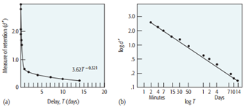

- Bahrick (1984): Graphed a negative acceleration in a retention function

- Retention of English–Spanish vocabulary items anywhere from immediately to 50 years

-> The strength of a memory trace decays as a power function of the retention interval.

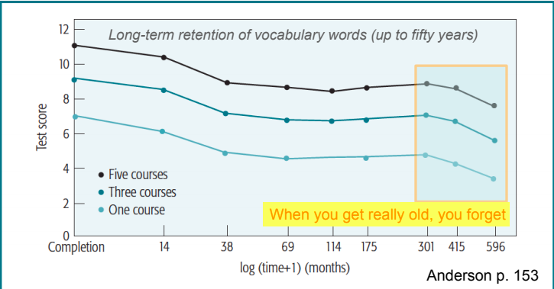

**Objection to decay theory**

Decay theory does not identify the psychological factors that produce the forgetting but rather just assert that forgetting occurs spontaneously with time. (if interested look at mice brain experiment p. 153-154)

Interference Experiment Keppel, (1968) with learning multiple lists of paired associates → how the learning of one list of paired associates would affect the memory for another list?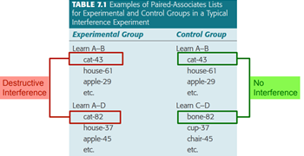

Result:

* It is difficult to maintain multiple associations to the same items
* Destructive interference - they do worse at remembering

FAN EFFECT

The increase in reaction time related to an increase in the number of facts associated with a concept

(J. R. Anderson, 1974)

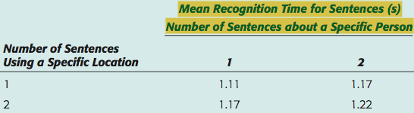

Anderson (2003) looked at the response in the prefrontal cortex during the verification of such facts. They contrasted recognition of high-fan sentences (composed of concepts that appeared in many other sentences) with low-fan sentences (composed of concepts that appeared in few sentences) in FMRI.

High fan = long RT.

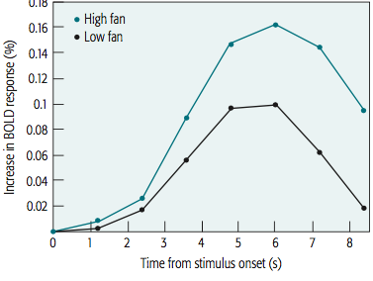

RETRIEVAL AND INFERENCE

Learning redundant material does not interfere with a target memory and may even facilitate the target memory.

Bradshaw and Anderson (1982) - Participants were tested for their ability to recall the target facts (single, relevant and irrelevant) immediately after studying them and after a week’s delay.

* 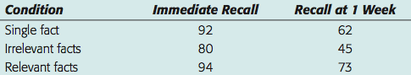
* The protecting effect of meaningful redundancy

THE INTERACTION OF ELABORATION AND INFERENCE

When participants elaborate on material while studying it, they tend to recall more of what they studied and also to recall inferences that they did not study.

Bower, and Black (1979)Participants were asked to recall the story 24 hours after studying it. Those in the theme condition introduced a great many more inferences that had not actually been studied.

EXACT >< PLAUSIBLE RETRIEVAL

People will often judge what plausibly might be true, rather than try to retrieve exact facts.

Participants use of exact retrieval versus plausible retrieval of textual information (Reder, 1982)

→ As delay intervals increase participants’ exact retrieval gets slower, but their plausible retrieval gets faster. (**Meaning sticks better with us - ch 5 p 102, washing machine instructions)**

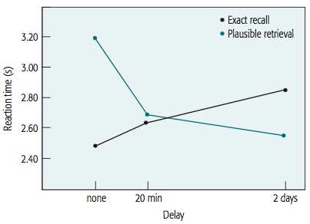

RETRIEVAL INHIBITION

M. C. Anderson & Spellman, 1995)

Red–Blood (practiced) (74%)

Red–Tomato (22%)

Food–Strawberry (22%)

Food–Cracker (36%)

* lower recall for Red–Tomato: explained by other interference theories, such as competition from the strengthened Red–Blood association
* lower recall of Food–Strawberry: considered evidence for the inhibition account.

Raaijmakers & Jakab, 2013). Other researchers sometimes can replicate these results but oftentimes cannot. - DOUBTFUL! (replication crisis… 91.7% successful replication rates in studies with author overlap compared to 64.6% success replication rates without author overlap Makel, Matthew C.; Plucker, Jonathan A.; Hegarty, Boyd (2012-11-01). "Replications in Psychology Research How Often Do They Really Occur?". )

## FORGETTING AND SLEEP

Ekstrand (1972) found that less is forgotten during sleep → Memories are encoded via the hippocampus and during sleep cortical connections get reinforced and hippocampal connections get “normalised”

(Hockey, Davies, and Gray, 1972): Participants better remembered material learned at night

• Even if they were kept up during the night and slept during the day

• Early evening is the period of highest arousal.

## FALSE MEMORIES

“Memories are constructions” - Mikkel’s quote

• When memories are retrieved and shared, they change

• The become more and more like stories (semantic memory)

• People fail to separate what they actually experienced from what they inferred, imagined, or were told (e.g. being lost in the mall as a kid)

Loftus, Miller, & Burns, 1978) showed that subsequent information can change a person’s memory of an observed event. In one study, for instance, Loftus asked participants who had witnessed a traffic accident about the car’s speed when it passed a Yield sign. Although there was no Yield sign, many participants subsequently remembered having seen one, confusing the question they were asked with what they had actually seen

false-memory syndrome. This controversy involves cases where individuals claim to recover memories of childhood sexual abuse that they had suppressed (Schacter, 2001)

* might have been created by the strong suggestions of the therapists

suggestive interview techniques. For instance, Loftus and Pickerall (1995)

* adult participants read four stories from their childhood three were true, but one was a false story about being lost in the mall at age 5.
* 25% of participants claimed to remember the event of being lost in a mall.

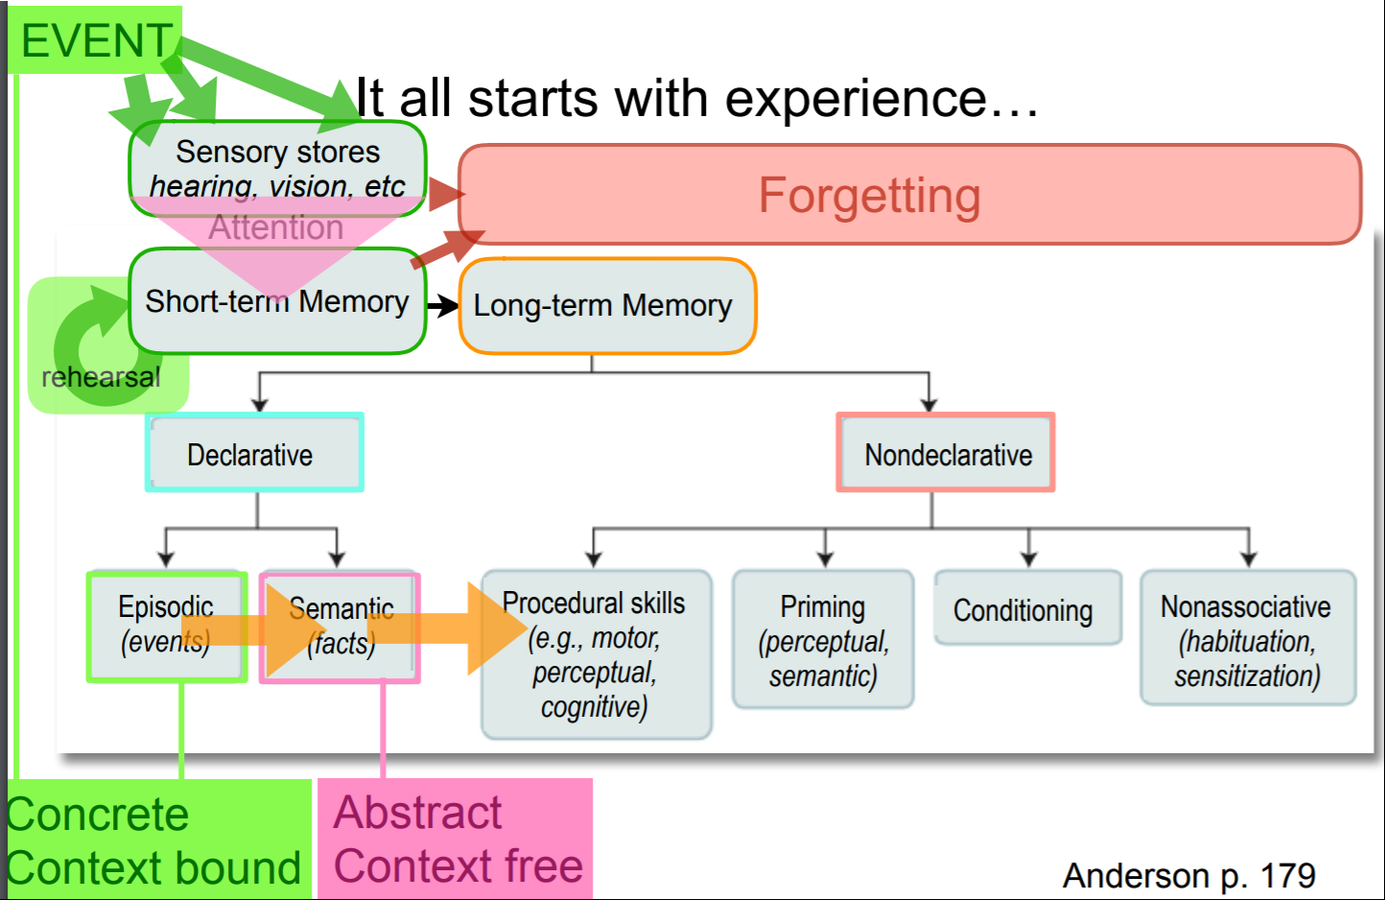

Deese-Roediger-McDermott paradigm (1959):

Participants study word lists: thread, pin, eye, sewing, sharp, point, prick, thimble, haystack, thorn, hurt, injection, syringe, cloth, knitting, bed, rest, awake, tired, dream, wake, snooze

Later tested on recall of words: True (e.g. sewing, awake) - 88% remembered

Close associates (e.g. needle, sleep) - 80% “remembered”

New (e.g. door, candy) - 12 % “remembered”

* Reflect back to plausible retrieval
* Spreading activation (134 - ACT)
* Priming - Rabbit and Hare/Hair

Cabeza et al fMRI study (p 168):

Bilateral hippocampal regions were more activated for true and false (but related) items than for new items. The parahippocampal gyrus was more activated for true items than for false (related) and new items, with no difference between the activations for false and new items.

* parahippocampal gyrus: maybe retains original sensory experience
* hippocampus: more abstract representation of memories

THE EFFECTS OF ENCODING CONTEXT

Godden and Baddeley (1975) – had divers learn a list of 40 unrelated words either on the shore or 20 feet under the sea. Participants showed superior memory when they were asked to recall the list in the same environment in which they studied it.

Bower, Monteiro, and Gilligan (1978) - Hypnotised in mood - learns list Mood congruence - one’s memory is better for studied material whose emotional content matches one’s mood at test

State-dependent learning - memory performance is better when we are tested in the same emotional and physical state as we were when we learnt the material (e.g. Eich, Weingartner, Stillman, & Gillin experiment - participants learned a free-recall list after smoking either a marijuana cigarette or an ordinary cigarette. Participants were tested 4 hours later—again after smoking either a marijuana cigarette or a regular cigarette -> better recall when the state at test matched the state at study. **Also, an overall higher level of recall when the material was studied in a nonintoxicated state)**

Encoding-specificity principle - The probability of recalling an item at test depends on the similarity of its encoding at test to its original encoding at study

AMNESIA

• anterograde amnesia: impairment in the ability to acquire new memories after the onset of amnesia (patient HM; Clive Wearing).

• retrograde amnesia: impairment in remembering events prior to onset of amnesia (also HM).

Patient HM

* temporal lobes removed (including hippocampal area)
* retrograde impairment extends back to 11 years before surgery.
* comprehension of language is undisturbed: he can repeat and transform sentences with complex syntax, and he gets the point of jokes, including those turning on semantic ambiguity."

Clive wearing – can still play piano (Procedural knowledge )-> procedural memory is independent of episodic memory

Korsakoff syndrome

- Retrograde and anterograde amnesia caused by chronic alcoholism and bad nutrition (the lack of thiamine - B1 vitamin) → confusion, forgetfulness

DISSOCIATIONS

* Situations in which different tests of memory (and cognition in general) show different results
* Important in arguing for different memory systems
* between explicit memory (declarative), what we can consciously recall, and implicit memory (non-declarative), what we remember only in our actions.
* (e.g. HM learned to mirror draw over a 3-day period and Clive Wearing still plays the piano) → procedural learning intact in amnesia
* 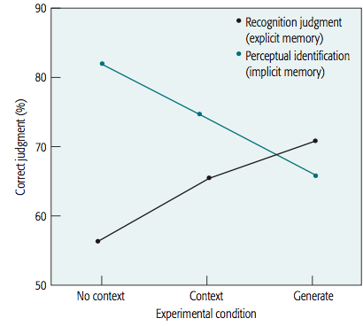
* between episodic and short-term memory system ( e.g. HM could remember a number for 15 minutes by continuously repeating, but forgot it within 1 minute -> Amnesics have normal digit span)

PRIMING

* An enhancement of the processing of a stimulus as a function of prior exposure (Jacoby, 1983)
* Amnesic patients were unable to recall words they had practiced e.g. banana, but came up with the words more often than expected when given a prime: • e.g. ban___

NON-ASSOCIATIVE LEARNING

1. Habituation: When one learns that a certain stimulus is neither harmful nor beneficial, responses to this stimulus are diminished (e.g. when one doesn’t “hear” the noisy neighbours anymore...)

2. Sensitization: the progressive amplification of a response follows repeated administrations of a stimulus (e.g. if a person rubs his arm continuously. After a while, this stimulation will create a warm sensation that will eventually turn painful)

# Key Terms

|  |  |
| --- | --- |
| Amnesia | A memory deficit due to brain damage. See also anterograde amnesia; retrograde amnesia; Korsakoff syndrome. (p. 173) |
| Anterograde amnesia | Loss of the ability to learn new things after an injury. Contrast with retrograde amnesia. (pp. 124, 173) |
| Decay theory | The theory that forgetting is caused by the spontaneous decay of memory traces over time. Contrast with interference theory. (p. 154) |
| Declarative memory | Explicit knowledge of various facts. Contrast with procedural knowledge. (p. 179) |
| Deese-Roediger-  McDermott paradigm | A paradigm for creating false memories of words by presenting associatively related words. (p. 167) |
| Dissociations | Situations in which different tests of memory (and cognition in general) show different results. |
| Encoding-specificity  principle | Tulving’s principle that memory is better when the encoding of an item at study matches the encoding at test. (p. 172) |
| Explicit memory | Knowledge that we can consciously recall. Contrast with implicit memory. (p. 175) |
| False-memory syndrome | A term used to describe the condition of false memories of childhood abuse. (p. 166) |
| Fan effect | The phenomenon that the retrieval of memories takes longer as more things are associated with the items composing the original memories. (p. 157) |
| Implicit/non-declarative memory | Knowledge that we cannot consciously recall but that nonetheless manifests itself in our improved performance on some task. Contrast with explicit memory. (p. 175) |
| Interference theory | The theory that forgetting is caused by other memories interfering with the retention of the target memory. Contrast with decay theory. (p. 154) |
| Korsakoff syndrome | An amnesia resulting from chronic alcoholism and nutritional deficit. (p. 173) |
| Mood congruence | The phenomenon that one’s memory is better for studied material whose emotional content matches one’s mood at test. (p. 170) |
| Power law of forgetting | The phenomenon that memory performance deteriorates as a power function of the retention interval. (p. 153) |
| Priming | The enhancement of the processing of a stimulus as a function of prior exposure. (p. 176) |
| Procedural knowledge | Knowledge of how to perform various tasks. Contrast with declarative knowledge. (p. 177) |
| Retrograde amnesia | Loss of memory for things that occurred before an injury. Contrast with anterograde amnesia. (p. 173) |
| State-dependent learning | e phenomenon that memory performance is better when we are tested in the same emotional and physical state as we were in when we learned the material. (p. 171) |
| Semantic | Takes time, changes gradually - a robust memory |
| Episodic | Include new memories immediately - can be crucial to survival |

# 8: Problem Solving

* Human problem solving
  + Well-defined problems
    - Well-defined problems have specific goals, clearly defined solution paths, and clear expected solutions.
    - Maze
  + Ill-defined problems
    - "Remember to be happy"
    - Most human problems
    - Ill-defined problems are those that do not have clear goals, solution paths, or expected solution.
  + Often we use search trees when discussing problem solving
    - Search trees = set of states that can be reached by applying operators to a start state
  + The problem space developed by Allen Newell and Herbert Simon
    - it consists a set of states and operators for moving among the states
    - Also called searching a state space
    - Good example: The eight puzzle
      * The goal is to achieve a particular configuration of tiles, starting from a different configuration
    - Initial state
    - Intermediate state
    - Goal state
      * Need operator
        + Action to transfer problem to a new state
    - It can be relevant to set a subgoal to achieve the larger goal
    - Sultan Monkey example - Longer stick as subgoal to reach food
  + Acquiring operators
    - Discovery
      * Trial and error
        + 1898, Thorndike placed cats in “puzzle boxes.”
      * Daw, Niv, and Dayan (2005) review evidence that there are two bases for learning such operators from experience
        + Basal ganglia (Chapter 7 - p.178)

Simple associations reinforced

sequence learning

* + - By instruction
      * Specification - Being told
      * Example “monkey see, monkey do”
      * It has now been shown many times that providing worked examples is one of the most effective methods of instruction for problem-solving skills like algebra (for a review, see Lee & Anderson, 2013) - expert solutions that students can emulate

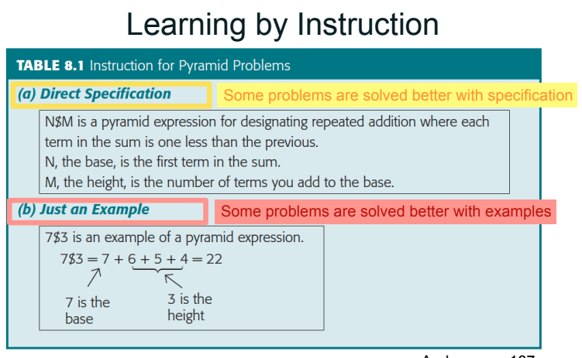

* + Christensen and Schunn (2007) found that engineers made 102 analogies in 9 hours of problem solving (see also Dunbar & Blanchette, 2001)
    - Analogy involves noticing that a past problem solution is relevant and then mapping the elements from that solution to produce an operator for the current problem.
      * Fortress + tumor
    - “Key is to a padlock as what is to a tin can? The answer: can opener.”
      * IQ test --> Ravens Matrices
      * Analogical problem solving appears to be a capability nearly unique to humans and to depend on the advanced development of the prefrontal cortex. (Chimpanzees might be able to)
    - Prefrontal cortex
      * Mental model is built of how the operators work
      * Only in larger mammals where the prefrontal cortex is large
  + Selecting operator
    - Biases
      * Backup avoidance
        + Bias to not use operators going backwards --> always forwards
      * Difference reduction (hill climbing)
        + Reduce the difference between the current state and the goal state

Difficulty solving the hobbit and orcs problem (having to go backwards) - counter-intuitive

* + - Means-ends analysis
      * Create new goal -> previously blocked operator possible to use
      * Newell and Simon, used means-ends analysis in a computer simulation program (called the General Problem Solver—GPS) that models human problem solving.
        + Mechanical representation
    - The Tower of Hanoi
      * A problem-solving task in which disks are moved among pegs.
      * People often use difference reduction in the beginning
      * But it is solved by adopting a means-ends strategy in which subgoals are created.
  + Representation of problem
    - Functional Fixedness
      * The candle problem Duncker (1945)
        + see the box as a container, not as a platform
        + Conventional function failing to see the novel function
      * The two-string problem Maier (1931),
        + Pliers as weight

pendulum

* + - Correct representation
      * IMPORTANT
      * Checkerboard problem (Kaplan and Simon 1990) is difficult >< marriage problem (easily see them as pairs)
      * Brazilian Kids - street calculators (expertise, transfer of knowledge/domain)
  + Set effects Luchins (1942)
    - Jug problem - Solution B-2C-A
    - Unable to see simpler solution because of previous solutions that has worked
      * Also known as the Einstellung effect   
         - “mechanization of thought”
    - Incubation effect
      * Cheap Necklace problem Silveira (1971)
      * Able to see solution after being away from the problem
      * Immediately = 55% , 30 min= 64% , 4 hours = 85% got it
    - Insight problem
      * "aha" experience
      * Do not know you are close to the solution
        + Eg. Checkerboard problem

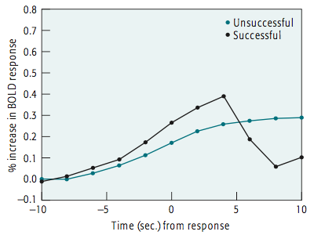

* + - * Jung-Beeman (2004) left prefrontal region that has been associated with retrieval from declarative memory
* Brain areas
  + Prefrontal cortex
    - Maintaining goal structures
    - Human large - other species smaller
      * More generally, it has been noted that patients with prefrontal damage have difficulty inhibiting a predominant response (e.g., Roberts, Hager, & Heron, 1994). For instance, in the Stroop task (see Chapter 3), these patients have trouble not saying the word itself when they are supposed to say the color of the word. Apparently, they find it hard to keep in mind that their goal is to say the color and not the word.
* Problem solving in other species
  + The Gestalt Approach - chimp reach banana (stick or boxes)
    - Wolfgang Köhler
      * Pigeon example -> Move box
      * 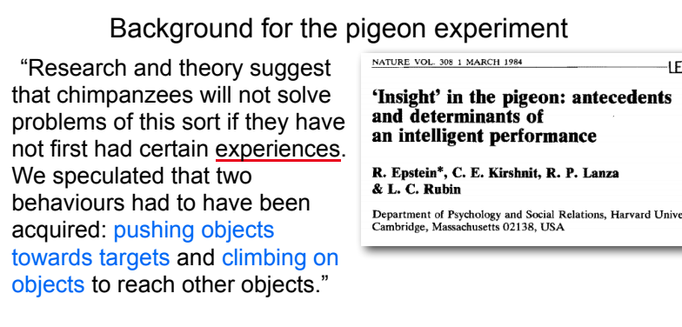
  + Insight learning
    - Broken down to smaller units
      * not that magical - combination of simpler learned skills
  + Creativity - Putting together known skills in a novel fashion

# Key Terms

|  |  |
| --- | --- |
| analogy | The process by which a problem solver maps the solution for one problem into a solution for another problem. (p. 188) |
| backup avoidance | The tendency in problem solving to avoid operators that take one back to a state already visited. (p. 191) |
| difference reductions | The tendency in problem solving to select operators that eliminate a difference between the current state and the goal. (p. 192) |
| Einstellung effect | The term used by Luchins to refer to the set effect, in which people repeat a solution that has worked for previous problems even when a simpler solution is possible. (p. 203) |
| functional fixedness | The tendency to see objects only as serving conventional problem-solving functions and thus failing to see that they can serve novel functions. (p. 202) |
| General Problem Solver (GPS) | A problem-solving simulation program created by Newell and Simon that embodies means-ends analysis. (p. 194) |
| goal state | A state in a problem space in which the goal is satisfied. (p. 183) |
| hill climbing | The tendency to choose operators in problem solving that transform the current state into a new state more similar to the goal. (p. 192) |
| incubation effect | The phenomenon that sometimes a solution to a particular problem comes more easily after a period of time in which one has stopped trying to solve the problem. (p. 204) |
| insight problem | A problem in which the subject is not aware of being close to a solution. (p. 206) |
| means-ends analysis | The creation of a new goal (end) to enable a problem-solving operator (means) to apply in achieving the old goal. (p. 192) |
| operator | A term used in problem-solving research to refer to a particular action that will transform the problem state into another problem state. The solution of an overall problem is a sequence of these known operators. (p. 183) |
| problem space | A representation of the various sequences of problem-solving operators that lead among various states of a problem. Also called state space. (p. 183) |
| search | The process by which one finds a sequence of operators to solve a problem. (p. 183) |
| search tree | A representation of the set of states that can be reached by applying operators to an initial state. (p. 185) |
| set effect | The biasing of a solution to a problem as a result of past experiences in solving that kind of problem. (p. 202) |
| state | A term in problem solving used to refer to a representation of the problem in some degree of solution. (p. 183) |
| subgoal | A goal set in service of achieving a larger goal. (p. 183) |
| Tower of Hanoi problem | A problem-solving task in which disks are moved among pegs. (p. 196) |

# 9: Expertise

*“Expertise is the use of memory in problem solving!”*

(quote Mikkel)

*“No pain, no gain!”*

* Expertise requires years of practice.

***“When the going gets tough, the tough gets going!”***

* The harder the problem the bigger the difference between novice and expert

## Brain changes with skill acquisition

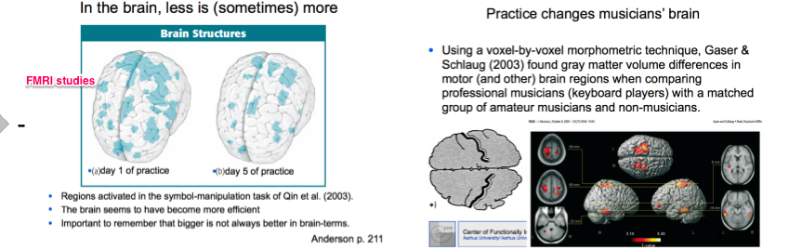

Generally: More expertise = more efficient processing in the brain = less activation (Non-declarative)

Sometimes, 'less is more'! (quantitative change)

## 3 stages of skill acquisition (J. R. Anderson, 1983; Fitts & Posner, 1967)

|  |  |  |
| --- | --- | --- |
| 1. The cognitive stage | 2) The associative stage | 3) The autonomous stage |
| Declarative encoding of the skill  Set of relevant facts to the skill rehearsed and memorized  Knowledge still in declarative form | Errors in initial understanding gradually eliminated  Connections among various elements required for successful performance strengthened  Declarative representation of skill --> nondeclarative procedural representation  (see end of chapter 7) | Performance of the skill becomes more automated and rapid  Central cognition/attention/Central executive) 'drops out'  (a typist not aware of typing, p.73) |

Attentional demands go DOWN. Efficiency goes UP.

## The power law of learning

Cognitive skill improves as a *power function* of practice (steep curve flattens out, practice becomes less efficient over time)

Log-log relation between practice and performance

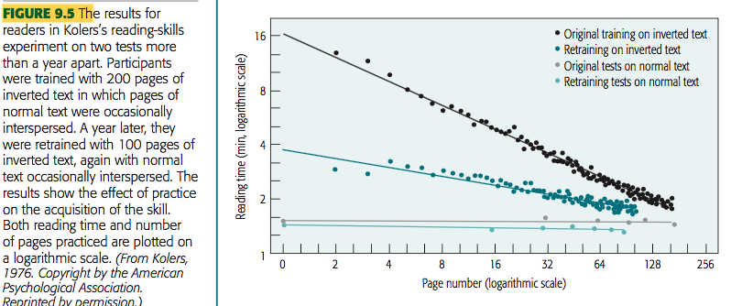

The same level of performance that participants had initially reached after 200 pages of training was now reached after 50 pages. Skills generally show very high levels of retention.

## Anderson's dimensions of expertise development

Proceduralization

* Declarative knowledge --> Procedural knowledge
* enables them to perform the task without thinking about it.

|  |  |
| --- | --- |
| Tactical learning | Strategic learning |
| Learning of sequences of actions that help solve a problem  A method that accomplishes a specific goal  Learning new pieces of skill  *"The foot soldier"* | Learning how to organize one's problem-solving for a specific class of problems    Putting skills together  *"The army general"* |

## Strategic learning and problem solving approaches (Priest and Lindsay)

|  |  |
| --- | --- |
| Novice | Expert |
| * Reasoning backwards method * Starts with the unknown * Puts strain on working memory that may lead to errors   Baking problem - turn on the oven | * Uses similar equations, but in opposite order * Starts with quantities that can be directly computed and works towards desired end * Knows which forward inferences are appropriate for the problem   Chunking - subgoals (Know the formula already) |

## Problem perception

Growing expertise = development of a set of richer perceptual features for encoding problems (better problem representation)

Reliance on simple features --> reliance on deeper features:

Chi, Feltovich, and Glaser (1981) asked participants to classify a large set of problems into similar categories. the novices chose surface features, such as rotations or inclined planes, as their bases for classification Experts saw problems that are completely different on the surface were similar because they both entailed conservation of energy or they both used Newton’s second law.

## Pattern learning and memory

* Development of retrieval structures for past patterns underlies the development of expertise
* Experts: enhanced memory for information about problems in their domain
  + - * Miller (1956): Humans have a span of seven (plus or minus two) meaningful verbal items/chunks. (Chapter 6)
  + Experts recognize *chunks* - patterns of elements that repeat in many problems
  + (e.g. Go, computer programming, bridge hands)
  + Superior memory for meaningful problems (washing machine, ch 5) (realistic chess board positions vs. random positions) Chase & Simon, 1973.) + SF and digit span

## Long-term memory, working memory and expertise

Experts have improved storage and retrieval. Better ability:

* To *store* problem information in long-term memory and
* To *retrieve* it

**Working memory:**

Charness (1976) compared experts’ memory for chess positions immediately after they had viewed the positions or after a 30-s delay filled with an interfering task. Class A chess players showed no loss in recall over the 30-s interval, unlike weaker participants, who showed a great deal of forgetting.

Chase and Ericsson (1982), SF the runner -> increase his digit span

## The role of deliberate practice

The best kind of practice! Highly motivated training involving careful self-monitoring.

Focus on improving, not just practicing. (Intelligent tutoring later on in chapter)

(But you can't explain everything with amount of practice… starting early is also important!)

* extensive practice appears to drive neural growth in the adult brain.
  + Taub (1995) found that violinists, who finger strings with the left hand, show increased development of the right cortical regions that correspond to their fingers.
  + In another study already mentioned in Chapter 4, Maguire et al. (2003) used imaging to examine the brains of London taxi drivers.

## Transfer of skill

|  |  |
| --- | --- |
| Positive transfer | Negative transfer (very small) |
| Previous knowledge enables you to perform a new task in a more efficient way | Previous knowledge prevents you from solving a new task efficiently (i.e. *functional fixedness (Pendulum string), set effects - see ‘problem solving’ chapter*) |

Expertise is often quite narrow

* + Failure to transfer skills to similar domains
  + Virtually no transfer to very different domains
    - Brazilian street vendor children. Good at applied math when selling stuff - but very bad at ‘normal’, written maths problems even when completely equal to the ones they did on the street(Carraher et al, 1985)
      * different problem representations
    - Encoding context - Reflect to scuba divers in water vs. on land (Chapter 7 - p.170)

**Brain Training**

Dual N Back task gave Improvement on the Raven’s Progressive Matrices test as a function of practice (From Jaeggi, S. M., Buschkuehl, M., Jonides, J., & Perrig, W. J. (2008)

Lot of Brain Trainers sprouted online

The early studies showing positive results had small sample sizes, and more adequately powered studies (Chooi & Thompson, 2012; Redick et al., 2013) have often failed to find positive results.

→ ‘brain tasks’ don’t always have transfer effects… no conclusion about if you can train your working memory!

# Theories

## Doctrine of formal discipline (No one really believes anymore)

* The idea that studying esoteric subjects (like latin and geometry) disciplines the mind
* The faculty view of the mind
* The mind as a collection of general faculties
* Transfer thought to be broad and at general levels across all disciplines (This is not the case!)
* … conflicting evidence. Discussion. E.g. video games and youth - bad/good effects?

## Theory of identical elements (behaviorism, Edward Thorndike)

* Transfer from one skill to another only when they share same knowledge elements
* Critique: Overly narrow definition - he believes in REALLY small transfer effects!

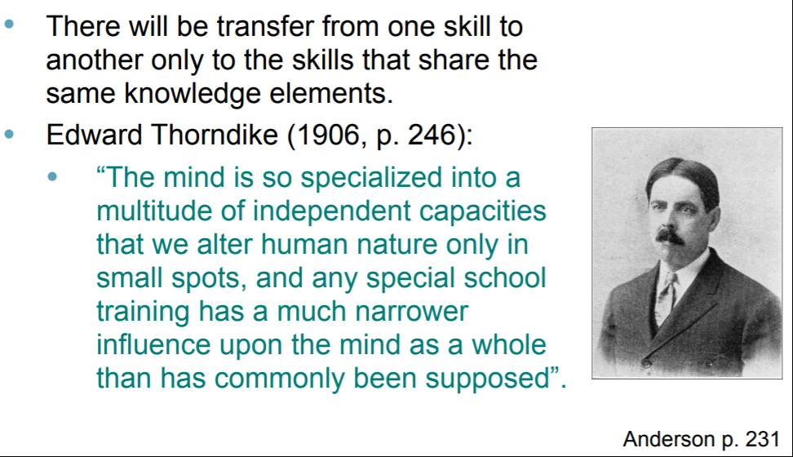

## Educational implications

* Componential analyses
  + instruction that begin with an analysis of the elements to be taught
  + Particularly important: mastery learning
    - Bring students to mastery of each element in a curriculum before continuing to new material
    - This failure to learn some of the components can snowball in a course in which mastery of earlier material is a prerequisite for mastery of later material. There is a good deal of evidence that mastery learning leads to higher achievement (Guskey & Gates, 1986; Kulik, Kulik, & Bangert-Downs, 1986).
  + Intelligent tutoring systems
    - Interact with students as they learn and solve problems --> like a human tutor
      * As the student is writing the function, the tutor is simultaneously trying to solve the same problem that the student is working on. As soon as it sees the student making a mistake, the tutor can intervene with remedial instruction.
    - Help them master complex skills more rapidly
      * A motivation for research on intelligent tutoring is the evidence showing that private human tutoring is very effective. The results of studies have shown that giving students a private human tutor enables 98% of them to do better than the average student in a standard classroom (Bloom, 1984)

Additional reading: Wallentin et al, The Musical Ear Test

Paper on the MET - a convenient, quick way to test people’s music expertise. Rhythms and melodies - are two lines identical? Highly correlated with actual musical performance tests.

# Key Terms

|  |  |
| --- | --- |
| associative stage | The second of Fitts’s stages of skill acquisition, in which the declarative representation of a skill is converted into a procedural representation. (p. 212) |
| autonomous stage | The third of Fitts’s stages of skill acquisition, in which the performance of a skill becomes automated. (p. 212) |
| cognitive stage | The first of Fitts’ stages of skill acquisition, in which the declarative encoding of a skill is developed and used. (p. 211) |
| componential analysis | An approach to instruction that begins with an analysis of the individual elements that need to be learned. (p. 232) |
| deliberate practice | The kind of practice that Ericsson postulated to be critical for the development of expertise. is practice is highly motivated and includes careful self- monitoring. (p. 228) |
| intelligent tutoring  systems | A computer system that combines cognitive models with techniques from artificial intelligence to create instructional interactions with students. (p. 233) |
| mastery learning | The effort to bring students to mastery of each element in a curriculum before promoting them to new material in the curriculum. (p. 232) |
| negative transfer | Poor learning of a second task as a function of having learned a first task. (p. 232) |
| proceduralization | The process by which declarative knowledge is converted into procedural knowledge. (p. 216) |
| strategic learning | The learning of how to organize one’s problem solving for a specific class of problems. Compare tactical learning. (p. 219) |
| tactical learning | The learning of sequences of actions that help solve a problem. Compare strategic learning. (p. 217) |
| theory of identical elements | The theory that there will be transfer from one skill to another only to the extent that the skills have the same knowledge elements in common. (p. 231) |

# 10: Reasoning

Superior intelligence (Solve problems and acquire new skills quickly) is thought to be the feature that distinguishes humans as a species, however psychological research on reasoning and decision making has started with prescriptions derived from logic and mathematics about how humans should behave, has then compared to what humans actually do, and has found humans deficient.

Computer algorithms and robots though, would often do stupid stuff too – lacking common sense – shortliffe (1976) Faced with such frustrations, researchers are now creating systems based on less logical computations, often emulating how neurons in the brain compute (Todays Machine learning) (e.g., Russell & Norvig, 2009).

IN THIS CHAPTER:

How do people reason about situations described in conditional language (e.g., “if–then”)?

How do people reason about situations described with quantifiers like *all, some,* and *none*?

How do people reason from specific examples and pieces of evidence to general conclusions?

## **Reasoning and the Brain**

· fMRI experiment by Goel, Buchel, Frith, and Dolan (2000)

o Participants solved logical **syllogisms →** Reading exp.

* **Content-free material: parietal regions (roles in solving algebraic equations)**
* **Meaningful content: left prefrontal and temporal-parietal areas (associated with language processing)**

o This indicates that people do not process all syllogisms in the same way but invoke different brain regions with content is present.

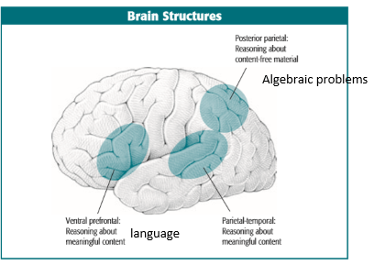

## **Different types of reasoning**

Reasoning deals with reaching conclusions

We have methods for reasoning, the most important is the scientific method

**• Descriptive statistics** (summarising the given/data)

• **Inferential statistics** (going beyond the given/data by testing hypotheses)

• INDUCTIVE (generalizing) REASONING

· Reasoning where the conclusions follow only probabilistically from the premises

· a doctor trying to diagnose the cause of a set of symptoms, someone trying to determine what is wrong with a TV

· Difficulties as recognized in class:

o The first number is 1

o The second number is 2

o The third number is 4

o What is the fourth number? 5, 7, 8, 10

o ALL solutions may be correct.

· Each number is twice the previous number.

· A characteristic of a good inductive inference like the above conclusion is that it is a statement from which one can deduce all the premises.

·

• DEDUCTIVE (logical) REASONING

· Reasoning where the conclusions can be determined to follow with certainty from premises

• ABDUCTIVE (intuitive) REASONING

• Finding the most probable, simple or appealing reason

• (if the grass is wet, it has probably been raining).

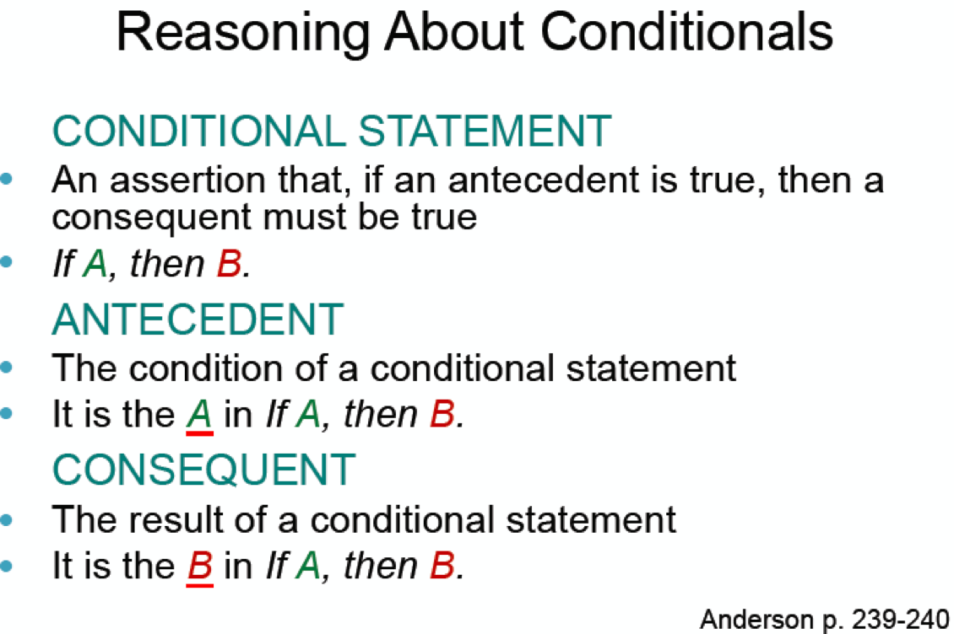

**modus ponens** (method for affirming)

• The rule of LOGIC that says that, if a conditional statement is true and its antecedent is true, then its consequent must be true

If you have money, then you are happy.

You have money.

Then you are happy.

• Allows us to infer the consequent from the antecedent

**modus Tollens** (method of denying)

• The rule of logic that says that, if a conditional statement is true and its consequent is false, then its antecedent must be false.

If you drink poison, then you die.

You are NOT dead?

Then you did NOT drink poison.

• Allows us to infer the antecedent if the consequent is false

**Fallacies**

**Affirmation of the Consequent**

If you have money, then you are happy. You are happy. Therefore you have money. (FALSE!)

**Denial of the Antecedent**  
If you drink poison, then you die. You did not drink poison. Therefore you did not die. (FALSE!)

***In both of these cases, the inference is invalid because there might be other ways in which Joan could get a good grade, such as doing a great term project.***

· **Evans (1993)** Anderson p. 241

o reviewed a large number of studies that compared the frequency of accepted valid inferences and the frequency of accepted invalid inferences.

o People are only able to show high levels of logical reasoning with modus ponens.

o Modus Tollens acceptance is low

o Invalid inferences are common

## **Evaluating Conditional Arguments in a Larger Context**

· **Byrne (1989)**

o “If (A) she has an essay to write, then (B) she will study late in the library.   
(If she has textbooks to read, she will study late in the library.)   
She will study late in the library (A).   
Therefore, she has an essay to write (B). “

§ Accepted the conclusion 71%, committing the fallacy of affirmation of the consequent. Given the parenthetical premise acceptance went down to 13%.

§ **People are more accurate reasoning if the material engages them to have a richer interpretation of the situation.**

o “If (A) she has an essay to write, then (B) she will study late in the library.   
(If the library stays open, then she will study in the library.)   
She has an essay to write (A).   
Therefore, she will study late in the library (B). “

§ Without the additional statement in parentheses, participants accepted the *modus ponens* inference 96% of the time. With the additional statement, acceptance rate went down to 38%. Logically the participants are making an error in not accepting the conclusion with the additional premise. However, in the world they would be viewed as making the right judgment—how could she actually study in the library if it were not open?

§ Example of trouble with algorithm based decision making

## **Wason selection task**

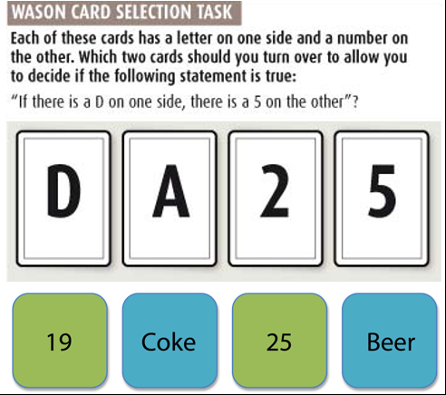

· If a card has a vowel on one side, then it has an even number on the other side.

· Averaging over a large number of experiments **(Oaksford & Chater, 1994),**

o Approx. 90% select E, logically correct choice because an odd number on the other side would disconfirm the rule.

o Approx. 60% turn over the 4, which is not logically informative because neither a vowel nor a consonant on the other side would have falsified the rule.

o 25% turn over the 7, which is a logically informative choice because a vowel behind the 7 would have falsified the rule.

o 15% elect to turn over the K, which would not be an informative choice.

· **Griggs and Cox (1982)** – Drinking beer alternative to numbers and letters (p. 243)

o when applied to a social “permission” situation it becomes easier

§ called the **permission schema**.

§ Cosmides and Tooby argue that this involves “Cheater detection”, a fundamental social skill

· **(Oaksford & Wakefield, 2003)** – example with broken headlights/taillights on cars

o The behavior in the Wason card selection task can be explained if we assume that participants select cards that will be informative under a probabilistic model.

o “If A, then B” is interpreted as B will probably occur when A occurs

^^Highlights: people judge on probability - it’s more efficient in the real world!

Assume that events A and B have low probabilities of occurring in the world because that is what would make such a statement informative.

Suppose you visited a city and a friend told you that the following rule: If a car has a broken headlight, it will have a broken taillight.

You should flip a card stating car has a broken headlight and without broken taillight according to logic but in real life you should look at those with broken headlight and those with broken tail light because there can be much more cars with no broken taillight - it is more informative

· **Cheng, Holyoak, Nisbett, and Oliver (1986)**

**o college students who had just taken a semester course in logic** did only 3% better on the card selection task than those who had no formal training in logic.

## **Deductive Reasoning: Reasoning About Quantifiers**

## **Categorical syllogisms**

· Much of human knowledge is expressed with **logical quantifiers** such as *all, no* or *some*.

o Research on reasoning with quantifiers has focused on trying to understand why people accept many invalid categorical syllogisms.

· No doctors are poor.

o But we often mean “hardly any” or “with small probability.”

* Two types of statements
  + Universal statements
    - Involving words like "all" or "none"
    - Interpreted as having no exceptions
  + Particular statements
    - Involving "some"
    - Interpreted as true for some members of a category

§ Roger Schank, a famous AI researcher, was once observed to make the assertion “No one uses universals” - no human is binary

## **Woodworth and Sells (1935) : The Atmosphere Hypothesis**

* The Atmosphere hypothesis
  + States that the logical terms (some, all, no, and some–not) used in the premises of a syllogism create an “atmosphere” that predisposes participants to accept conclusions having the same terms/order.
    - (Negative or Positive).
    - Tend to accept: No A’s are B’s. All B’s are C’s. -> No A’s are C’s.
  + when faced with a categorical syllogism, people tend to accept conclusions having the same quantifiers as those of the premises.
    - No A’s are B’s. All B’s are C’s. -> No A’s are C’s.

### **Limitations of Atmosphere**

· Participants are more likely to accept the conclusion in the valid case. Thus, contrary to the atmosphere hypothesis, participants do display some ability to evaluate a syllogism accurately.

· **(Johnson-Laird & Steedman, 1978).**

o In general, participants are more willing to accept a conclusion from *A* to *C* ---- Compared to: Some *B*’s are *A*’s. Some *C*’s are *B*’s. -> Some *A*’s are *C*’s.

## **Mental models**

· **Johnson-Laird & Steedman, (1978)** proposed participants judge whether a conclusion is possible by creating a mental model of a world that satisfies the premises of the syllogism and inspecting that model to see whether the conclusion is satisfied.

o All the squares are striped. Some of the striped objects have bold borders. (not all striped objects have to be squares)

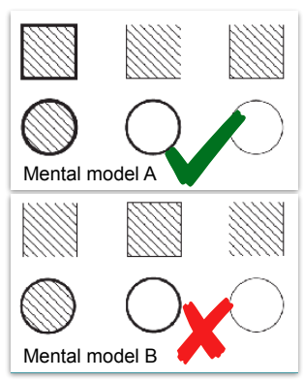

· Johnson-Laird claimed participants have difficulty developing alternative models and tend to accept syllogisms if its conclusion is correct in the first mental model (Einstellung effect + incubation effects, ch 8) + confirmation bias (falsify)

o (1983) developed a computer simulation of this theory that reproduces many of the errors that participants make.

o (1995) neurological evidence for the mental model explanation. Patients with right-hemisphere damage are more impaired in reasoning tasks than are patients with left-hemisphere damage and that the right hemisphere tends to take part in spatial processing of mental images.

o Kroger, Nystrom, Cohen, and Johnson-Laird (2008) found that the right frontal cortex was more active than the left in processing such syllogisms but that the opposite was true when people engaged in arithmetic calculation

* Forming hypothesis
  + Identifying what features are relevant and how they are related
  + Attribute identification - problem of determining what attributes are relevant to form a hypothesis
  + Rule learning - how the features combine to make a hypothesis
* Testing your hypothesis
  + Often focus on instances consistent with one's hypothesis
  + Often select only positive instances = confirmation bias
    - **falsification** is important, but not natural!
    - 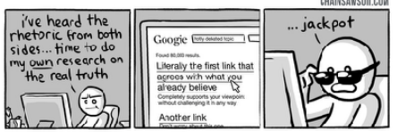
  + This is all a problem if the hypothesis is too narrow
  + In scientific discovery participants tend to show reluctance for alternative hypotheses

## **Dual Process theory**

Human reasoning both does and does not correspond to normative prescriptions (Evans, 2007; Stanovich, 2011)

• Suggests human reasoning is governed by two different types of processes:

• TYPE 1: Rapid, automatic, and rely on associations between situations and actions

• TYPE 2: Slow, deliberative, and may follow prescriptions of the normative models

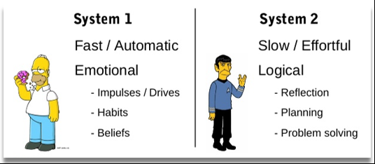

### **Dual-Process Theories (criticism)**

• Not falsifiable (perfect for confirmation bias):

• Theories can accommodate any result and so can predict none.

• If people display normatively irrational behaviour, this is because their Type 1 processes dominate.

• If they display normatively rational behaviour, this is because their Type 2 processes dominate.

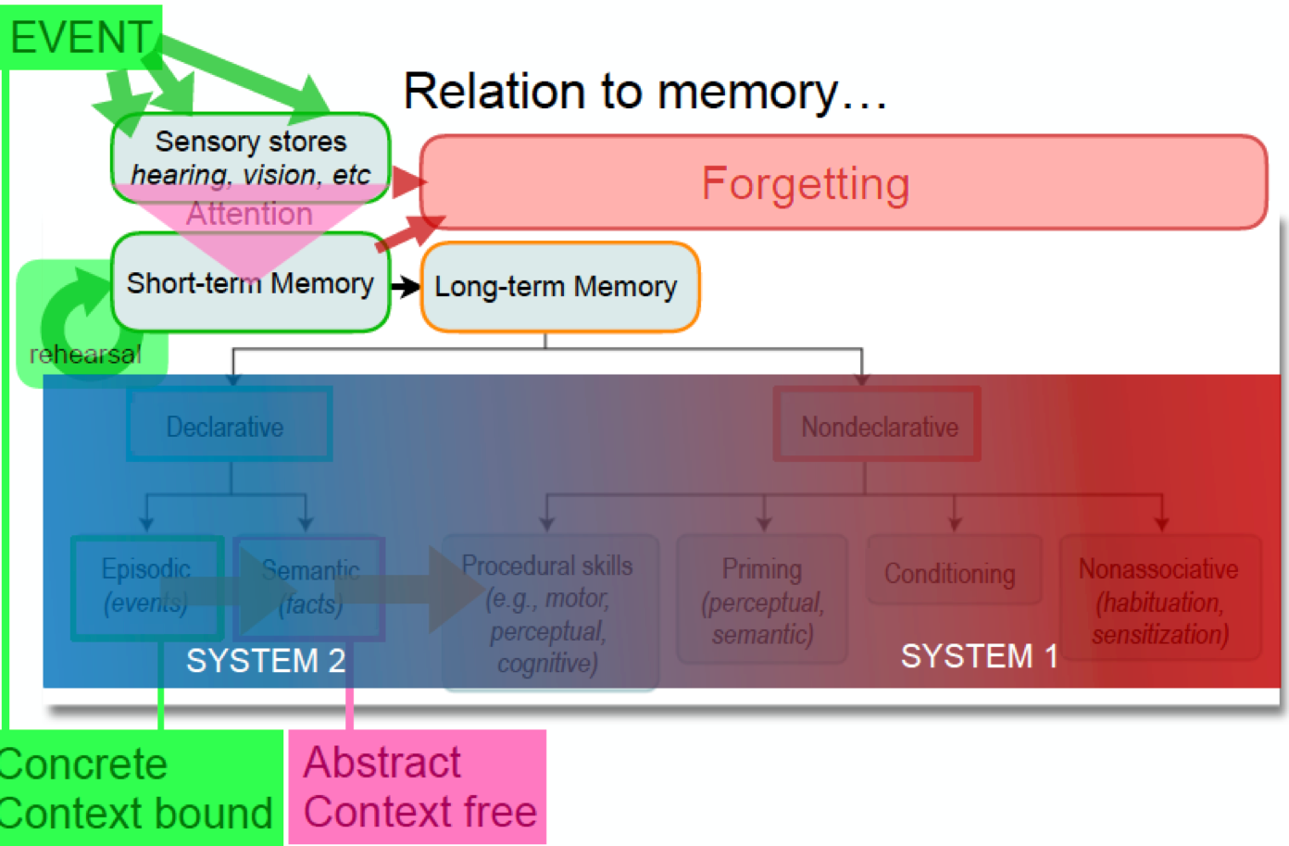

Example of why conditioning is automatic, irrational behaviour - a dog bite me some years ago I have conditioned fear from dogs that I can not explain - irrational because it does not mean that now all the dogs are going to bite you

# Key Terms

|  |  |
| --- | --- |
| affirmation of the consequent | The logical fallacy that one can reason from the affirmation of the consequent of a conditional statement to the affirmation of its antecedent: If A, then B and B is true together can be thought (falsely) to imply A is true. (p. 240) |
| antecedent | The condition of a conditional statement; that is, the A in If A, then B. (p. 239) |
| atmosphere hypothesis | The proposal by Woodworth and Sells that, when faced with a categorical syllogism, people tend to accept conclusions having the same quantifiers as those of the premises. (p. 248) |
| attribute identification | The problem of determining what attributes are relevant to the formation of a hypothesis. See also rule learning. (p. 253) |
| categorical syllogism | A syllogism consisting of statements that have logical quantifiers in which one premise relates A to B, another relates B to C, and the conclusion relates A to C. (p. 247) |
| conditional statement | An assertion that, if an antecedent is true, then a consequent must be true: a statement of the form If A, then B. (p. 239)  Valid |
| confirmation bias | The tendency to seek evidence that is consistent with one’s current hypothesis. (p. 255) |
| consequent | The result of a conditional statement; the B in If A, then B. (p. 239) |
| deductive reasoning | Reasoning in which the conclusions can be determined to follow with certainty from the premises. (p. 239) |
| denial of the antecedent | The logical fallacy that one can reason from the denial of the antecedent of a conditional statement to the denial of its consequent: If A, then B and Not A together are thought (falsely) to imply Not B. (p. 241) |
| inductive reasoning | Reasoning in which the conclusions follow only probabilistically from the premises. (p. 239) |
| logical quantifiers | An element such as all, no, some, and some not that appears in such statements as All A are B. (p. 246) |
| mental model theory | Johnson-Laird’s theory that participants judge a syllogism by imagining a world that satisfies the premises and seeing whether the conclusion is satisfied in that world. (p. 250) |
| modus ponens | The rule of logic stating that, if a conditional statement is true and its antecedent is true, then its consequent must be true: Given both the proposition If A, then B and the proposition A, we can infer that B is true. (p. 239) |
| modus tollens | The rule of logic stating that, if a conditional statement is true and its consequent is false, then its antecedent must be false: Given the proposition If A, then B and the fact that B is false, we can infer that A is false. (p. 240) |
| particular statements | A statement, frequently using the word some, that logicians interpret as meaning it is true about at least some members of a category. Contrast with universal statement. (p. 248) |
| permission schema | An interpretation of a conditional statement in which the antecedent specifies the situations in which the consequent is permitted. (p. 243)  Society has many rules how its members should conduct themselves, therefore people are good at applying social rules |
| rule learning | Determining how the features combine to make a hypothesis. (p. 253) |
| selection task | A task in which a participant is given a conditional statement of the form If A, then B and must choose which situations among A, B, Not A, and Not B need to be checked to test the truth of the conditional. (p. 242) |
| syllogisms | A logical argument consisting of two premises and a conclusion. (p. 238) |
| Type 1 processes | Rapid and automatic processes that sometimes determine reasoning and decision making. (p. 257) |
| Type 2 processes | Slow and deliberative processes that sometimes determine reasoning and decision making. (p. 257) |
| universal statements | A statement, often involving words like all or none, that logicians interpret as having no exceptions. Contrast with particular statement. (p. 247) |

# xx: EMOTION

Additional: Ward (The Student’s Guide to Cognitive Neuroscience)

## What is an emotion?

* A state associated with stimuli --> either rewarding or punishing
* An emotion is brief and swift compared to moods
* Moods lasts and/or recurrent
  + E.g. Fear is an emotion and anxiety is a mood

## How to measure emotions?

* The subjective nature → using questionnaires (introspection)
* Bodily response → skin conductance or recordings of facial expression
* Behavioral consequences → pressing a lever for a reward

## How we communicate emotions

* Emotions have a hedonic value = they are subjectively liked or disliked
* Emotions results in motor outcomes in the face and body known as expressions
  + E.g. To send signals to others
* We can share emotions between each other
  + Through mirroring → understand each other through simulation of emotional, motor or bodily states
  + Through mentalizing (also called theory-of-mind) --> inferring mental states to others, putting yourself in their shoes
    - Child and chocolate hidden while person away
* We also have moral emotions
  + Related to our one behavior (in relation to others) or other people’s behavior ( in relation to our self or others)
    - We evaluate our actions against some standard of acceptable behavior (culture, religion, norms…)

## History

* Darwin claimed that expressions such as anger are innate and go across species
  + Animals are able to interpret these expressions in other animals
* He also argued that they have been conserved by evolution
* He believed that humans might have unique expressions such as blushing (linked to shame or embarrassment)

James-Lange theory

* The self-perception of bodily changes produces emotional experience
  + E.g. We feel sad because we are crying
    - Stimulus → expression → emotional processing
* A study by Schacter and Singer goes against this theory
  + Changes in bodily states do not sufficiently produce an emotion
    - Injected participants with adrenaline = no self-reported expression
    - Presence of appropriate cognitive setting (angry man) → self-report emotion → Though they Amplify the emotional experience
* However, smiling in order to feel happy sometimes works

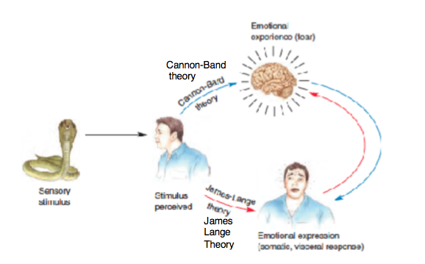

Canon-Bard theory

* Bodily feedback cannot account for the differences between emotions
* Bodily expressions occur AFTER the emotion
* They found that the hypothalamus is the centerpiece of emotions
  + Receive input --> send signals to the autonomic system (induce bodily feelings) and to the cortex (conscious experiences of emotion)

The "emotional brain"

* Papez claimed that the feeling of emotions originated in the Papez circuit → thought to be involved in bodily regulation
  + Also a second circuit, involving the cortex, involved a deliberative analysis which retrieved memory associations about the stimulus
    - save memory about snake: “this is bad, run!”
* MacLean also included the amygdala and orbitofrontal cortex → the "Limbic Brain"
* Together with the cingulate cortex, hippocampus, hypothalamus and anterior nucleus of the thalamus --> it were hypothesized to produce an integrated "emotional brain"
* However, this theory is no longer endorsed by cognitive neuroscientists.

→ now: different emotions involve different areas! No ‘emotional brain’

## Basic emotions → Ekman

* Independent of culture
* Own biological basis
* Six basic emotions:
  + Anger, fear, disgust, surprise, happiness, sadness
  + Study across diverse culture in categorizing facial expression
* (Plutchik, 1980) Basic emotions can be comprised:
  + Fear + surprise = alarm, joy + fear = guilt
  + Basic emotion can also be contextualized to self (Shame) or others (Guilt)

## Other views on emotions

* Feldman-Barrett (1999) → all emotions tap into the core affect
  + Has two dimensions:
    - Pleasant/unpleasant
    - High/low arousal
  + Categorizing emotions --> tap the core affect system differently --> affected by executive control, language, theory-of-mind etc.

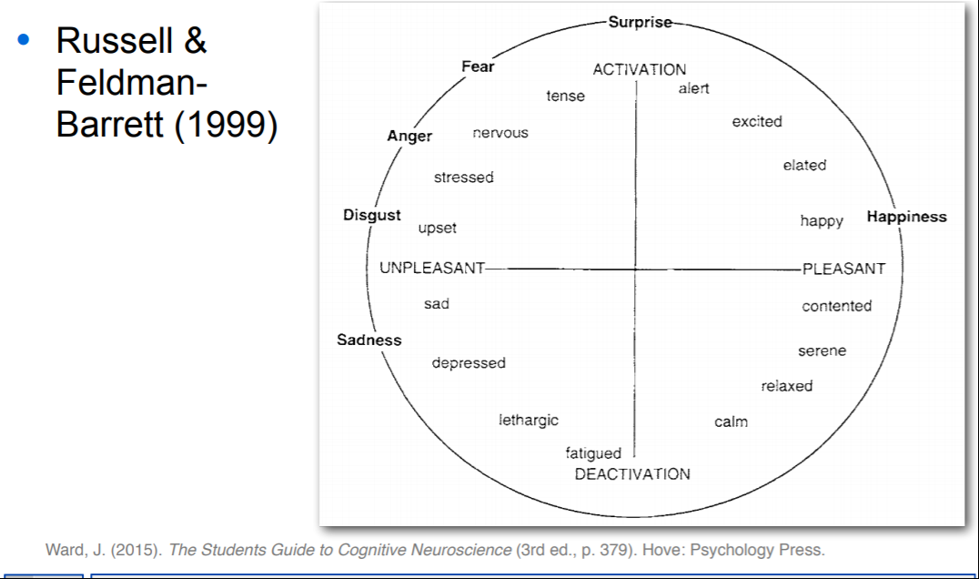

---

* Rolls (2000) → core set of basic emotions → dimensions of
  + Reward/punishment and Presence/absence
* Intensity
  + Different types of emotions emerge by considering whether a reward or punishment is applied ( pleasure >< fear ), reward removed (anger), punishment absence ( relief )

Can occur in combination: reward + punishment (e.g. Guilt)

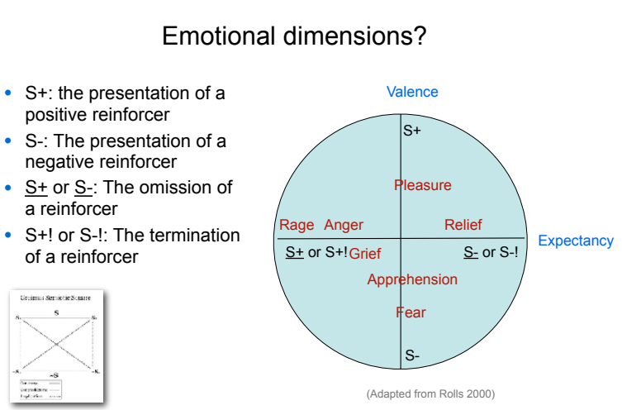

## Fear

* Amygdala (latin for Almond) and hippocampus important for memory → especially emotional content + if a stimulus is rewarded or punished (positive AND negative associations)
  + Experiment with monkeys (Kluver & Bucy, 1939):
    - Bilateral lesions of the amygdala = Kluver-Bucy syndrome
      * Unusual tameness
      * Emotional blunting; examine object with the mouth (hyperorality -> Oral examination)
        + Objects lost their emotional value
* Amygdala especially important in fear
  + Experiment with mice
    - Lesions to amygdala:
      * disrupt fear condition
      * after conditioning disrupt storage of response
      * does not disrupt fear response to shocks

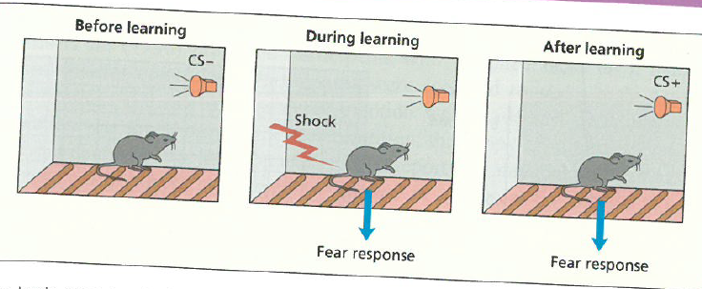

* + Using skin-conductance response, Bechara
    - Amygdala lesioned people failed to show conditioned shock response
    - Can verbally learn the association, “when I saw the blue square I got a shock”.

**→ suggests that associations are stored in both Amygdala (Direct response) and hippocampus (declarative memory).**

* + Patient SM
    - Patient S.M. with selective bilateral damage to the amygdala → less ability to recognize fearful expressions than other expressions.
  + Spiders among flowers (Ohman et al., 2001)
    - pop-out effect
    - Generally believed (Adolphs, 2002) that there’s a fast direct subcortical route from thalamus (receives and passes on sensory signals) to amygdala and a slow route via the visual cortex
      * Cucumber cats

## Disgust

Insula (small island) situated under temporal lobes - About bodily perceptions (e.g. taste)

* Huntington's syndrome (kipps, 2007)
  + Impairment of insula corresponds with degree of unableness to point out the vocal and facial expressions of disgust

## Reward values

* Orbitofrontal cortex = computing the current value of a stimulus.
  + Experiment by Small et al. PET study
    - Participants had to eat chocolate between functional imaging
      * In the beginning = wanted + pleasant
      * After excessive consumption = not-wanted + unpleasant
      * All linked to changes in activity in orbitofrontal regions
    - This can be regarded as a form of extinction = a previously rewarded stimulus is no longer rewarded
  + Plassman (2008) = regulating and Contextualizing emotions
    - Identical wines, different prices: Wine taste better when more expensive - related to heightened activity in orb. cortex
* Anterior Cingulate
  + Rushworth (2007) - predicts whether an action brings punishment or reward
    - Dif. from Orb. Cortex, that knows whether a stimulus is currently rewarded or punished.
    - Monkeys with lesions will not take into account pictures of dominant males or sexually cycled / horny females when reaching for food
* Reward-based learning involved the ventral striatum (placed in the basal ganglia)
  + Dopamine goes to this region
    - In humans, implicated in hedonic aspects of drug use (e.g. cocaine)
    - Increased dopamine release = when male rats ‘presented’ with a female rat
  + In human fMRI = activity in ventral striatum correlates with level of potential monetary reward
    - Is even greater when there is social cooperation as opposed obtaining price through noncooperation
* Predicted reward vs actual reward
  + Experiment Schultz (1992):
    - Monkeys presented with a light or tone cue = reward
    - After some time in training they get the dopamine release even though they don't get the reward → they predict it → no reward --> dopamine goes below baseline
* Morality
  + lesions to orbitofrontal (and ventromedial prefrontal) cortex
    - Low empathy as judged by family members
      * Push people in front of train scenario (Koenigs, 2007)

**Mikkel’s extra that has no sources:**

* **Neurotransmitters (All interacting heavily)**
  + **dopamine (reward prediction error)**
    - **Ventral tegmental area (Dopamine modulator)**
  + **serotonin (mood and food)**
  + **opioids (e.g. endorphins - pain killing and evoking**
  + **euphoria)**

# Key Terms

|  |  |
| --- | --- |
| Emotion | A state associated with stimuli that are rewarding (i.e. That one works to obtain) or punishing (i.e. That one works to avoid). These stimuli often have inherent survival value. |
| Mentalizing | The process of inferring or attributing mental states to others |
| Mirroring | The process of sharing the emotions or mental states of others |
| Mood | An emotional state that is extended over time (e.g. Anxiety is a mood and fear is an emotion or sadness is an emotion and depression is a mood) |
| James-Lange theory | The self-perception of bodily changes produces emotional experience (e.g. One is sad because one cries) |
| Canon-Bard theory | Theory centered on the hypothalamus' role in emotions which bodily responses occur after the emotions itself |
| Papez circuit | A limbic-based circuit that was once thought to constitute a largely undifferentiated "emotional" brain. |
| Basic emotions | Different categories of emotions assumed to be independent of culture and with their own biological basis (in terms of evolution and neural substrate) |
| Moral emotions | Emotions that are related to the behavior of oneself (in relation to others) or the behavior of others (in relation to oneself or others) |
| Amygdala | Part of the limbic system implicated in learning the emotional value of stimuli (e.g. In fear conditioning) |
| Kluver-Bucy syndrome | In monkeys after bilateral amygdala and temporal lesions, an unusual tameness and emotional blunting; a tendency to examine objects with the mouth; and dietary changes |
| skin conductance response (SCR) | Changes in electrical conductivity on a person's skin, triggered by certain stimuli (e.g. Emotional or familiar stimuli) |
| Extinction learning | Learning that a previously rewarded stimulus is no longer rewarded. |
| Ventral striatum | Part of the basal ganglia that includes the nucleus accumbens; involved in a "limbic circuit" connecting the orbitofrontal cortex, basal ganglia and thalamus. |

# 11: Decision Making

THE BRAIN AND DECISION MAKING

The ventromedial prefrontal cortex plays an important role in achieving the motivational balance and social sensitivity that is key to making successful judgments.

The case of Phineas Gage

* Accident: metal railroad spike tore through his ventromedial prefrontal cortex.
  + Ventromedial prefrontal cortex: important to motivation, emotional regulation, and social sensitivity (Gilbert, Spengler, Simons, Frith, & Burgess, 2006))
* Survived, but his personality changed
  + “fitful, irreverent and grossly profane, showing little deference to his fellows”.
  + Showing gambling tendencies

BAYE’S THEOREM

* Specifies how to combine **the prior probability** of a hypothesis with the

**conditional probabilities** of the evidence to determine **the posterior probability** of a hypothesis.

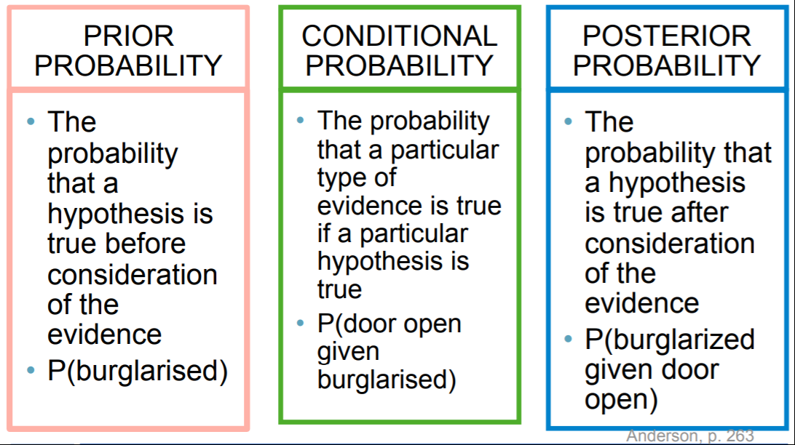

Example: *I come home and find the door to my house ajar.*

***The prior probability (A)****: the probability that the door is ajar.*

***The prior probability (B):*** *the probability of being burglarized*

***The conditional probability:*** *probability of door open if burglarized*

***The posterior probability:*** *probability of* burglarized given door open (WHAT WE WANT TO KNOW!)

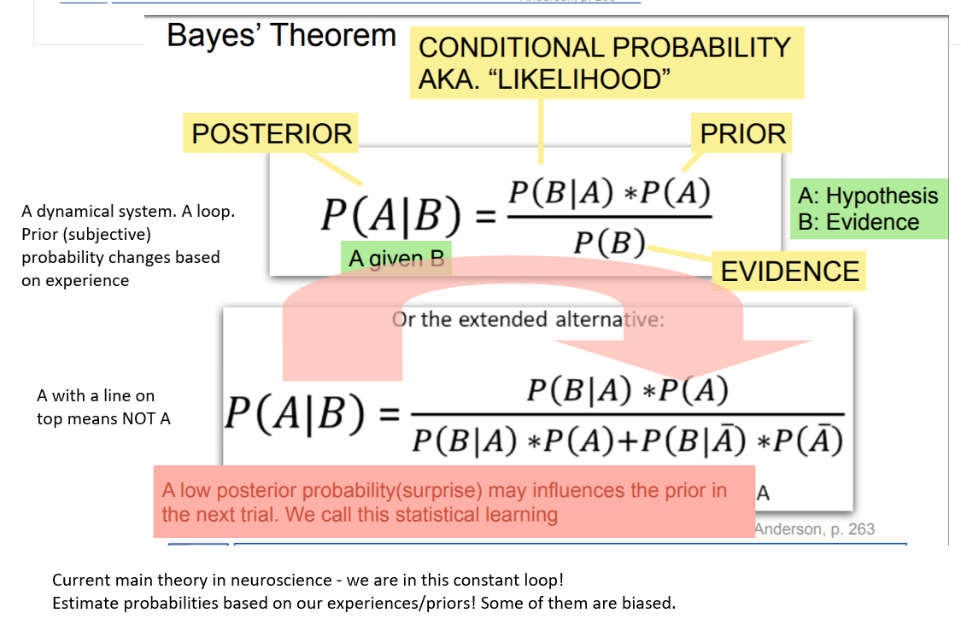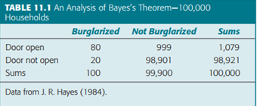

*Thus, in total there are 1,079 cases of front doors left open, and the probability of the house being burglarized is 80∕1,079 = 0 .074 = 0.074*100 = 7,4%*   
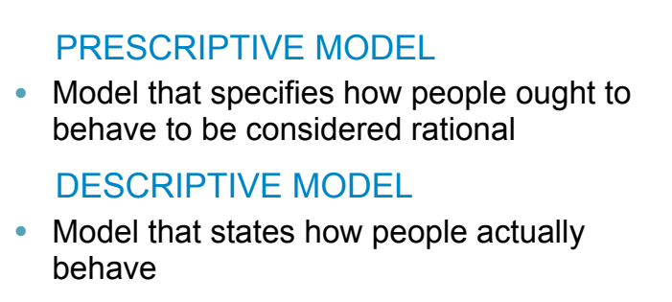

The theorem serves as **a prescriptive model** (normative model), specifying the means of evaluating the probability of a hypothesis.

Such a model contrasts with **a descriptive model**, which specifies what people actually do. People often fail to take base rates into account in making probability judgments.

BASE-RATE NEGLECT

→ failure to take base rates into account in making probability judgments

→ people sometimes ignore prior probabilities

* (Kahneman & Tversky 1973): page 264
* Cancer example (p 265): low base rate of cancer

Correspondence to Bayes’s Theorem with Experience

**How do people use their past experiences to make judgments?**

→ Although participants’ processing of abstract probabilities often does not correspond with Bayes’s theorem, their behavior based on experience often does (non-declarative knowledge!)

* Example with experience
  + Doctors were quite sensitive both to base rates and to the evidence provided by the symptoms (
  + The more clinical experience the more tuned were their judgments
* Probability matching

**We can reason better with frequencies than with probabilities**

* we experience frequencies of events, but not probabilities, in our daily lives.

CONSERVATISM (the opposite of base rate neglect!)

→ underestimating of the cumulative force of evidence in making probability judgments.

JUDGEMENT OF PROBABILITY

Gambler’s fallacy - the belief that if an event has not occurred for a while, then it is more likely, by the “law of averages,” to occur in the near future.

(e.g. *experiment by Tversky and Kahneman (1974) in which participants see a sequence of coin tosses and must guess whether each toss will be a head or a tail. If they see a string of heads, they become more and more likely to guess that tails will come up on the next trial. Even though there is still 50% probability it will be a head.*

→ Therefore, people can be biased in their estimates of probabilities when they must rely on factors such as memory and similarity judgments.

Recognition heuristic - Goldstein and Gigerenzer (1999) found that if one item is recognized and another is not, people view the recognized item to have a higher value on dimensions like size

→ useful in many but not all domains

→ in some domains, researchers have shown that people intelligently combine it with other information.

→ For instance, Richter and Späth (2006) had participants judge which of two animals has the larger population size:

Are there more Hainan partridges or arctic hares?

Are there more giant pandas or mottled umbers?

In the first case, most people have heard of arctic hares and not Hainan partridges and would correctly choose arctic hares using the recognition heuristic. In the second case, most people would recognize giant pandas and not mottled umbers (a moth). Nonetheless, they also know giant pandas are an endangered species and therefore correctly choose mottled umbers

**→ recognition of an item and it’s combination with other information is needed to make a good judgement**

**Availability bias/heuristic**

* People can be biased by memory and similarity judgments
* Experiment with the letter "k"
  + What is the most frequent? Words beginning with "k" or "k" as the third letter?
  + Memory makes them say the incorrect answer --> words are more strongly associated with their first letter than the third.
  + Even though there are three times more letters with "k" as the third letter people answer words beginning with "k"

UTILITY THEORY

→ the goal is to maximise utility

Expected utility = (probability of a given outcome) x (utility of the outcome)

Example : *If A) there is a 50/50 chance that I will get a 100 kroner then the expected utility is 50 = 0.50 x 100 kroner*

*If B) there is a 100 percent chance of getting 40 kroner then the utility is 40= 1 x 40 kroner.*

According to the **dominance principle**, I should always choose A. In fact people more often choose B. Most people show loss aversion, they take the sure win even if a risky bet has higher expected utility. But in the face of a sure loss they are willing to take a chance (e.g. choosing between a sure loss of 50 DKK and a 51 percent chance of losing 100 DKK.)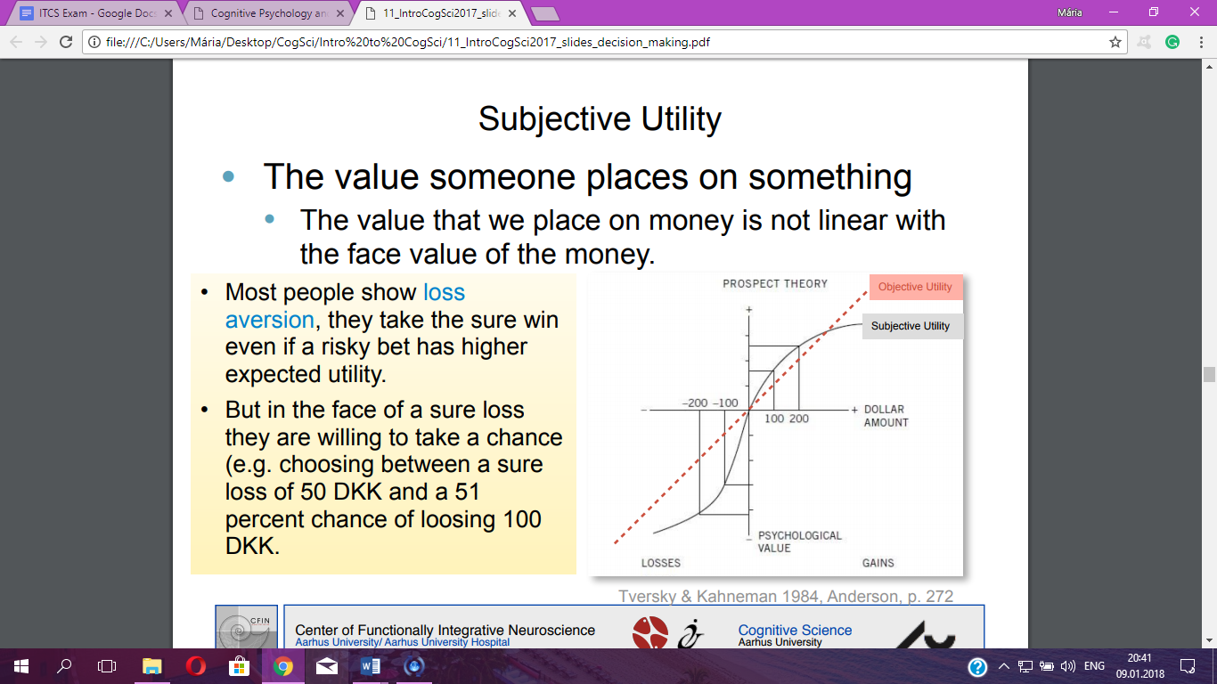

This is because of **subjective utility** - the value someone places on something. The value that we place on money is not linear with the face value of the money.

Subjective probability: not identical with objective probability. Low probabilities overweight.

Neural Representation of Subjective Utility and Probability

Nucleus accumbens (in the basal ganglia) - dopamine activity reflects the magnitude of reward

Ventromedial cortex - involved in integrating probabilities of succeeding in an action with reward

Example: *The Iowa gambling task*

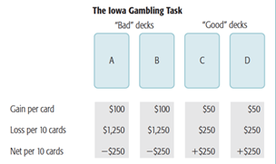

*Normal participants eventually learn to avoid decks with higher payoff. Participants with* ***ventromedial damage*** *(e.g. Phineas Gage) keep returning to high paying decks and do not show measures of emotional engagement when selecting these decks*

FRAMING EFFECTS

→ When there is no clear basis for making a decision, people are influenced by the way in which the problem is framed

→ in situations with no clear basis for choice

Example - The Asian disease problem:

1. You are a physician working in an Asian village, and six hundred people have come down with a life-threatening disease.

Two possible treatments exist.

• If you choose treatment A, you will save exactly 200 people.

• If you choose treatment B, there is a one-third chance that you will save all 600, and a two-thirds chance that you will save no one no one!!!

* 78% chose A

2. Two possible treatments exist.

• If you choose treatment C, exactly 400 people will die.

• If you choose treatment D, there is a one-third chance that no one will die, and a twothirds chance that everyone will die.

* 78% chose D

**Loss aversion with “die” - “saved” sounds better.**

Wording matters!

Additional literature: The Paradox of Choice (chapter 4)

The book discusses how the range of choices people face every day has increased in recent years, how we choose and shows how difficult and demanding it is to make wise choices

Maximizers vs satisficers

* Maximizers need to be assured that every purchase or decision was the best that could be made. Yet how can anyone truly know that any given option is absolutely the best possible? The only way to know is to check out all the alternatives
* Satisficers settle for something that is good enough and don’t worry about the possibility that there might be something better. A satisficer has criteria and standards.

Maximizers:

* engage in more product comparisons than satisficers, both before and after they make purchasing decisions.
* take longer than satisficers to decide on a purchase.
* are more likely to experience regret after a purchase.
* are more likely to spend time thinking about hypothetical alternatives
* generally feel less positive about their purchasing decisions.

Satisficers:

* the number of available options need not have a significant impact on one’s decision making.

Studies conducted by B.Schwartz show that being a maximizer is correlated with being unhappy. However, they do not show that being a maximizer causes unhappiness, because correlation does not necessarily indicate cause and effect. Another finding showed in his studies is that almost everyone who scores high on the Maximization Scale also scores high on regret.

**Maximizing and Regret**

* Maximizers are more likely to experience all forms of regret
  + E.g. Buyers remorse
* If you find something better around the corner it is a real pain
  + Will diminish some of the satisfaction you get from the choice you have made
* Experiment with a Regret scale
  + Example question:
    - "Once I make a decision, I don't look back"
  + Found that everyone who scores high on the maximization scale also scores high on regret scale

**Maximizer vs. Perfectionists**

* Experiment with a scale to measure perfectionism
  + The two scales are correlated
* A perfectionist is not satisfied with doing "good enough" if they can do better
  + Seek to achieve the best
  + High standards, but do not expect to meet them
  + Scoring high on perfectionism scale does not result in unhappiness, depression or being regretful
* Maximizers expect to meet their high standards
* “Expect the worst and hope for the best”

Does Choice Create Maximizers?

The world offers a wide range of options, and something (presently unknown) creates maximizers, and then the two combine to make people unhappy with their decisions. But it is certainly possible that choice and maximizing are not independent of each other. It is possible that a wide array of options can turn people into maximizers.

# Key Terms

|  |  |
| --- | --- |
| Bayes’s theorem | A theorem that prescribes how to combine the prior probability of a hypothesis with the conditional probability of the evidence, given the hypothesis, to assess the posterior probability of the hypothesis, given the evidence. (p. 262) |
| conditional probability | In the context of Bayes’s theorem, the probability that a particular piece of evidence will be found if a hypothesis is true. (p. 262) |
| descriptive model | A model that states how people actually behave. Contrast with prescriptive model. (p. 263) |
| framing effects | The tendency for people to make different choices among the same alternatives, depending on the statement of the alternatives. (p. 273) |
| gambler’s fallacy | The belief that, if a string of probabilistic events has turned out one way, there is an increased probability that the next event will now turn out the other way. (p. 269) |
| posterior probability | In Bayes’s theorem, the probability that a hypothesis is true after consideration of the evidence. (p. 263) |
| prescriptive model | A model that specifies how people ought to behave to be considered rational. Contrast with descriptive model. (p. 263) |
| prior probability | In Bayes’s theorem, the probability that a hypothesis is true before consideration of the evidence.  (p. 262) |
| probability matching | The tendency to choose an alternative with a probability that matches the frequency with which that alternative occurs in experience. (p. 267) |
| recognition heuristic | If one item can be recognized and another cannot, people view the recognized item to have a higher value on dimensions like size. (p. 270) |
| subjective probability | The probability people associate with an event, which need not to be identical to the event’s objective probability. (p. 273) |
| subjective utility | The value that someone places on something. (p. 272) |
| ventromedial prefrontal cortex | The portion of the cortex in the front and center of the brain. It seems to be involved in decision making and self-regulation, including activities like gambling behavior. (p. 260) |

### The additional reading key terms

|  |  |
| --- | --- |
| Maximizer | those determined to make the best choices - only the best is good enough  Seek and accept only the best |
| Satisficer | Good enough is fine, searches until their standards are met |
| Buyer's remorse | a feeling of regret ( = a wish that you had not done something ) after making a choice or decision |
| Perfectionist | High standards, but to not expect to meet them. Want to do the best as possible. |

# 14: Individual Differences in Cognition

**Nature vs. Nurture debate**

**Cognition and behavior attributed to:**

* **Nature?**
  + **Galton's study of Victorian genius (Weird guy - Sterilize)**
  + **Chomskyan linguistics (Language in brain)**
* **Nurture?**
  + **Freud (childhood forms the subconscious)**
  + **Skinner's behaviorism**

PROBABLY both!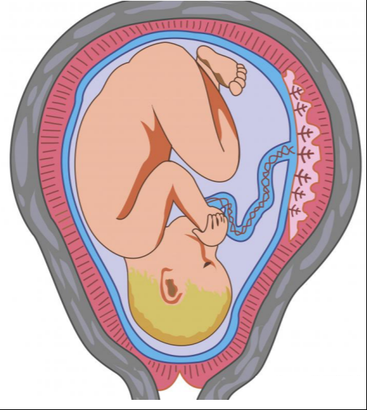

Nature + Nurture or Nature * Nurture

**Constraints on cognitive development**

Large brain-body proportion causes challenges:

* Progressive enlargement of birth canal at birth
* Sufficiently pliable skull
* First year of life: volume of brain doubles

**Delay of human development**

* Human babies helpless compared to other mammals
* Enables growth of large brain + acquisition of a large amount of knowledge
* Majority of neural development complete by age 5 - BUT the brain changes through life
* The number of synaptic connections increases tenfold in the first 2 years
* The number of neurons can’t be increased!

**Piaget's 4 stages of development**

(HOWEVER, ALL DEVELOPMENT IS OBVIOUSLY MORE CONTINUOUS AND GRADUAL!)

**Sensory-motor stage (birth - 2 years)**

* Children develop basic schemes for thinking about the physical world
  + Learn object permanence (a variation of conservation)
  + 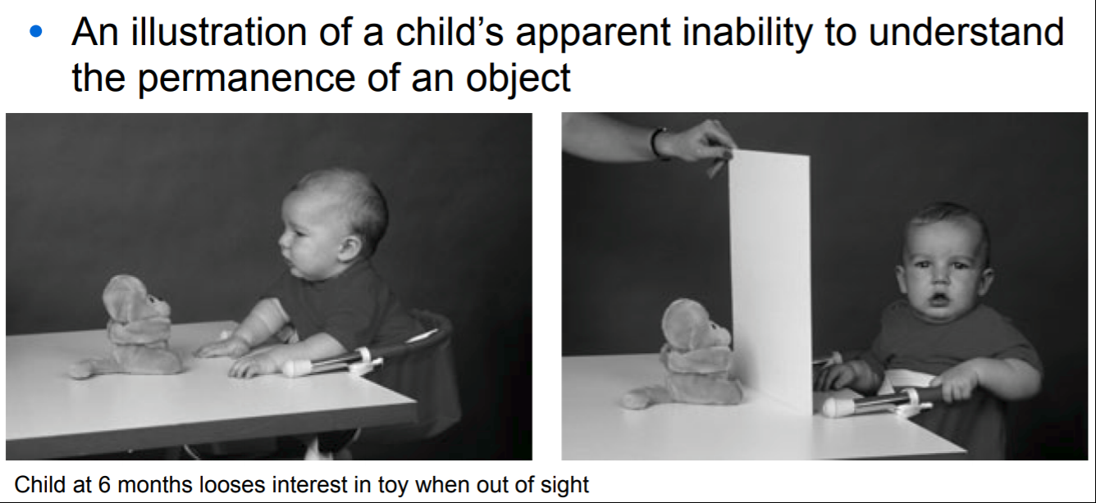
  + In these kinds of experiments there is usually a race towards the lowest incidence - Which could be an "outlier" in statistics.
  + A lot of these kinds of experiments are therefore still questionable
  + But, nonetheless: In the first couple of years of life children learn about permanence

Contradicting experiment:

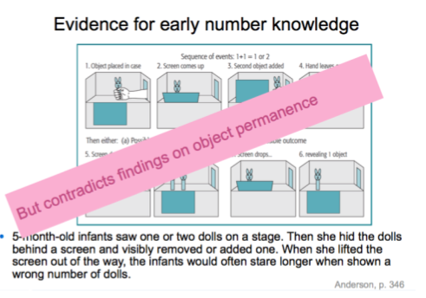

**Preoperational stage (2 - 7 years)**

* Children begin to represent the world with words, images and drawings

**Concrete-operational stage (7 - 11 years)**

* Children can perform mental operations (e.g. maths)
* Conservation starts to develop for rows of objects and liquids

**Formal-operational stage (11 - adult)**

* Individuals move beyond concrete experiences and think in more abstract and logical ways
  + Some adults never reach this stage… (quote Mikkel)
  + Now they understand different instances of the concept of conservation:
    - Physical features no longer distract children:
      * Two rows of objects - the same number of objects in each row - they know there are the same amount. If you compress one row in front of them they earlier said it was not the same amount
      * 3 containers - 2 are identical and hold the same amount of milk - if you poor from one of them to the 3, they would earlier say the 3 holds more

# **Learning in the brain**

A mix of learning to **“think better”** (basic cognitive processes like working memory) and to **“know better”** (learned more facts)

* Formation of new synapses (plasticity) → See chapter 1
* Formation of new receptors in the synapses (potentiation)
* Optimization and signal transmission (myelination of the axons + and pruning)
  + Myelin can't be removed, comes at a cost: now less flexible, can't form new connections
  + Pruning = killing off unused neurons (“*if you don’t use it, you lose it”)*

More white matter → more experienced → less flexible

(e.g. expertise, ch 9. Myelination → non-declarative encoding - hard to unlearn something!)

*(Myelin and white matter is the same)*

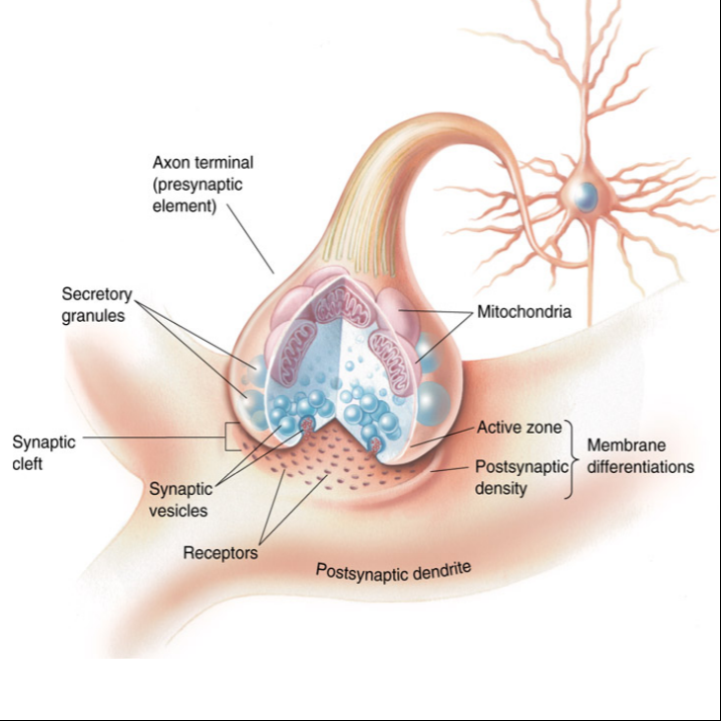

## **Postnatal development**

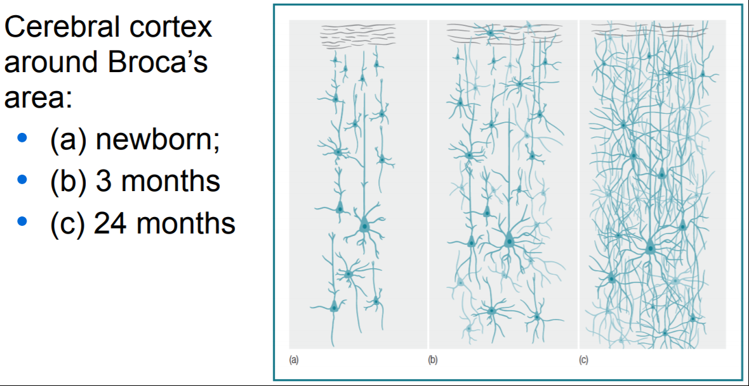

^^more synaptic connections

### **Some development is simply a matter of training:**

* Developmental differences may be linked to amount of exposure (NURTURE)
  + Experiment: mental rotation task. Adults and children on the same learning curve, but adults are ahead, advanced by 1800 trials. (Kail, 1988)
  + 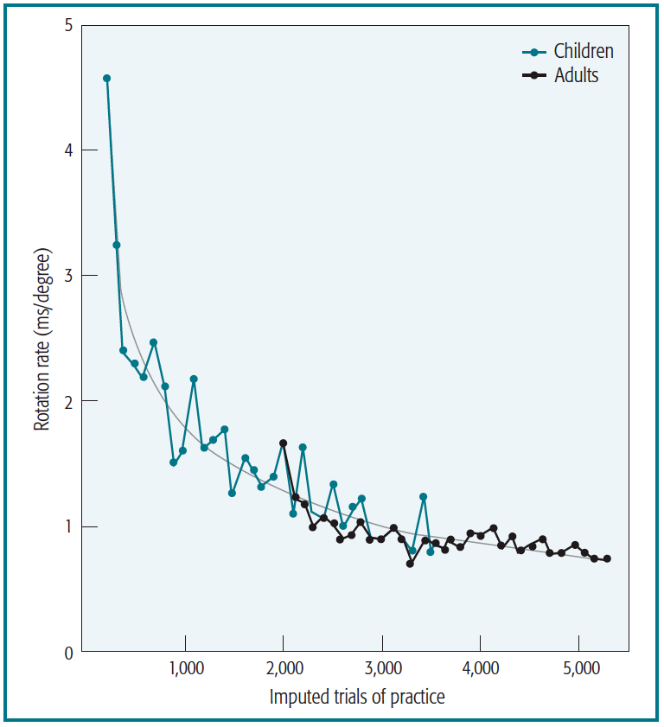

**Psychometric tests and intelligence**

**Intelligence Quotient (IQ)**

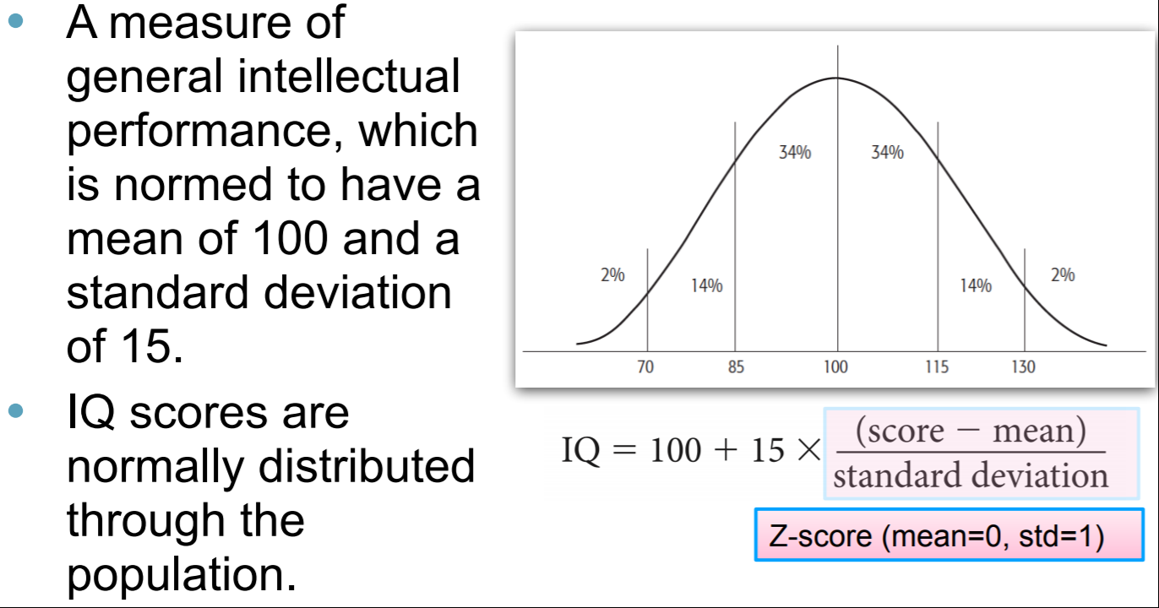

Example: Raven's progressive matrices (RPM)

* a non-verbal test (avoiding cultural differences)
* measures abstract reasoning
* 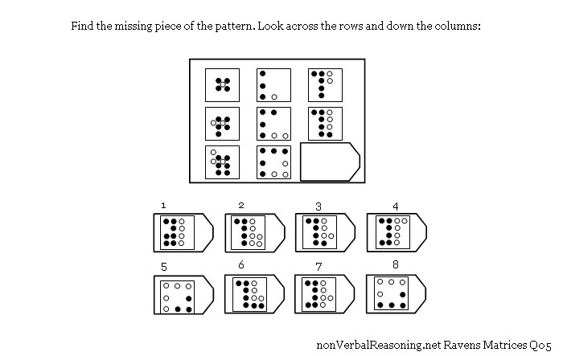

# **Nature >< Nurture and intelligence**

# **The concept of Heritability (NATURE)**

* A measure of the *degrees of variance* in a trait that can be assigned to genetic rather than environmental differences
* Not the same as causation
  + If heritability is 80%, we can't necessarily conclude that it is mainly caused by genes
  + 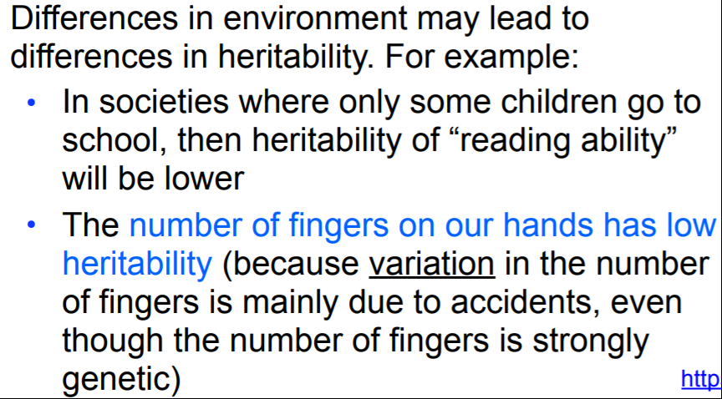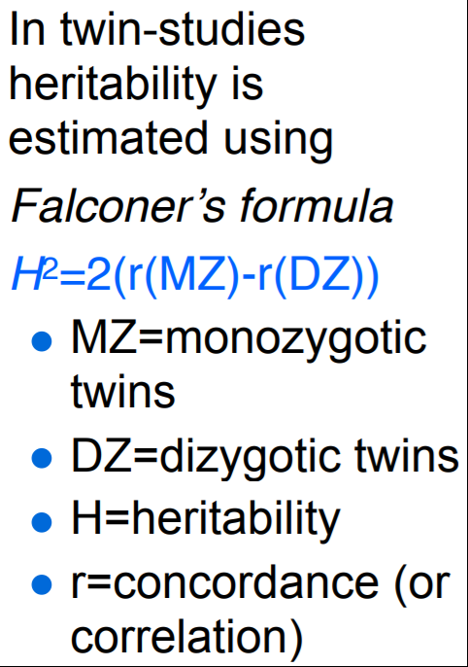

**Behavioral genetics**

* Twin studies + adoption studies
* Help disentangle genes from environment
  + twin studies: compare *concordance rates* (same traits) in:
* 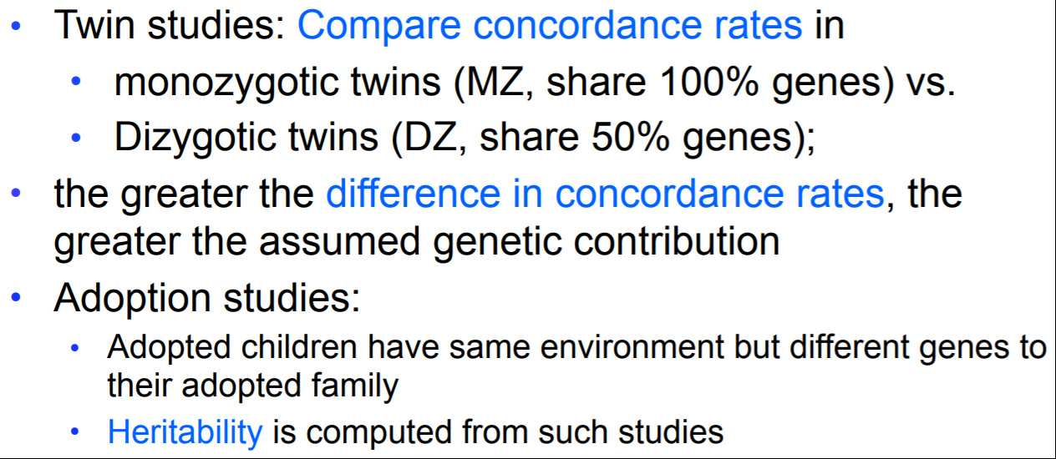

Some conditions seem to be somewhat heritable (NATURE):

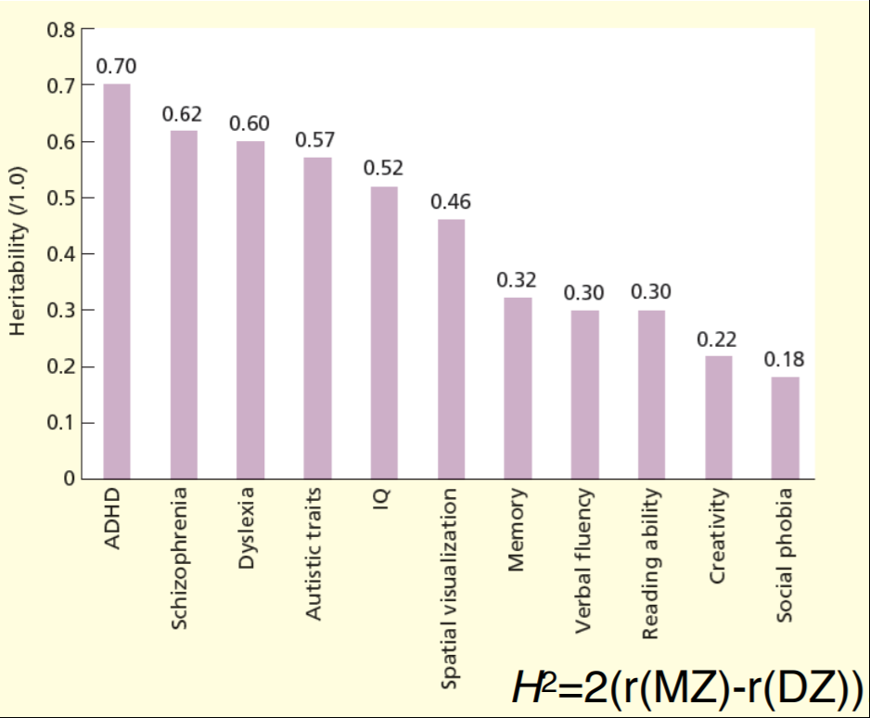

## **BUT it's complicated!:**

* "Gifted" people may actively seek out stimulating environments
  + Talented football players admitted to teams with better training
  + High grade students admitted to high grade educations with better teaching
* “Small differences grow on you”

## **Intelligence: The Flynn Effect**

IQ has been rising over time.

Argues against a solely genetic component of IQ (NATURE)

In Denmark tested with:

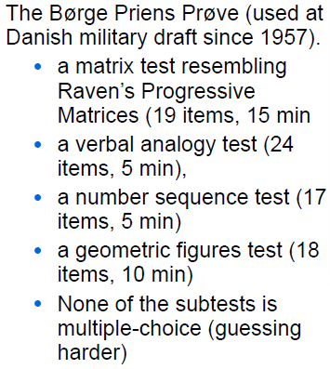

**The reverse Flynn Effect:** are we getting less intelligent?

**Additional: Teasdale (A long-term rise and recent decline in intelligence test performance: The Flynn Effect in reverse)**

* paper discussing the reverse Flynn Effect in Denmark
* declining since around year 2000

Why?:

* simultaneous decline in students entering 3-year advanced-level school programs (cause?)
* because of technology? (Who needs a brain)
* war → people don’t want to pass the military test?

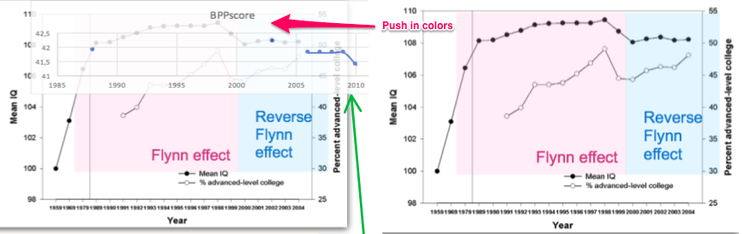

## **One or many intelligences? Different theories:**

* One: Spearman's g-score
* Many: Thurstone's (1938) verbal, spatial, reasoning

**Factor analysis (-->) (kind of like topic modelling)**

* Statistical method that tries to reduce tests to a smaller set of factors that will account for performance across a range of tests
* Based on correlation among tests

## 

## **Crystallized vs. Fluid intelligence**

|  |  |
| --- | --- |
| **Crystallized** | **Fluid** |
| The factor in intelligence that depends on acquired knowledge (memory)  (semantic memory, ch.7) | The factor in intelligence that reflects the ability to reason or solve problems in novel domains  Shows age-related decay  (problem solving skills, ch ?) |

OVERALL

Still a fragmented picture - more research needed!

# Key Terms

|  |  |
| --- | --- |
| Concrete-operational stage | The third of Piaget’s four stages of development, during which a child has systematic schemes for thinking about the physical world. (p. 340) |
| Conservation | A term used by Piaget to refer to the particular properties of objects that are preserved under certain transformations. (p. 341) |
| Crystallized intelligence | Cattell’s term for the factor in intelligence that depends on acquired knowledge. (p. 358) |
| Factor analysis | In the context of intelligence tests, a statistical method that tries to find a set of factors that will account for performance across a range of tests. (p. 356) |
| Fluid intelligence | Cattell’s term for the factor in intelligence that depends on the ability to reason or solve problems. (p. 358) |
| Formal-operational stage | The fourth of Piaget’s four stages of development, during which a child has abstract schemes for reasoning about the world. (p. 340) |
| Intelligence quotient | A measure of general intellectual performance that is normed to have a mean of 100 and a standard deviation of 15. (p. 353) |
| Preoperational stage | The second of Piaget’s four stages of development, during which a child has unsystematic schemes for thinking about the physical world. (p. 340) |
| Psychometric test | A test of various aspects of a person’s intellectual performance. (p. 353) |
| Sensory-motor stage | The first of Piaget’s four stages of development, during which a child lacks basic schemes for thinking about the physical world and experiences it in terms of sensations and actions. (p. 340) |

Brain areas worth remembering:

|  |  |  |
| --- | --- | --- |
| Name of area | Where is it located? | What does it do? |
| Anterior cingulate cortex (ACC) |  | * dealing with conflict |
| Amygdala |  | * memory * fear relations |
| Basal ganglia |  | * critical role in the control of motor movement and complex cognition |
| Broca’s area | * A region in the left frontal cortex | * language processing * speech related → especially syntax |
| Dorsolateral prefrontal cortex (DLPFC) | * Upper portion of the *prefrontal cortex* | * cognitive control |
| Frontal lobe | * region at the front of the cerebral cortex | * includes the motor cortex and the prefrontal cortex |
| Fusiform face area | * A part of the temporal cortex | * involved in fine discriminations, particularly of faces |
| Fusiform gyrus | * A region in the temporal cortex | * in recognition of complex patterns like faces and words |
| Hippocampus | * within the temporal lobe | * formation of permanent memories * responds also to false memories |
| Occipital lobe | * region at the back of the cerebral cortex | * controls vision |
| Parahippocampal place area (PPA) |  | * active when perceiving places |
| Parietal lobe | * region at the top of the cerebral cortex | * attention * higher level sensory information * roles in solving algebraic equations |
| Prefrontal cortex | * region at the front of the frontal cortex | * controls planning * higher level cognition |
| Temporal lobe | * region at the side of the cerebral cortex | * primary auditory areas * controls recognitions of objects |
| Ventromedial prefrontal cortex | * the portion of the cortex in the front and center of the brain | * involved in decision making * self-regulation   + such as gambling |
| Wernicke’s area | * A region of the left *temporal lobe* | * language * semantic content of speech |

The memory model - with a sprinkle of a touch from Mr. Wallentin

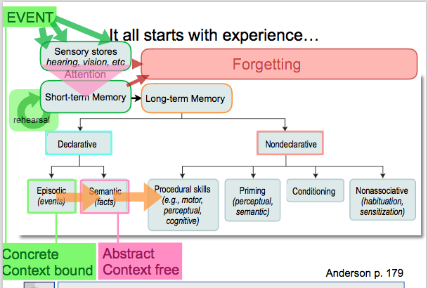

# 

# 

Perspectivation

|  |  |
| --- | --- |
| **Chapter** | **Relates to:** |
| 1: The Science of Cognition |  |
| 2: Perception |  |
| 3: Attention and Performance |  |
| 4: Mental Imagery |  |
| 5: Representation of Knowledge |  |
| 6: Human Memory: Encoding and Storage |  |
| 7: Human Memory: Retention and Retrieval |  |
| 8: Problem Solving |  |
| 9: Expertise |  |
| 10: Reasoning |  |
| X: Emotion |  |
| 11: Decision Making |  |
| 14: Individual Differences in Cognition |  |